Lesson 3-Holiday-Grammar (part2)
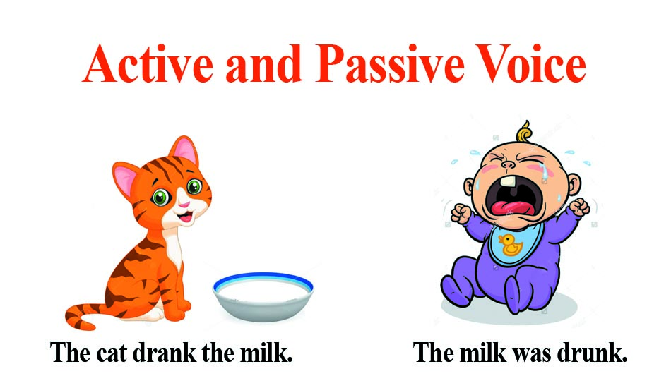
Exercise 1
Раскройте скобки, употребляя глаголы в Present, Past или Future Simple Passive.
1. My question (to answer) yesterday.
2. Hockey (to play) in winter.
3. Mushrooms (to gather) in autumn.
4. Many houses (to burn) during the Great Fire of London.
5. His new book (to finish) next year.
6. Flowers (to sell) in shops and in the streets.
7. The letter (to receive) yesterday.
8. Nick (to send) to Moscow next week.
9. I (to ask) at the lesson yesterday
10. I (to give) a very interesting book at the library last Friday.
11. Many houses (to build) in our town every year.
12. This work (to do) tomorrow.
13. This text (to translate) at the last lesson.
14. These trees (to plant) last autumn.
15. Many interesting games always (to play) at our PT lessons.

Exercise 2
Упражнение в hot potatoes

Exercise 3
Complete the sentences using one of the verbs in the box in the correct form
cause- damage - hold - invite - make - overtake - show - surround - translate - write
- Many accidents … by dangerous driving
- Cheese … from milk.
- The roof of the building … in a storm some days ago.
- You … to the wedding. Why didn't you go ?
- A cinema … is a place where films .
- In the US, elections for president … every four years.
- Originally the book … in Spanish , and a few years ago it … into English.
- Although we were driving quite fast, we … by a lot of cars.
- You can't see the house from the road. It … by a lot of trees.
Exercise 4
Change the sentences from Active to Passive
- People eat 40 million hamburgers every day.
- People speak English all over the world.
- Where did they invent gun powder ?
- The police didn't find the missing girl last weekend.
- Tourists don't visit this museum very often.
- Workers are building a new fun park in town
- When did they translate this book into English ?
- Women send thousands of emails to the star every month.
- Sally brought me some fresh grapes.
- Some dangerous looking men were following me the whole evening.
- George told me about the incident at dinner.
- They will hold the election next week.
- You must put coins into the slot machine.
- Sharon will meet you at the airport and take you to the hotel.
- You should send your children to a good school.
- They won't take a decision until the next meeting.
- They ever open the door before.
Exercise 5
Game
http://www.eslgamesplus.com/passive-voice-past-passive-esl-grammar-sentence-activity-fun-game-online/

