|  |
| --- |
| 001_intermediate_grammar  Present Continuous, Present Simple, Future Simple |

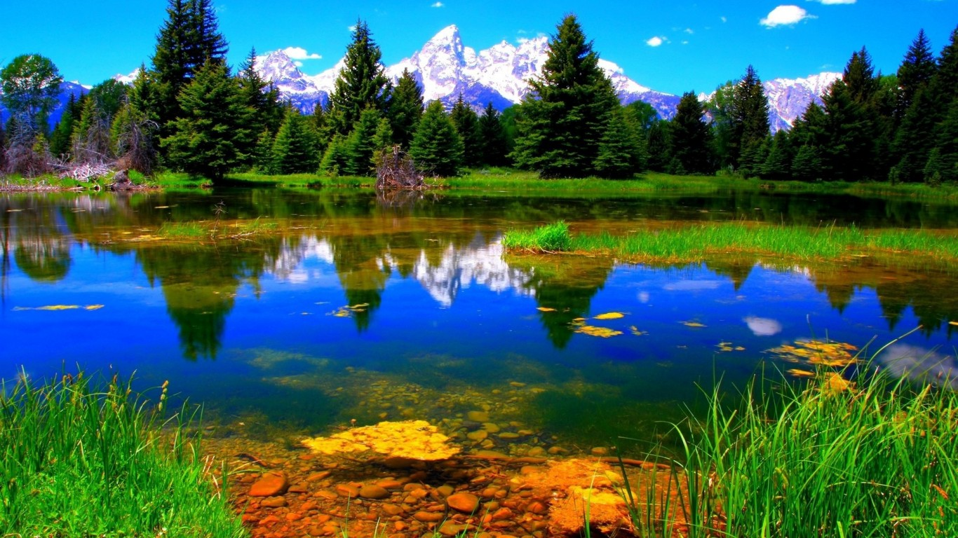

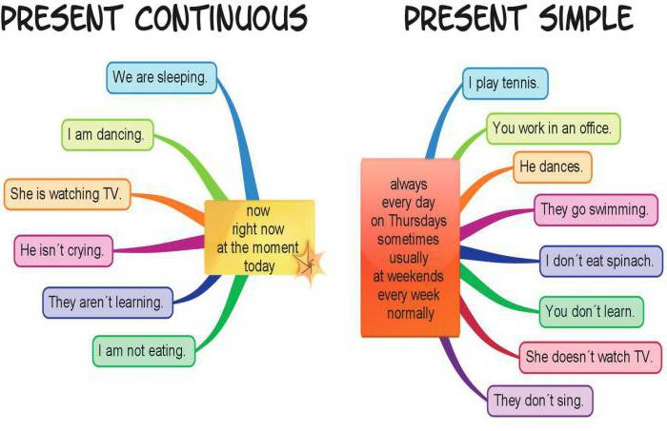

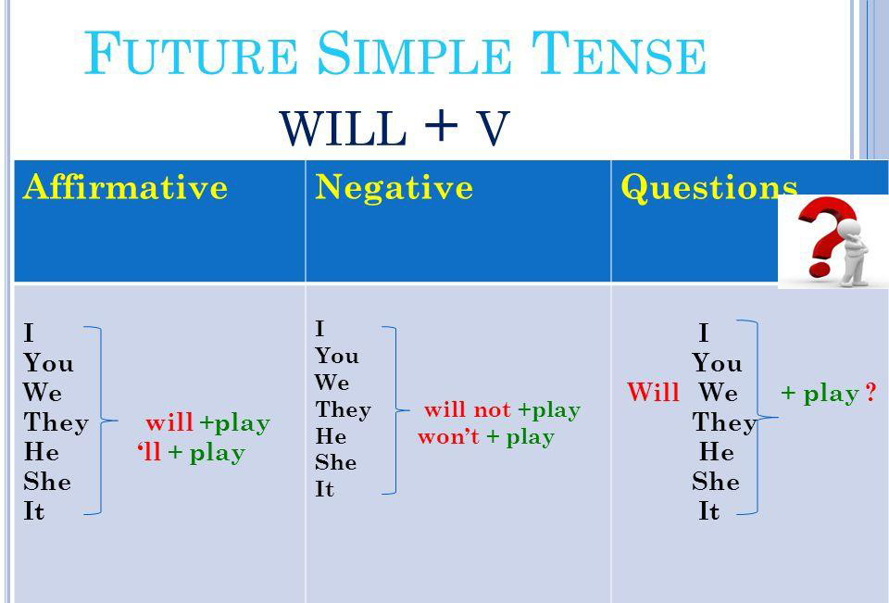

Exercise 1

Open up the brackets using Present Simple, Present Continuous or Future Simple

1. I (to play) chess tomorrow.

2. I (not to play) chess tomorrow.

3. You (to play) chess tomorrow?

4. He (to play) chess every day.

5. He (not to play) chess every day.

6. He (to play) chess every day?

7. They (to play) chess now.

8. They (not to play) chess now.

9. They (to play) chess now?

10. Nick (to go) to the park now.

11. Nick (to go) to school every day.

12. Nick (to go) to school tomorrow.

13. I (to miss) your excellent cooking!

14. You ever (to buy) presents?

15. You (to think) it (to be) easy or difficult to choose the right presents for people?

Exercise 2

are you going, will not see, is dancing, will you do, will you go, do you do, Are you reading, Will you come, Do you read, Will you read

1. You (to come) to my place next Sunday?

2. You (to read) this book next week?

3. You (to read) books every day?

4. You (to read) a book now?

5. I (not to see) him tomorrow.

6. What you (to do) tomorrow?

7. Look! Mary (to dance).

8. Where you (to go) next summer?

9. What you (to do) every morning?

10. Where you (to go) now?

Exercise 3

Choose the right answer

1. **The level, when water _____ at sea, is 212 degrees Fahrenheit.**  
   is boiling  
   boils
2. **I … tomatoes and potatoes in my garden.**  
   usually grow  
   am usually growing
3. **Do you speak English? I …. My brother teaches me.**  
   am learning  
   learn
4. **I would like to lose weight, so I … supper this week.**  
   am not eating  
   do not eat
5. **Tom is in Warsaw at the moment. He … at the Mariott Hotel.**  
   is staying  
   stays
6. **Can you see those people? I wonder what … about.**  
   do they talk  
   they are talking
7. **He is amazingly talented at languages. He … seven languages very well.**  
   speaks  
   is speaking
8. **Usually I … at 3.00, but this month I have worked until 5.00 to earn more money.**  
   finish  
   am finishing
9. **Who (answer) this question?**  
   answering  
   answers  
   will answer
10. **You don’t know the new words. What you (do)?**  
    do you do  
    will you do  
    are you doing
11. **It (not / take) you long to get to my place if you go by metro.**  
    is not take  
    does not  
    will not take
12. **I am sure they (wait) for us.**  
    will wait  
    waiting  
    waited
13. **7. He (be) fourteen next year.**  
    was  
    is  
    will be
14. **You …..u (ese Present Continuous lethe dictation tomorrow.**  
    does not write  
    will not write  
    is not writing
15. **You (remember) this rule if you learn it.**  
    will remember  
    should remember  
    remembers
16. **They (buy) a new house next year.**  
    bought  
    will buy  
    buying