|  |
| --- |
| 001_intermediate_grammar  Present Continuous, Present Simple, Future Simple |
| Keys |

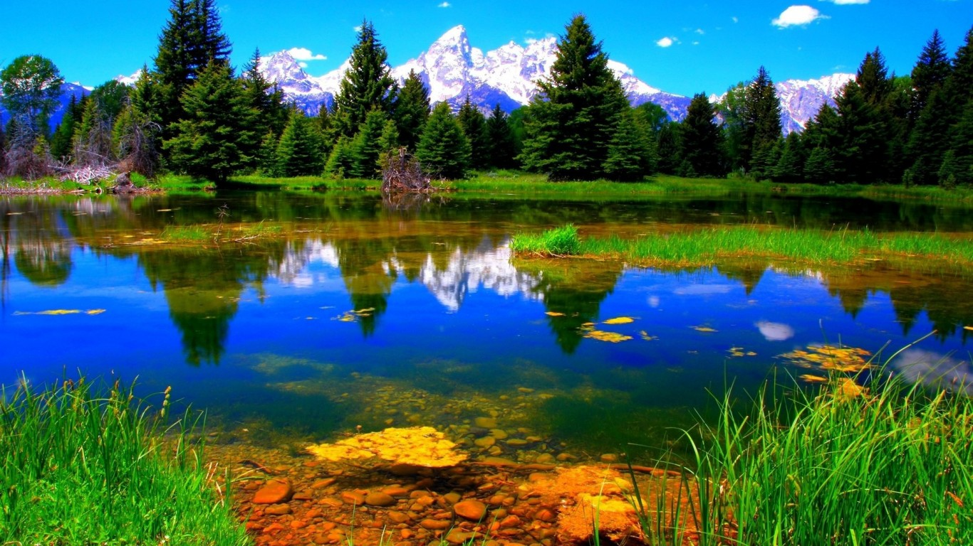

Exercise 1

Open up the brackets using Present Simple, Present Continuous or Future Simple

1. I will play chess tomorrow.

2. I will not play chess tomorrow.

3. Will you play chess tomorrow?

4. He plays chess every day.

5. He doesn’t play chess every day.

6. Does he play chess every day?

7. They are playing chess now.

8. They are not playing chess now.

9. Are they playing chess now?

10. Nick is going to the park now.

11. Nick goes to school every day.

12. Nick will go to school tomorrow.

13. I will miss your excellent cooking!

14. Do you ever buy presents?

15. Do you think it is easy or difficult to choose the right presents for people?

Exercise 2

Choose the right answer

are you going, will not see, is dancing, will you do, will you go, do you do, Are you reading, Will you come, Do you read, Will you read

1. Will you come to my place next Sunday?

2. Will you read this book next week?

3. Do you read books every day?

4. Are you reading a book now?

5. I will not see him tomorrow.

6. What will you do tomorrow?

7. Look! Mary is dancing.

8. Where you will you go next summer?

9. What do you do every morning?

10. Where you are you going now?

Exercise 3

Choose the right answer

1. **The level, when water _____ at sea, is 212 degrees Fahrenheit.**  
   is boiling  
   boils
2. **I … tomatoes and potatoes in my garden.**  
   usually grow  
   am usually growing
3. **Do you speak English? I …. My brother teaches me.**  
   am learning  
   learn
4. **I would like to lose weight, so I … supper this week.**  
   am not eating  
   do not eat
5. **Tom is in Warsaw at the moment. He … at the Mariott Hotel.**  
   is staying  
   stays
6. **Can you see those people? I wonder what … about.**  
   do they talk  
   they are talking
7. **He is amazingly talented at languages. He … seven languages very well.**  
   speaks  
   is speaking
8. **Usually I … at 3.00, but this month I have worked until 5.00 to earn more money.**  
   finish  
   am finishing
9. **Who (answer) this question?**  
   answering  
   answers  
   will answer
10. **You don’t know the new words. What you (do)?**  
    do you do  
    will you do  
    are you doing
11. **It (not / take) you long to get to my place if you go by metro.**  
    is not take  
    does not  
    will not take
12. **I am sure they (wait) for us.**  
    will wait  
    waiting  
    waited
13. **7. He (be) fourteen next year.**  
    was  
    is  
    will be
14. **You …..u (ese Present Continuous lethe dictation tomorrow.**  
    does not write  
    will not write  
    is not writing
15. **You (remember) this rule if you learn it.**  
    will remember  
    should remember  
    remembers
16. **They (buy) a new house next year.**  
    bought  
    will buy  
    buying