016_intermediate_grammar
Past Perfect, Past Perfect Continuous
Keys

Exercise 1
It was Marie’s birthday party yesterday. What had she done before the party? Look at the pictures and give the answers.
She had prepared the food.
She had put up the decorations.
She had baked a cake.
She had cleaned the house.
She had sent the invitations.
She had borrowed some CDs.
Exercise 2
Match up two parts of the sentences.
- By the time he reached the airport the plane had already taken off

- Mary was angry because her husband had forgotten about her birthday

- The bank robbers had escaped before the police arrived

- We went to the theater after we had bought the tickets

- The actress gave an interview after she had won the prize

Exercise 3
Open up the brackets using either Past Perfect or Past Perfect Continuous

Yesterday was a bad day for Andrew. He 1) hadn’t been sleeping well because there was a terrible storm in the night. 2)had had a shower, he made breakfast. After he 3) had eaten he got into his car and drove to work. He 4) had only been driving for five minutes when he remembered that he 5) had left his briefcase at home. He turned the car around and went home again. Then, he realized that he 6) had locked himself out. The keys were still inside the house! Andrew was already late for work, so he decided to leave the briefcase and go to work. When he arrived, his secretary told him that his boss 7) had been trying to call him home. Andrew went to find his boss. When he asked his boss why he 8)had called, he told him that it hadn't been necessary for him to come to work that day after all! Poor Andrew drove all the way home again.

Exercise 4
Match up the pictures with the sentences
- She was wet. She had been walking in the rain.
- They were happy. They had been playing for hours.
- He was irritated. He had been waiting for a bus for an hour.
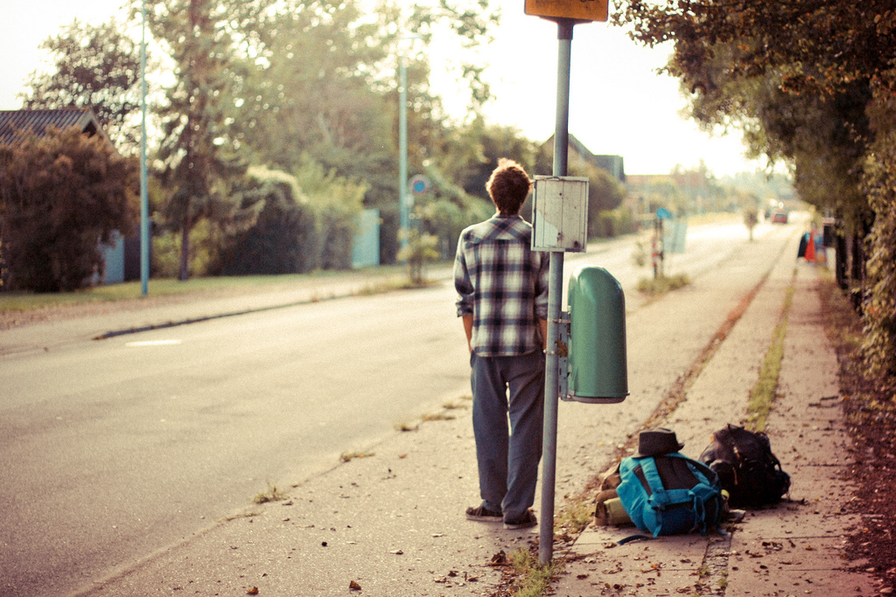
- He was tanned. He had been tanning for hours.
- They were happy. They had been talking the entire morning.

- They were tired. They had been writing the test for two hours.
- Linda was exhausted. She had been shopping the entire day.
- Pete was sweaty. He had been running for an hour.

Exercise 5
Choose the right answer

- A: Did you do anything last night?
B: I went to the gym and I had just arrived home when Michael called me. He said had been trying to call me for ten minutes before I finally answered the phone.

2. A: Did you catch any fish on your fishing trip today?
B: Yes, I had been sitting in the boat for two hours when I caught a huge fish.

3. A: Did you enjoy the open-air concert yesterday?
B: The music was good, but the weather was terrible. The concert had just started when it suddenly began to rain. The musicians had only been playing for ten minutes.
A: What a shame!

4. A: Was the house tidy when you got home?
B: Yes, the children had dusted the furniture and they had put away all of their toys.

- A: Why were you so upset this morning?
B: Well, I had been cleaning for hours when the children came in dirty shoes.

6 A: Why are you so late for work this morning?
B: I am sorry. I had been waiting for train for over an hour before it eventually arrived.

Exercise 6
Choose the right answer
- I … four cups of coffee today.
  - have drunk
  - drank
  - have drank
- At last the bus came. We … for 20 minutes.
  - had waited
  - had been waiting
  - waited
- I felt very tired when I got home, so I … straight to bed.
  - have gone
  - had gone
  - went
- Sarah went to Sue’s house, but she wasn’t there. She … .
  - went out
  - had gone out
  - has gone out
- Jim is on holiday. He … to Italy.
  - went
  - had gone
  - has gone
- We were extremely tired at the end of the journey. We … for more than 24 hour.
  - had been traveling
  - have travelled
  - travelled
- When I got home, Tom was sitting in front of the TV. He had just turned it off. He … a film.
  - had been watching
  - was watching
  - watched
- Rob … very hard this term.
  - has studied
  - is studying
  - studied
- Jim was on his hands and knees on the floor. He … for his contact lens.
  - had been looking
  - looked
  - was looking
- Linda is a teacher. She … for ten years.
  - works
  - has been working
  - is working
- My hands are very dirty. I … the car.
  - have repaired
  - was repairing
  - have been repairing
- Sarah is very tired. She … very hard recently.
  - worked
  - was working
  - has been working
- I’m Spanish. I started classes in December. I … since December.
  - learn
  - have been learning
  - am learning
- I didn’t know who she was. I … her before.
  - never saw
  - had never seen
  - have never seen
- The house was dirty. They … it for weeks.
  - have been cleaning
  - had cleaned
  - hadn’t cleaned
- Kate … home when I phoned.
  - just got
  - has just got
  - had just got
- Bill is phoning his girlfriend again. That’s the second time he … her this evening.
  - phones
  - had phoned
  - has phoned
- Joe … too much recently. He should eat less.
  - ate
  - has been eating
  - was eating
- We … for half an hour when it … to rain.
  - had been playing / started
  - played / started
  - had been playing / had started
- Susan really loves that film. She … it eight times
  - had seen
  - saw
  - has seen
HOME MORE TESTS

