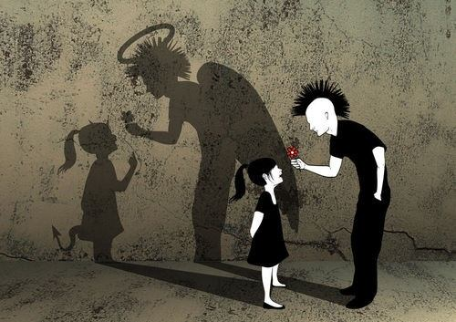
Ex.1 Fill in the gaps

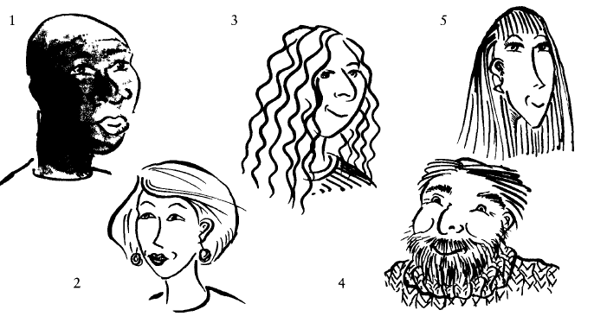
1. He's b_____, and d_____-skinned.
2 She's got b_______ hair and is f______-skinned.
3 She's got 1______, с_____ hair.
4 He's got a beard and a m______ and a slightly c________ face.
5 She's got long, s______ hair and
is t________-faced.

Ex.2 Answer the questions. You are sometimes given the first letter of the missing word.
1 What is the adjective form of the word waves when it refers to a person's hair?
2 What do we call the small, pale brown spots some people have on their skin, especially fair-skinned people? f_________
3 Give an adjective that means a person has red or reddish hair. g_________
4 What colour is auburn? Is it 'golden, reddish-brown' or is it 'very dark, almost black'?
5 If someone has a crew cut, is their hair long or short?
6 Is stout similar in meaning to (a) slim or (h) plump?
7 What is a polite word that means 'fat'. o_________
8 If someone is stocky, they are rather thin. Is this true or false?
9 If someone is anorexic, they are usually very thin indeed. Is this true or false?
10 What word means 'extremely fat'? o_________
11 If a person is scruffy, is that normally a positive or a negative thing?
12 Which is more negative, to call someone slim or skinny?
13 How do we describe someone who is losing their hair at the front of their head? We say `His/her hair is r____________
14 What does it mean to say that someone has a healthy complexion? Is it that their face and skin look healthy or that just their eyes look healthy?
15 What should you remember about the adjective handsome?

https://en.islcollective.com/video-lessons/princess-diaries-appearance

https://en.islcollective.com/video-lessons/describing-hair

Answer key

Ex.1
1 bald; dark
2 blond; fair
3 long; curly
4 moustache; chubby
5 straight; thin

Ex.2
1 wavy
2 freckles
3 ginger
4 golden, reddish-brown
5 very short
6 plump
7 overweight
8 false; they are rather solidly built
9 true
10 obese
11 negative(= untidy-looking)
12 skinny
13 His hair is receding or He has a receding hairline.
14 their face and skin look healthy
15 it is normally only used for men

