Lesson 28-Appearance-Speaking

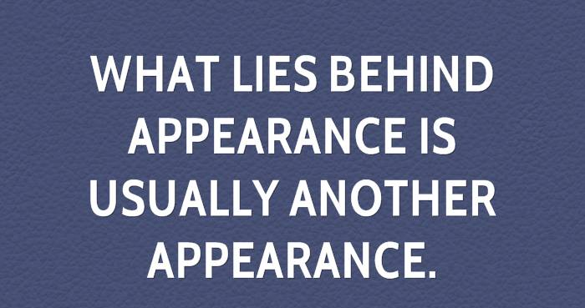
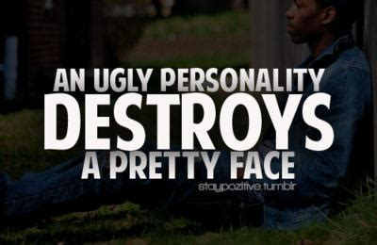

Exercise 1

Watch the presentation

Exercise2

- What is the fist thing you notice about a person?
- Can clothes defne a person?
- Is there a part of your appearance that you are proud of?
- Have you ever gone through the entire day without noticing something was wrong with your appearance? For instance, food in your teeth, missing button.
- What kinds of things do you do to maintain your appearance?
- Do you often follow trends? Which were the best/worst?\
Watch the video
https://www.youtube.com/watch?v=YJ5V_3GAucc&frags=pl%2Cwn
- What are the pros and cons of being beautiful?
- What personality trait is the most important for inner beauty
- Is beauty related to power?
- Do people spend too much time and money on beauty?
- Do you think self-esteem affects beauty and vice versa?
- Does beauty affect one's success in life?
- Is it better to be physically attractive or intelligent?
- Is it better to be physically attractive or wealthy?

Exercise 3
Play the game
https://jeopardylabs.com/play/appearance16

