Ex. 1 Match the beginnings and endings of the adjectives.
embarr--assed -yed
up--set -ointed
over- joyed -ious
conf- used -hted
delig- hted -used
disapp- ointed -assed
ner- vous -joyed
fur- ious -ied
worr- ied -vous
jeal- ous -ous
exci- ted -set
anno- yed -ted

Ex.2 Read the letters. Match the title bellow with the suitable letter.

- Test Nerves
- Does she like me?
- Love triangle
- Good marks, bad situation

1. Good marks, bad situation
Dear Marnie,
The other day, I got my exam results and I was overjoyed to find out that I passed with flying colours. But when I rang my friend to arrange a night out to celebrate, I found out that she had done really badly. She's really upset and doesn't want to go out. It's really awkward because I did so well, and I'm disappointed we can't go out and paint the town red. What should I do to make her feel better?

Karen

2. Does she like me?
Dear Marnie,
Last week, this girl invited me out to the cinema. I was really delighted because I really liked her. We went out and had a really good time. But yesterday, I saw her hanging out with her friends and I told her what a good time I'd had. She made fun of me and said she didn't know what I was talking about. I felt really embarrassed, and now I'm really confused because I don't know if she likes me or not. What should I do?

Kevin

3. Love triangle
Dear Marnie,
There's a boy at our school who my friend and I have always really liked. The problem is that last week he asked me out, and of course I said yes. I'm really excited about it, but my friend is really annoyed. I think she's jealous. Now she wants nothing to do with me any more. What can I do to convince her that she's still important to me?

Jess

4. Test Nerves
Dear Marnie,
We have to do presentations for a test next week, and I'm really worried about it. The thing is, I get really nervous when I'm talking in front of people and I know I'm going to make a real mess of it. The problem is, I'm usually a pretty good student at school, and my dad is going to be furious if I get bad marks. What should I do?
Andy

Ex. 3 Find phrases in the letters with the following meanings
to pass with flying colours
to want nothing to do with me
to hang out
to convince
to arrange a night out
to make a real mess
to make fun of

1. to do very well in a test to pass with flying colours
2. to go out to celebrate to arrange a night out
3. to talk informally to hang out
4. to laugh at me to make fun of
5. no to want to be with me to want nothing to do with me
6. to persuade to convince
7. to do it badly to make a real mess

Ex. 4 How would you feel in these situations? Use the adjectives from Ex. 1
- You go to town with odd shoes on.
- You lose your credit cards.
- A friend breaks a promise.
- You win a lot of money.
- A friend can’t come to your party.
- Your friend moves to another country.
- You don’t understand some grammar.
- You are going on holiday soon.

Ex. 5 Discuss following questions

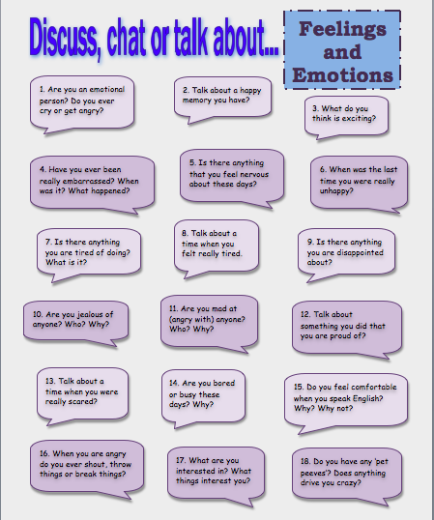

PDF

Ex. 1 Match the beginnings and endings of the adjectives.
embarr- -yed
up- -ointed
over- -ious
conf- -hted
delig- -used
disapp- -assed
ner- -joyed
fur- -ied
worr- -vous
jeal- -ous
exci- -set
anno- -ted

Ex.2 Read the letters. Match the title bellow with the suitable letter.

- Test Nerves
- Does she like me?
- Love triangle
- Good marks, bad situation

1.
Dear Marnie,
The other day, I got my exam results and I was overjoyed to find out that I passed with flying colours. But when I rang my friend to arrange a night out to celebrate, I found out that she had done really badly. She's really upset and doesn't want to go out. It's really awkward because I did so well, and I'm disappointed we can't go out and paint the town red. What should I do to make her feel better?

Karen

2.
Dear Marnie,
Last week, this girl invited me out to the cinema. I was really delighted because I really liked her. We went out and had a really good time. But yesterday, I saw her hanging out with her friends and I told her what a good time I'd had. She made fun of me and said she didn't know what I was talking about. I felt really embarrassed, and now I'm really confused because I don't know if she likes me or not. What should I do?

Kevin

3.
Dear Marnie,
There's a boy at our school who my friend and I have always really liked. The problem is that last week he asked me out, and of course I said yes. I'm really excited about it, but my friend is really annoyed. I think she's jealous. Now she wants nothing to do with me any more. What can I do to convince her that she's still important to me?

Jess

4.
Dear Marnie,
We have to do presentations for a test next week, and I'm really worried about it. The thing is, I get really nervous when I'm talking in front of people and I know I'm going to make a real mess of it. The problem is, I'm usually a pretty good student at school, and my dad is going to be furious if I get bad marks. What should I do?
Andy

Ex. 3 Find phrases in the letters with the following meanings
to pass with flying colours
to want nothing to do with
to hang out
to convince
to arrange a night out
to make a real mess
to make fun of

1. to do very well in a test
2. to go out to celebrate
3. to talk informally
4. to laugh at me
5. not to want to be with me
6. to persuade
7. to do it badly

Ex. 4 How would you feel in these situations? Use the adjectives from Ex. 1
- You go to town with odd shoes on.
- You lose your credit cards.
- A friend breaks a promise.
- You win a lot of money.
- A friend can’t come to your party.
- Your friend moves to another country.
- You don’t understand some grammar.
- You are going on holiday soon.

Ex. 5 Discuss following questions

