Lesson 34 – Grammar - Indirect Speech
Read and remember
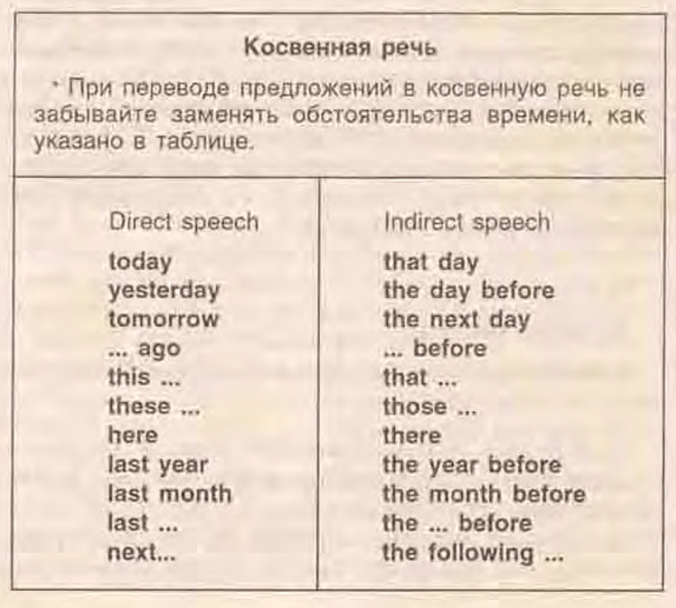
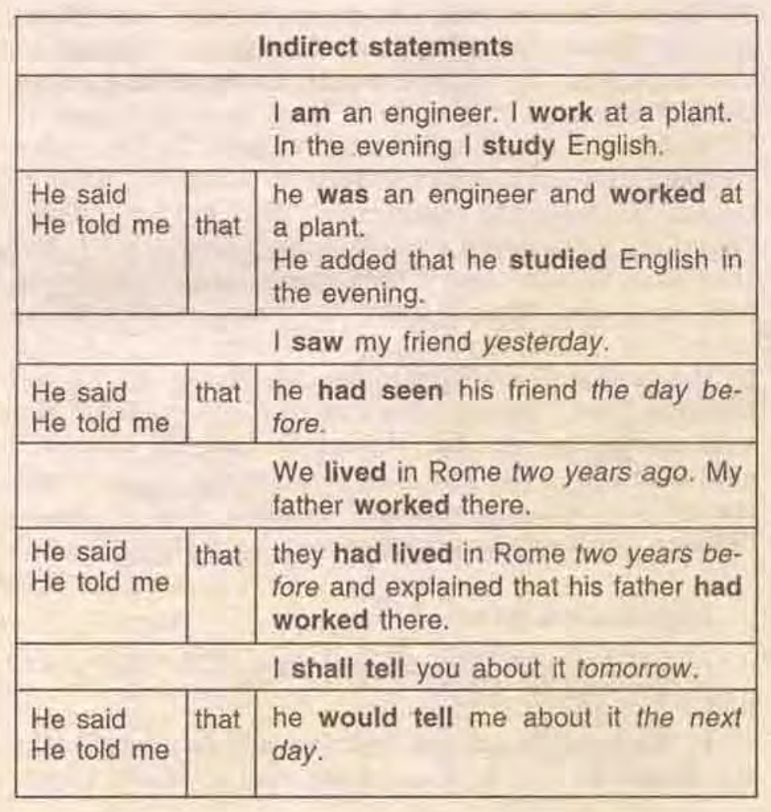
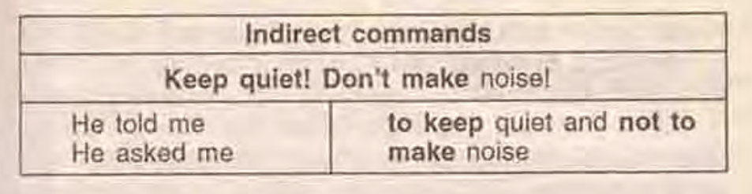

Exercise 1
Turn imperative sentences into Indirect Speech.
- Andrew: "Clean the blue bike!"
- Jessica: "Write a text message!"
- Nelly: "Help Peter's sister!"
- Fred: "Wash your hands!"
- Anna: "Open the window!"
- Tom: "Come at 8!"
- Teacher: "Do your homework!"
- Doris: "Dance with me!"
- Sabine: "Meet Sandy at the station!"
- Victoria: "Check your e-mails!"

Exercise 2
Turn the following statements into Indirect Speech.

- “Му son is a student” , said Henry.
2. “She is working at the library” , said her mother.
3. My friend said to me:” I have not seen you for ages!”
4. “ I shall solve the clues tomorrow,” said All.
5. He said: “ There is nobody here to stop them” .
6. The soldier said: “ We will find a place to lie up. I am
afraid they will kill us”.
7. My friend said to me: “We have been waiting for you
for ten minutes”.
8. Jane said: “I am all right. Nothing worries me”.
9. “I am busy now. I am doing my lessons”, said Tom.
10. “She is not here. She has just left the office”, the secretary said to us.
11. He said to me: “This man is the doctor for the hospital”.
12. “There is no one by that name here”, they answered.
13. “I am ill. I have a high temperature” , he said to us.
14. “We have tried to telephone to Odessa for him”, they said.
15. “I don’t think I will have done this work by the evening”, she said.

Exercise 3
Choose the correct answer to complete the sentence.
- I told him__do it.
  - ? to not
  - ? to don`t
  - ? not to
  - ? don`t
- He asked us__show our passports.
  - ? if
  - ? to
  - ? for
- She asked us if we__finished the work on Monday.
  - ? have
  - ? had
  - ? Either could be used here.
- She asked us__on time.
  - ? to be
  - ? for being
- She asked if she__leave early.
  - ? can
  - ? could
- They asked me__going to the party.
  - ? that
  - ? I was
  - ? if I was
- He told me__my father.
  - ? phone
  - ? to phone
- She said that no one__to the meeting last week.
  - ? has come
  - ? had come
- She told me__she wasn`t going to come.
  - ? that
  - ? ---
  - ? Either could be used here.
- He asked me what I__if I failed to get the job.
  - ? would do
  - ? would have done
- He told me he__be here by three o`clock at the latest and it`s half past already.
  - ? will
  - ? would
  - ? Either could be used here.
- She promised she__do it by the end of the week and then let me down.
  - ? will
  - ? would
  - ? Either could be used here.
- She said it__raining when she got here.
  - ? already started
  - ? had already started
  - ? Either could be used here.
- She explained how__do it.
  - ? to
  - ? I should
  - ? Either could be used here.
- He said he__her before.
  - ? didn`t see
  - ? hadn`t seen
  - ? Either could be used here.

Exercise 4
Turn the following statements into Indirect Speech.
- “We are going to have dinner” , my mother said to me.
2. “She has made great progress in her English” , her teacher said.
3. “I will be glad to help you, don’t mind” , Joe said to Polly.
4. “We are playing a boring game” , his children said.
5. Robert said: “Nobody has mentioned about it” .
6. “I can’t stay here” , he said.
7. “As soon as you see him, give him my telephone number” , Henry said to me.
8. “I’ll just step out the door for a minute” , Julia said.
9. “Be a good boy and be careful” , his father said.
10. “If I go back my parents will not let me go out” , the boy
said to his friends.
- Tom said, “This meal is delicious.”
- “I’ve written you a letter,” she said to her friend.
- Jill said, “I’ll go to the bank tomorrow.”
- She said to him, “I can do it myself”

Exercise 5
Translate the following sentences from Russian into English.
- Мама попросила меня купить хлеб.
2. Мой брат сказал мне помыть машину.
3. Она попросила свою дочку не шуметь.
4. Родители сказали ему не выходить из дома.
5. Сестра попросила меня помочь ей.
6. Милиционер приказал им остановиться.
7. Они попросили ее не рассказывать правду об этом случае.
8. Я сказал своему другу прийти в семь вечера.
9. Учитель попросил ученика подойти к доске.
10. Она попросила не звонить ей.
11. Почтальон сказал: «Я доставлю это письмо завтра».
12. Она спросила: «Тебе здесь комфортно?»
13. «Я не приму его извинения», — сказала она.
14. Он сказал: «Я никогда не был в Южной Корее».
15. Я сказал ей: «Дай мне, пожалуйста, эту книгу».
16. «Я читаю книгу», – пояснил он.
- «Я всегда пью кофе», – сказала она
- Он сказал: «Мы окончили свою работу к пяти часам».
- Джон сказал: «Я хочу получить новую работу».
- Он говорит: "Мне нравится мой новый мотоцикл."
- «Суп слишком горячий!», закричал малыш Джейк.

Keys:
Exercise 1:
- Andrew told me to clean the blue bike.
- Jessica told me to write a text message.
- Nelly told me to help Peter's sister.
- Fred told me to wash my hands.
- Anna told me to open the window.
- Tom told me to come at 8.
- The teacher told me to do my homework.
- Doris told me to dance with her.
- Sabine told me to meet Sandy at the station.
- Victoria told me to check my e-mails.
Exercise 2:
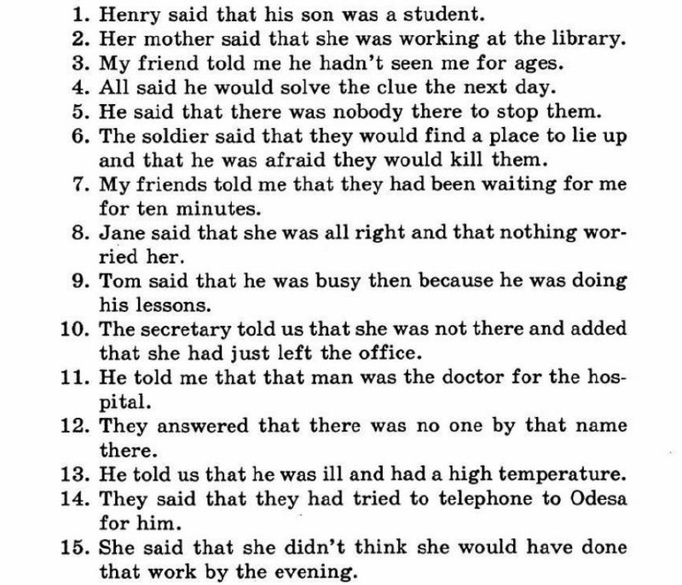
Exercise 3:
1.C 2.B 3.B 4.A 5.B 6.C 7.B 8.B 9.C 10.A 11.B 12.B 13.B 14.C 15.B

