intermediate_lesson_36_promotion_and_success_speaking_part_3

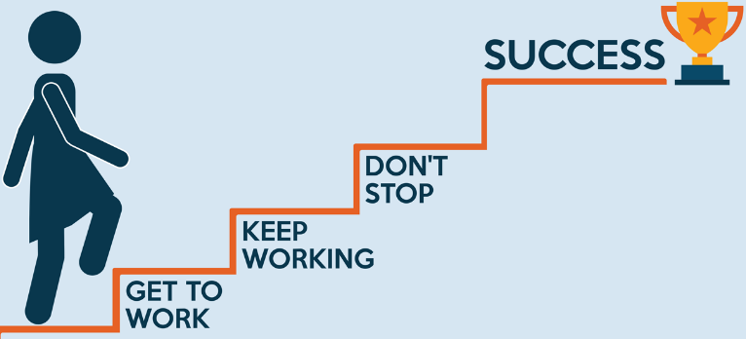

Discuss the following pictures.

Exercise 1
Watch the video and answer the questions
Video 1
https://www.youtube.com/watch?v=ulShj4keKNw

- What comes to mind when you hear the word ‘success’?
- Do you think people focus too much on appearing to be successful?
- Why is money the most common way of judging success?

Video 2
https://www.youtube.com/watch?v=cX7Ey6tQ3tU
- Is your idea of success the same as your parents’ idea of success?
- What are your success habits?
- What is your formula or recipe for success?

Exercise 2
Discuss the following quotes

Exercise 3
Discuss the following questions
- What is your dream job?
- Are there any jobs you would refuse to do?
- Can money buy happiness?
- Will you ever become a millionaire by working?
- Is raising a family hard work?
- Is housework really work?

Exercise 4
Quizlet
https://quizlet.com/332881763/video-36-interm-success-flash-cards/?new
Watch the video
http://thinkonline.smarttutor.com/from-failure-to-success-inspirational-video-for-kids/

Find the synonyms for the words:
refuse – advantage - drop out of – shortage - defeat
- to be dismissed
- lack
- turn down
- to lose
- virtue

Answers
Exercise 4
Quizlet
https://quizlet.com/332881763/video-36-interm-success-flash-cards/?new
Watch the video
http://thinkonline.smarttutor.com/from-failure-to-success-inspirational-video-for-kids/

Find the synonyms for the words:
- to be dismissed - drop out of
- lack - shortage
- turn down - refuse
- to lose - defeat
- virtue - advantage

