Lesson 37-Vocabulary-Thanskgiving
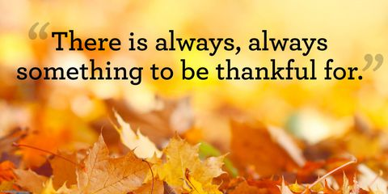
Exercise 1

Watch the video and answer the questions below
https://www.youtube.com/watch?v=QJY6L52RhUs

What do you think this holiday about?
What do you know about Thanskgiving day?
Have you ever celebrated this holiday?

Exercise 2

Watch the video
https://www.youtube.com/watch?v=uG4XyNqUQxg&t=80s&frags=pl%2Cwn

Exercise 3
Read the text below

Exercise
Answer the questions
- The Pilgrims and Wampanoag celebrated their Thanksgiving
A in Texac
B after the harvest
C in the spring
D on December 25th
- Which of the following is not fowl?
A deer
B turkey
C geese
D ducks
- Which of the following was on the menu at the first Thanksgiving?
A vegetables
B cornmeal
C fruit
D all of these
- How many people attended the Thanksgiving celebration in 1621?
A forty
B ninety
C one hundred ten
D one hundred forty
- What is venison?
A geese
B deer meat
C ducks
D turkey
- Why was the Thanskgiving celebration in 1621 held outside?
A The weather was nice
B The buildings were too small
C They liked outside
D none of these
- Which of the following is not true ?
A Many Pilgrims died during the harsh winter
B The Wampanoag taught the Pilgrims to grow crops
C Seventeen women attended the first Thanksgiving
D The Pilgrims were thankful for their harvest
- Why was the Thanksgiving celebration held in 1621?
A to give thanks for their many blessings
B because everybody was hungry
C to have a cooking contest
D so the Pilgrims could invite their friends to their new homes
- Why did so many Pilgrims die during their first year in America?
A illness
B they were killed
C lack of shelter
D both A and C
- When do we celebrate Thanskgiving in the United States?
A second Tuesday in August
B first Monday in April
C third Wednesday in March
D fourth Thursday in Nov

Exercise ( вот такой кроссворд нужно сделать)

Across
- people who have migrated to a different land from where they were born
5. reddish growth that covers the throat and neck of a turkey
6. Thanksgiving time of year
7. fills up the bird and then fills up the people
10. main course at Thanksgiving supper

Down
- another word for family members
- another name for corn
- a celebration including large quantities of food
8. people we visit on Thanksgiving
9.yummy sauce to pour over turkey

