Exercise 1. Complete the sentences.

Exercise 2. Fill in the missing words.

Exercise 3. Read the text and answer the questions afterwards.

Exercise 4. Read the text and do the tasks.
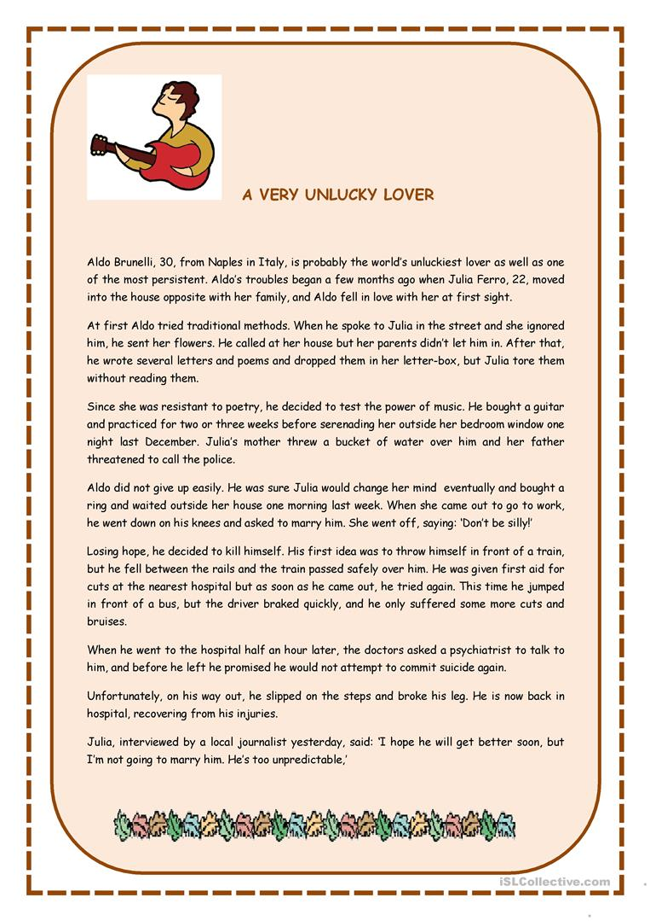

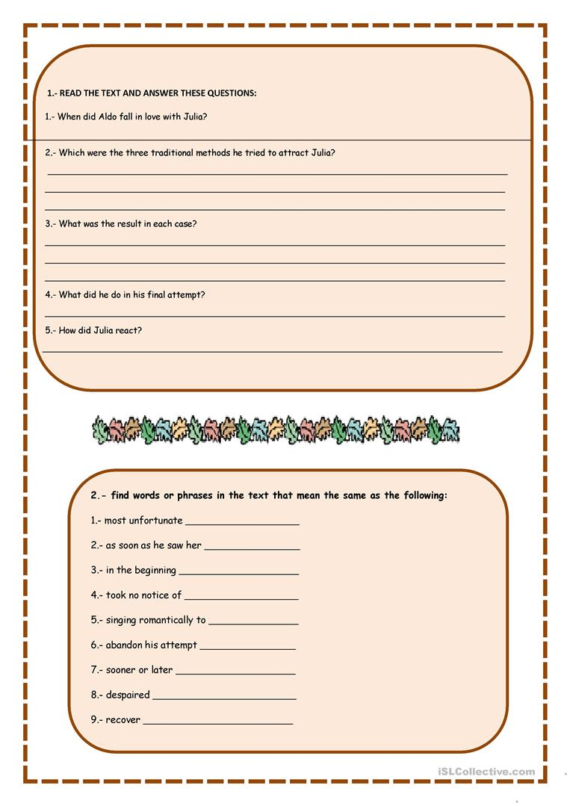

Exercise 5. Fill in the gaps.
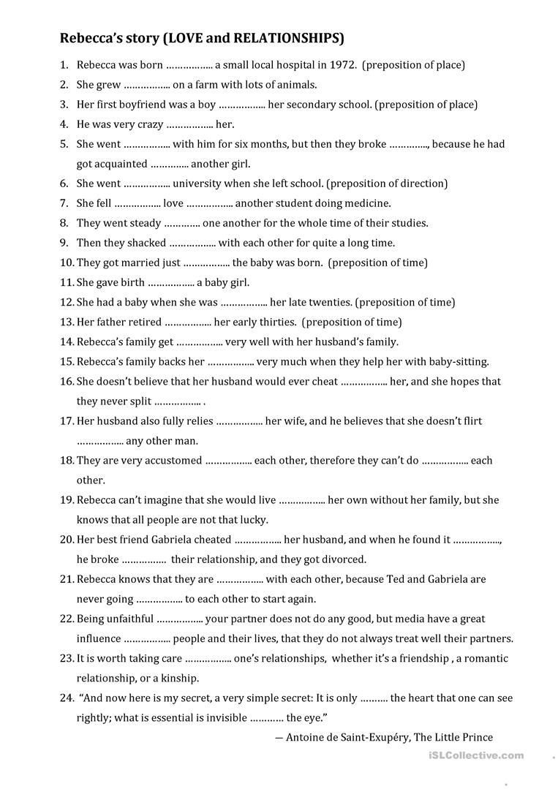

Answers:
Exercise 4. Read the text and do the tasks.
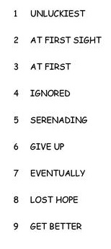
Exercise 5. Fill in the gaps.
