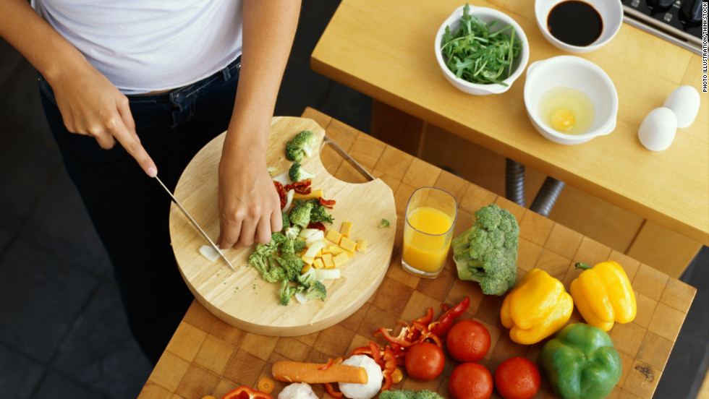
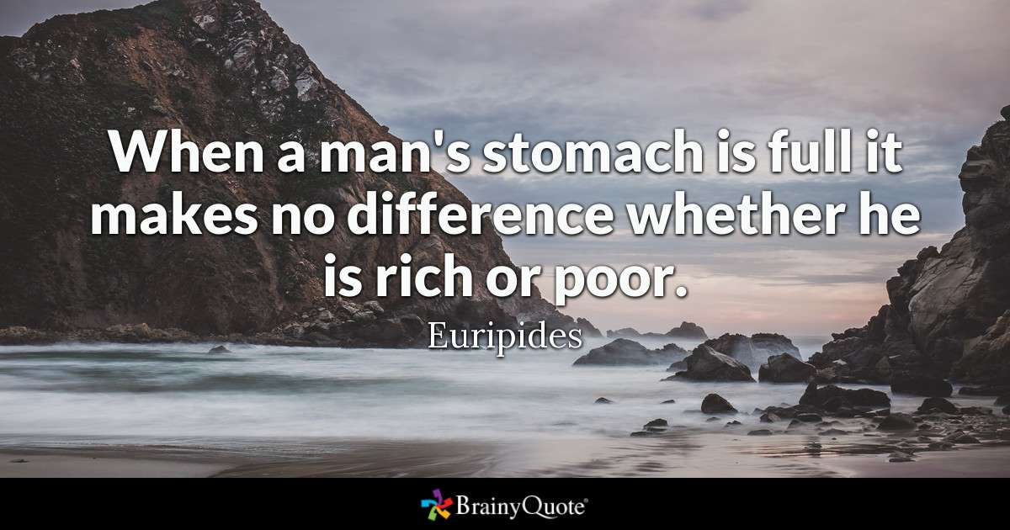
Exercise 1. Answer the questions.
1. What kind of food do you like?
2. What kind of food don’t you like?
3. Do you like fast food?
4. Is eating mostly routine or pleasure for you?
5. What time do you usually have dinner?
6. Do you usually eat at the same time on weekdays and at weekends?
7. Have your tastes changed since your childhood?
8. How often do you eat out?
9. What’s your favorite restaurant?
10. Do you ever get takeaway food?
11. When you eat out, do you prefer something new or what you know?
12. What’s the most unusual dish you've ever tried?

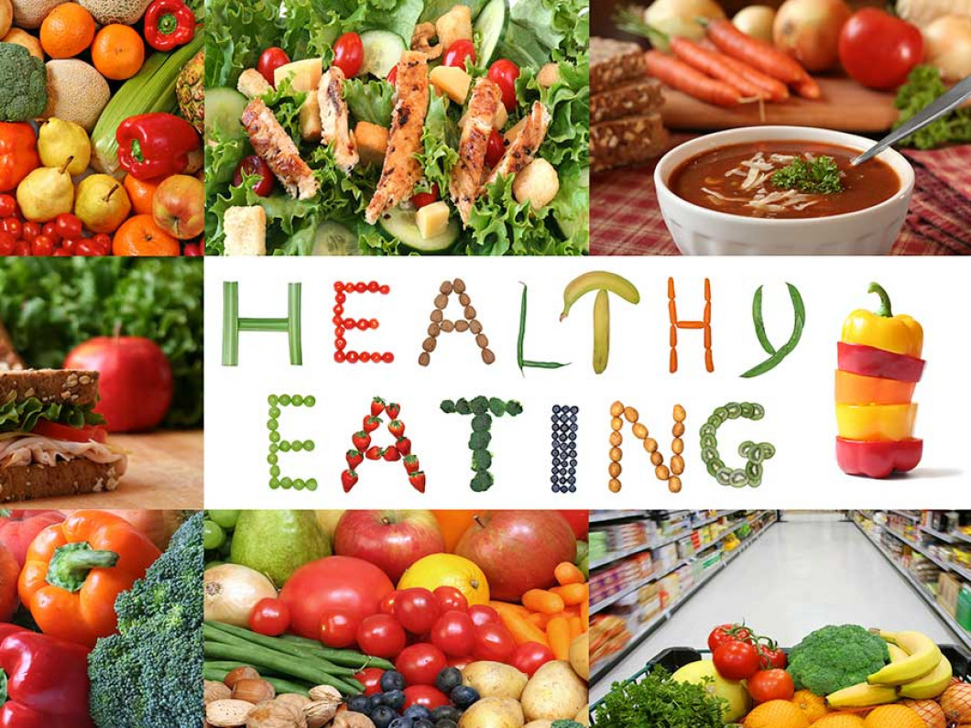
13. Do you have a healthy diet?
14. Do you care where the food you eat comes from?
15. Do you avoid any food or drinks for health reasons?
16. What do you think about vegetarians?
17. How has food changed over the recent years?

Exercise 2.
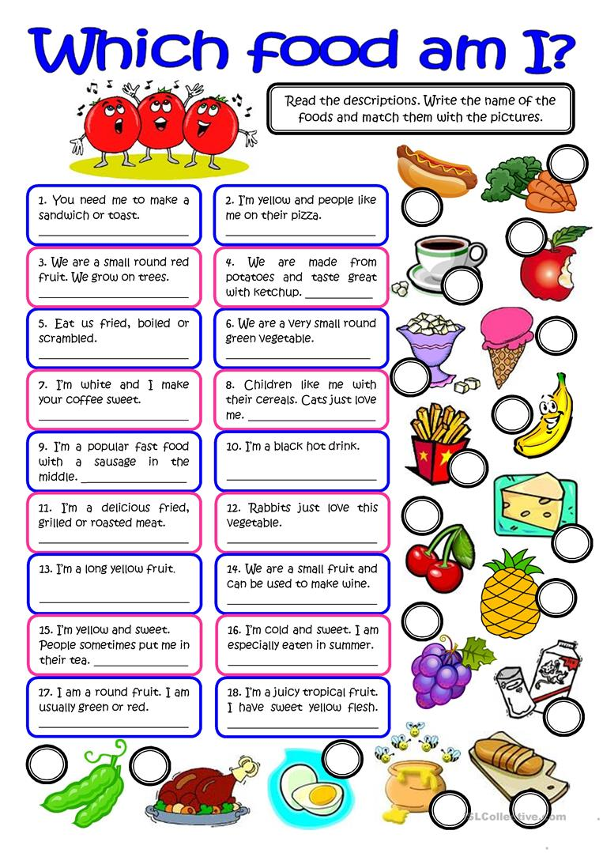

Exercise 3. Match and collocate the phrases with the appropriate verbs of food and cooking.
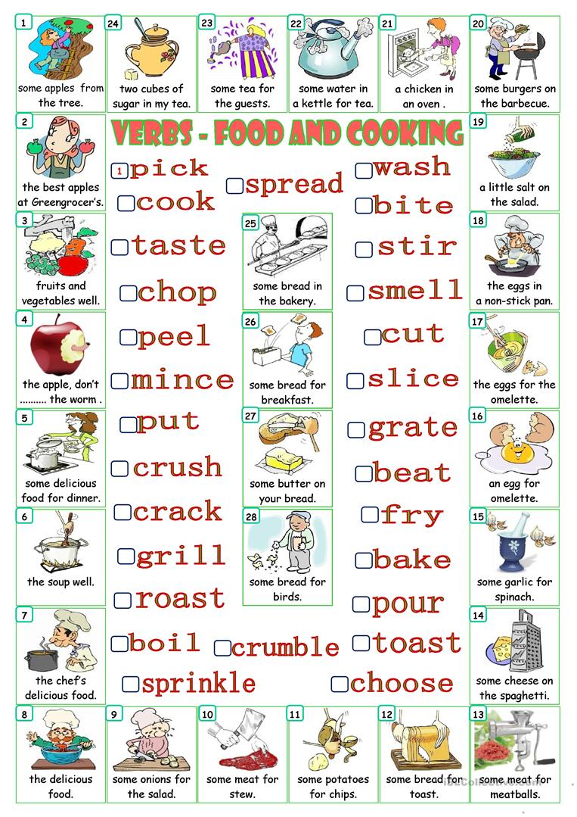
Exercise4.
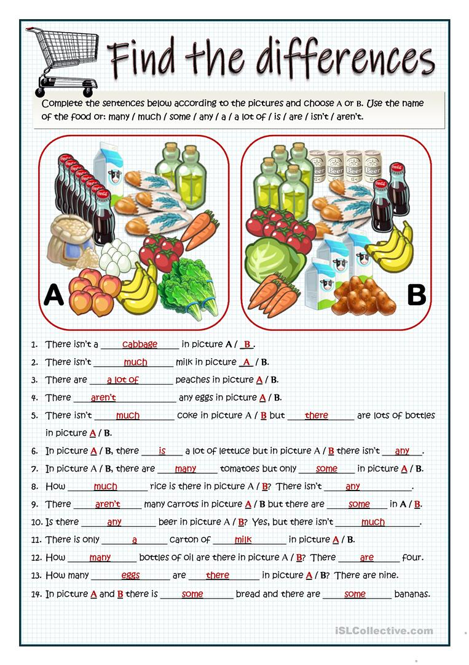

Answers:
Exercise 2.
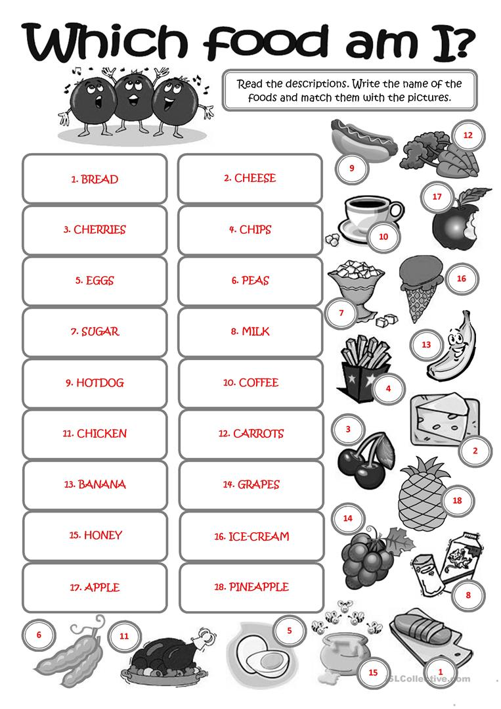
Exercise 3.
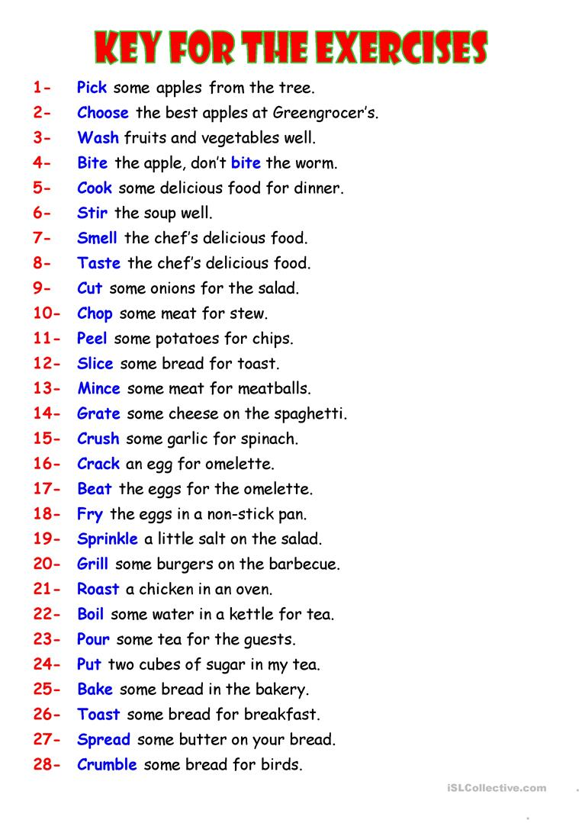

Exercise 4.

