Lesson 9, Listening, PI
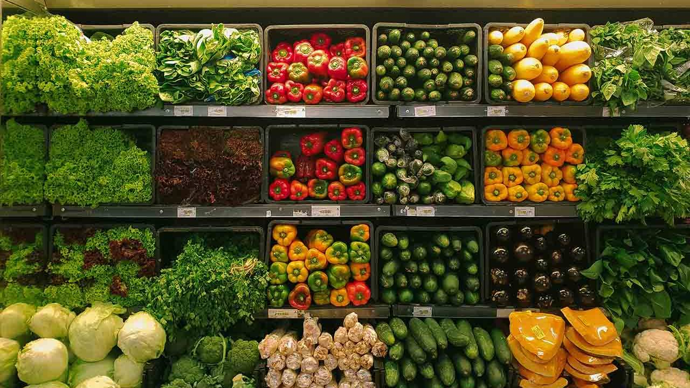

Exercise 1
Look at the words and translate them.
https://quizlet.com/490552115/lesson-9-listening-pi-flash-cards/?new

Exercise 2
Now listen to the recording and define whether statements are true or false.
https://www.youtube.com/watch?v=3CWAuOFW1Qg

1) There are fridges and freezers filled with food in the grocery store.-
2) You can find sauces and soups in the bakery.-
3) You can find sweets in the dairy section.-
4) Ham and baloney are examples of cold cuts.-
5) In the bakery department you can buy biscuits and bagels.-
6) There is also a canned goods section in the grocery store.-
7) The meat department also has cheese and butter.-
8) There are also cold cuts in the meat department.-
9) The butcher works in the bakery department.-
10) Clerks in the produce department spray water on the fruit and vegetables to keep them clean.-
11) Grocery store does not have a section for personal hygiene.-
12) In the section for pets you can buy toys for cats and dogs.-

Exercise 3
Listen to the conversation and choose the correct variant.
https://www.esl-lab.com/easy/restaurant-order/

1) How many cheeseburgers does the man order?

a. 18

b. 48

c. 80

2) The man is ordering food for a ___________ team.

a. basketball

b. tennis

c. soccer

3) The man asks for _______ orders of fries.

a. 60

b. 50

c. 40

4) He also orders 40 ___________ shakes.

a. strawberry

b. vanilla

c. chocolate

5) The total comes to _____.

a. $219.13

b. $290.13

c. $290.30

Exercise 4
Listen to the conversation and choose the correct variant.
https://www.esl-lab.com/easy/snack-time/

1) What time of day does this conversation take place?
a. in the morning
b. in the evening
c. in the afternoon

2) The man doesn't give his son something to eat because ____.

a. there isn`t any food
b. the boy just ate
c. they are going to eat soon

3) The boy wants ______ for a snack.

a. candy

b. donuts

c. potato chips

4) The father offers his son a ________ sandwich.

a. vegetable

b. fish

c. ham

5) The boy is going to _______ while they father prepares some food.
a. watch TV
b. play with toys
c. look at books

Keys:
Exercise 2
1.True 2.False 3.False 4.True 5.True 6.True 7.False 8.True 9.False 10.False 11.False 12.True

Exercise 3
1.c 2.c 3.a 4.c 5.b

Exercise 4
1.c 2.c 3.a 4.a 5.b

