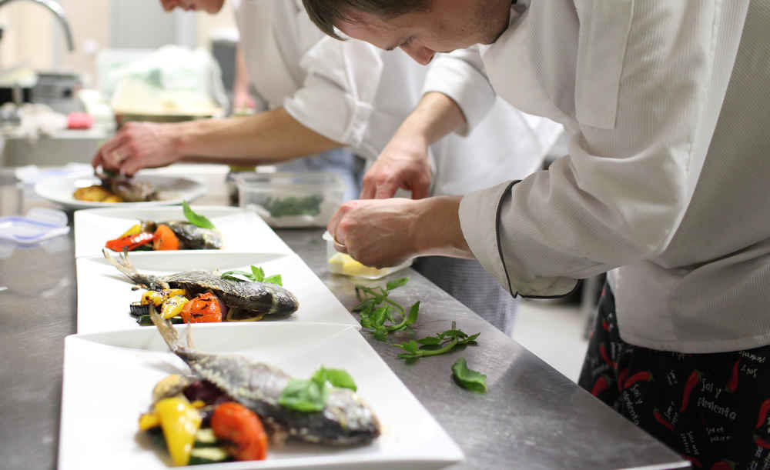

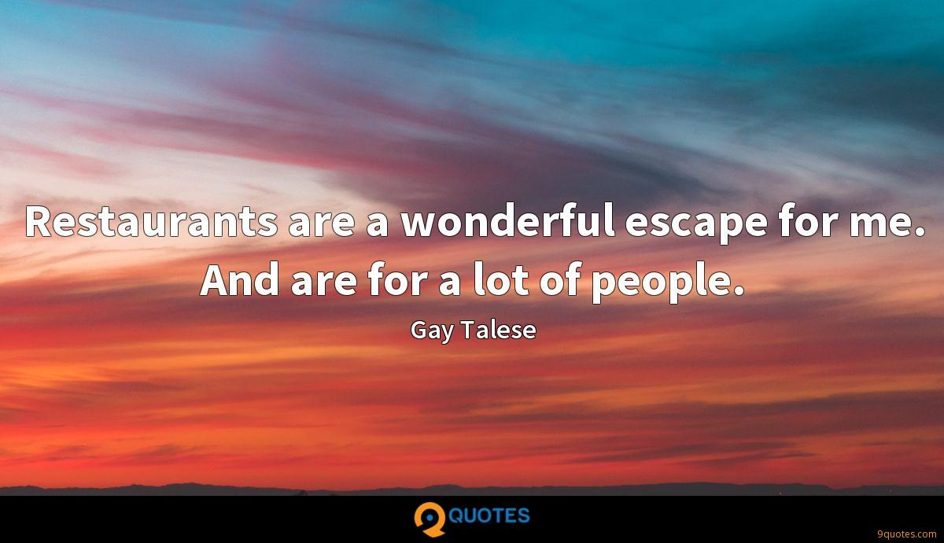

Exercise 1. Look at the picture and answer the questions.
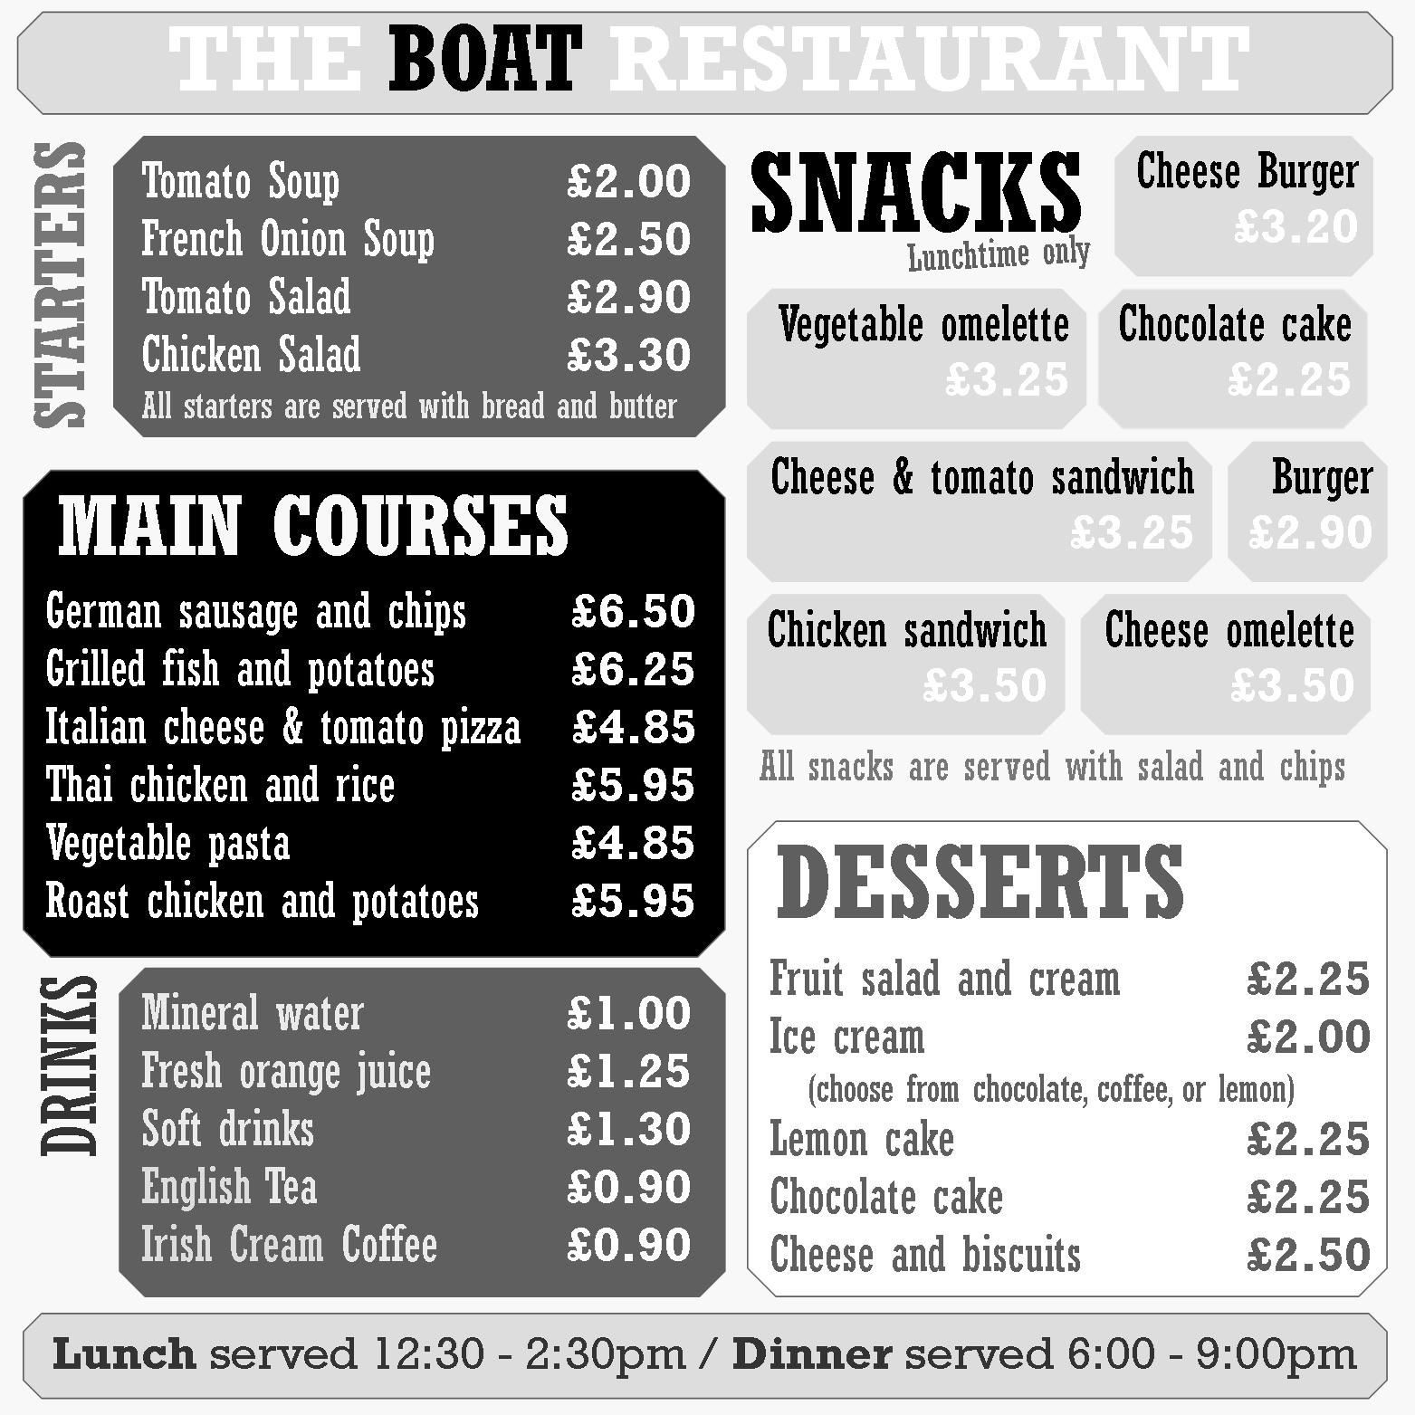
1. What would you order from this menu?
2. What wouldn’t you like to order from this menu?
3. Does the design of the menu affect your ordering behaviors?
4. Have you ever asked for something not listed on the menu?
5. What would you like to add to the menu?

Exercise 2. Watch the video and answer the questions.
https://www.youtube.com/watch?v=bgfdqVmVjfk

1. How often do you eat out?
2. Where do you usually go?
3. Who do you usually go with when you eat out?
4. How often do you eat at McDonalds?
5. Did you enjoy eating out in other countries you have visited?
6. Which country had the best food?
7. Do you know anyone who has owned a restaurant?
8. What advantages and disadvantages of having a restaurant?
9. Have you ever worked in a restaurant?
10. Do you usually leave a tip at a restaurant? How much?
11. What's the worst experience you ever had at a restaurant?
12. Do you like to try new restaurants, or do you prefer to go to those you have already been to? Why?
13. Do you care what a restaurant looks like, or is the food the only thing you care about?
14. Do you worry about calories and fat content when you eat out?
15. Have you ever ordered food from a restaurant?

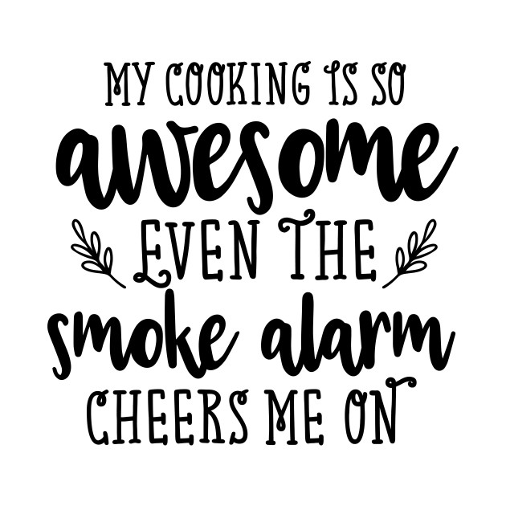
Exercise 3. Answer the questions.
1. Are you a good cook?
2. Who taught you to cook?
3. How often do you cook?
4. What are some things that you can cook?
5. What dish or food are you best at cooking?
6. What is the hardest thing to cook?
7. Do you think you can cook better than your mother?
8. Who is a better cook, your mother or your grandmother?
9. When you were a child did you help your parents to prepare a meal? What did you do?
10. Are cooking shows popular in our country? Do you usually watch them?

