Lesson 13, Listening, PI (Home-Types of Buildings)
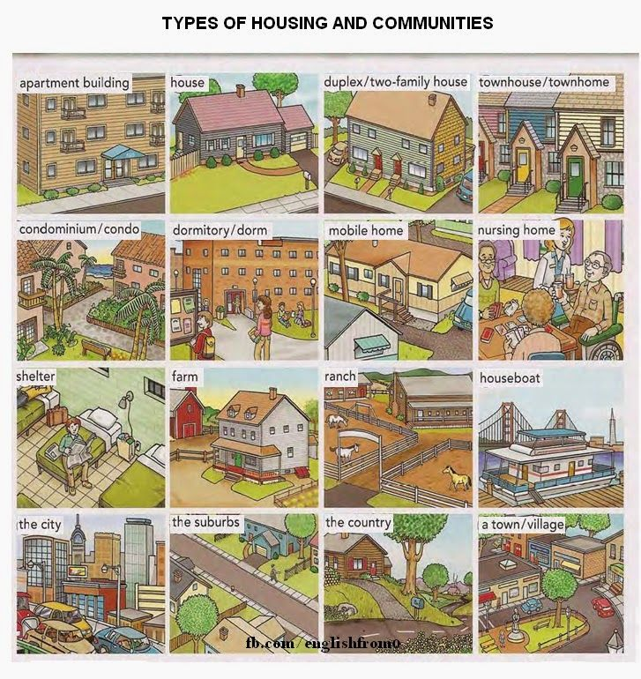

Exercise 1
Choose the best definition to each type of a house

1) A small house, especially in the country is a…
a. cottage
b. mansion
c. palace

2) A building divided into flats sharing the same front door is a/an…
a. thatched cottage
b. block of flats
c. igloo

3) One of a row of houses is a…
a. semi-detached house
b. detached house
c. terraced house

4) A house that stands on its own is a…
a. detached house
b. terraced house
c. bungalow

5) A house joined together with another one by a common wall is a…
a. detached house
b. semi-detached house
c. cottage

6) A large splendid house is a…
a. palace
b. terraced house
c. bungalow

Exercise 2
Listen to the conversation between Lisa and her friend Tom about her family´s new flat. In what places has the family put the following items?

Exercise 3

Robert is going to a conference next month. He phones different places to find accommodation. Listen to the recording and choose the best answer.

https://www.examenglish.com/A2/A2_listening_accommodation.htm

Exercise 4

Listen to the recording and then fill the gaps.
https://listenaminute.com/h/houses.html
are built in are unique at houses when at the way eco-friendly how they copy on the inside special designs still see much that save energy

All houses . Even if they look the same from the outside, they are very different . I think houses are very interesting. I like looking they are built and the style they . In London there are many houses that are hundreds of years old. These are beautiful. You can of the original wood and stone structure. Modern houses are also interesting. It’s funny many of the features of older houses. I love looking I travel. Every country has its own , from Japan to Arabia to Greece. Nowadays people are building houses. They want houses and help protect the planet.

Exercise 5
Look at the picture and describe the houses. Use the key words listed below.
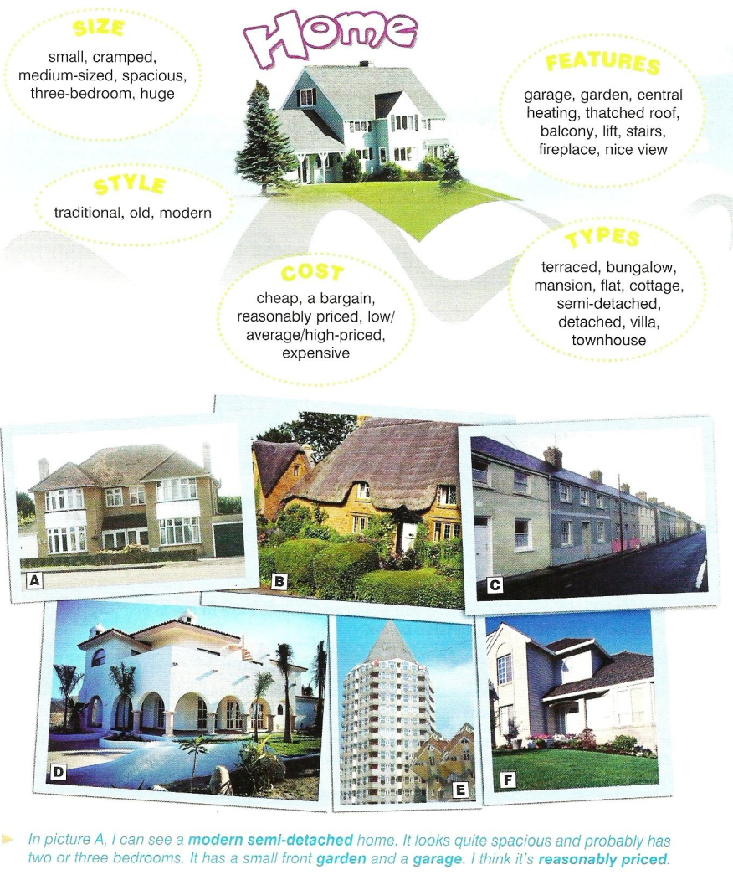

Keys:
Exercise 1
1 – a 2 – b 3 – c 4 – a 5 – b 6 – a
Exercise 2
Exercise 3
1 – b 2 – c 3 – b 4 – a 5 – a 6 – b 7 – b 8 – a 9 – c 10 – c

Exercise 4
All houses are unique. Even if they look the same from the outside, they are very different on the inside. I think houses are very interesting. I like looking at the way they are built and the style they are built in. In London there are many houses that are hundreds of years old. These are beautiful. You can still see much of the original wood and stone structure. Modern houses are also interesting. It’s funny how they copy many of the features of older houses. I love looking at houses when I travel. Every country has its own special designs, from Japan to Arabia to Greece. Nowadays people are building eco-friendly houses. They want houses that save energy and help protect the planet.

