Lesson 16, Speaking, PI
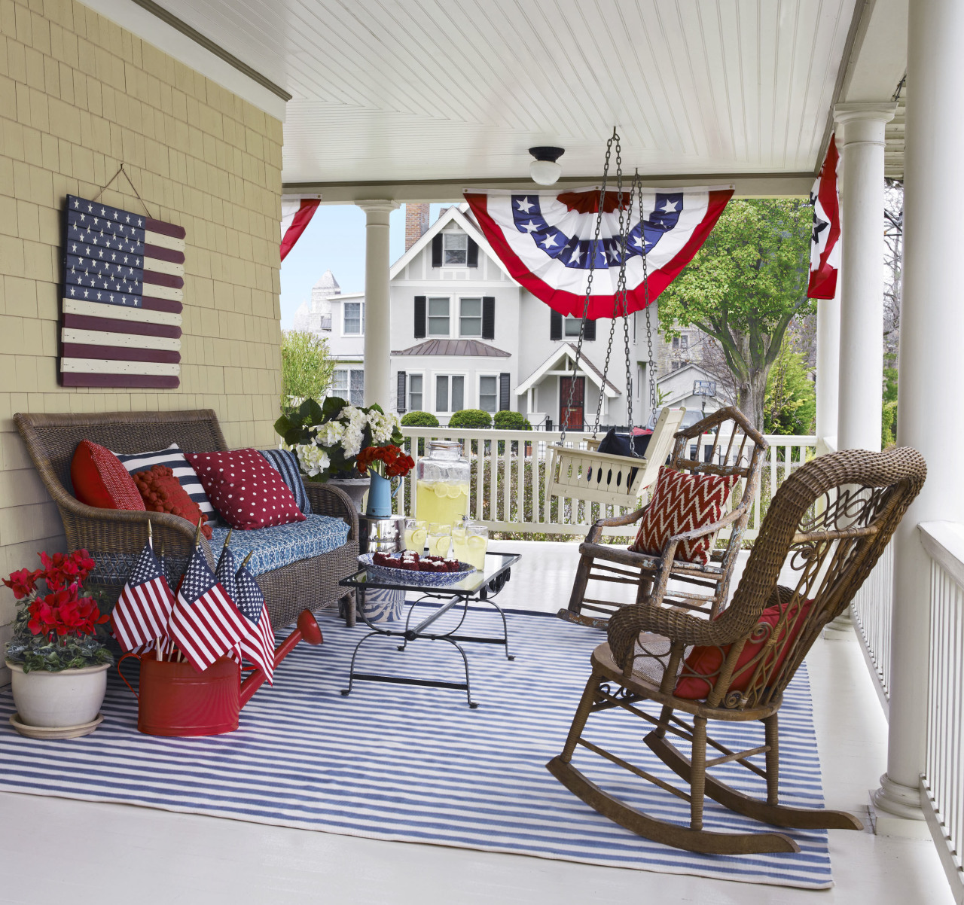
Exercise 1
Look at the words and translate them.
https://quizlet.com/490292290/speaking-lesson-16-pre-intermediate-flash-cards/?new
Exercise 2
Look at the picture and name the types of the houses

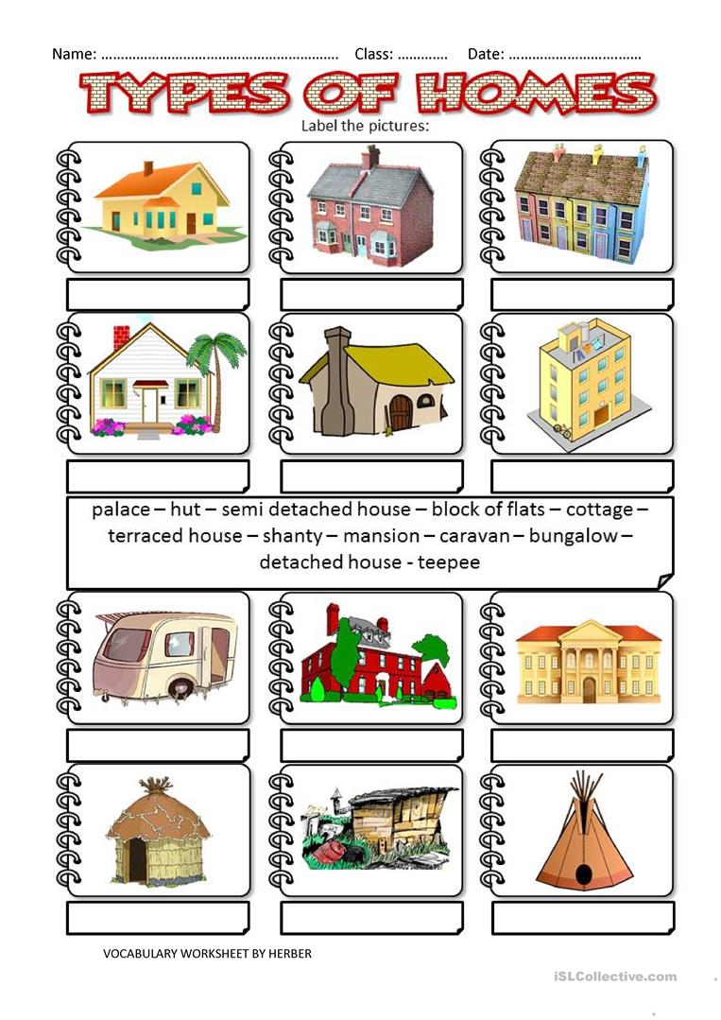

Exercise 3
Discuss the following questions
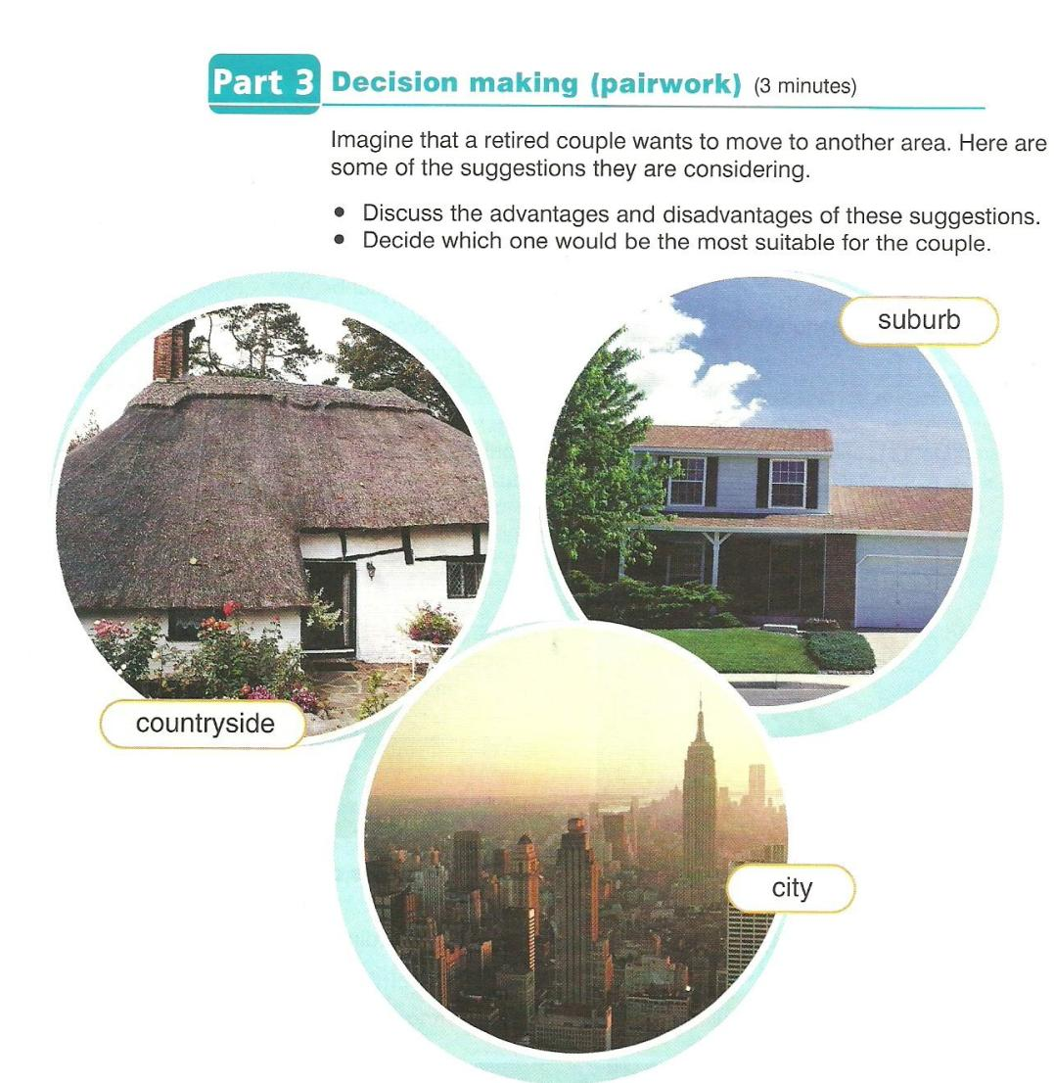
Exercise 4
Look at the pictures and answer the following questions
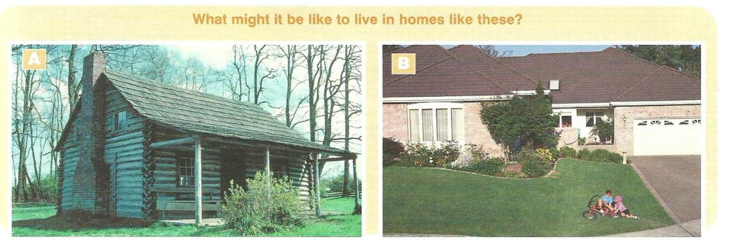
- Compare the pictures and say which one do you prefer to live in?
- Decide what pros and cons do these houses have?
- What it might be like to live in homes like these?

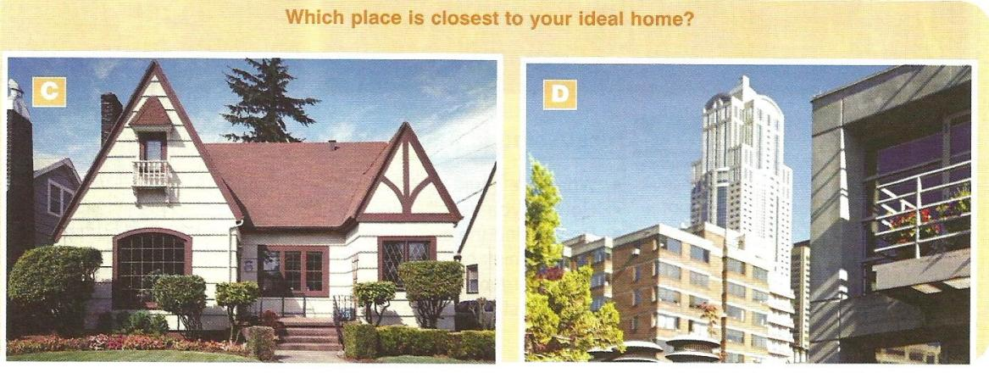
- Compare the pictures and say which place is closest to your ideal home?
- Where would you like to live in a house or in a flat, and why?
- What things are important for you in choosing your place for living?

Exercise 5
Answer the following questions
