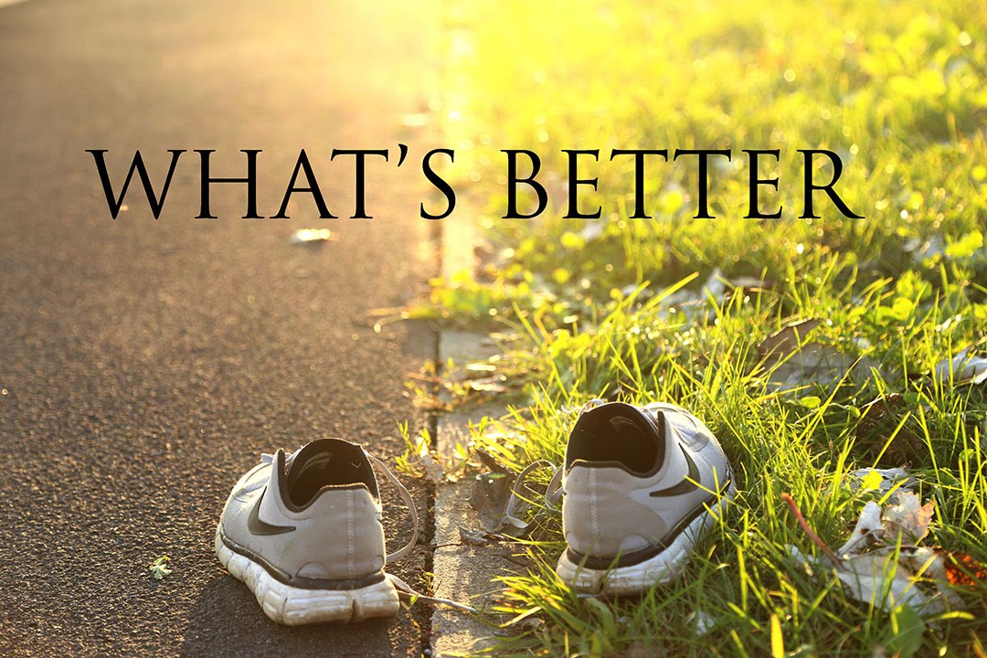

Exercise 1. Watch the video and answer the questions afterwards.
https://www.youtube.com/watch?v=NR7z9FbUf5k
1. Do you prefer city or country life?
2. How are city people and country people different?
3. What damage do cities do to the countryside?
4. Is it better to grow up in the city or in the countryside?
5. What are some differences between living in the city and living in the country?

Exercise 2. Watch the video and do the tasks.
<iframe width='640' height='480' src='https://en.islcollective.com/video-lessons/embed/61295' frameborder='0' allowfullscreen></iframe>

Exercise 3. Watch the video and answer the questions.
<iframe src="https://player.vimeo.com/video/81368735" width="640" height="360" frameborder="0" allow="autoplay; fullscreen" allowfullscreen></iframe>
<p><a href="https://vimeo.com/81368735">London in 1927 &amp; 2013</a> from <a href="https://vimeo.com/mrsimonsmith">Simon Smith</a> on <a href="https://vimeo.com">Vimeo</a>.</p>

1. What adjectives spring to mind when you think of London?
2. How has London changed from 1927 to the present days?
3. What places would you like to visit in London?
4. How has your home town changed from the past to the present days?
5. What has changed for better/worse?
6. What would you change about your home town to make it a better place to live in?
7. Which world city do you think would be the best to live in?
8. How will cities in the future be different from those today?
9. What are the major problems in cities?
10. Is your city very cosmopolitan?

