Lesson 20, Speaking, PI (Transport- City- Countryside)
Exercise 1
Look at the pictures. Which means of transport would you use if you wanted to…
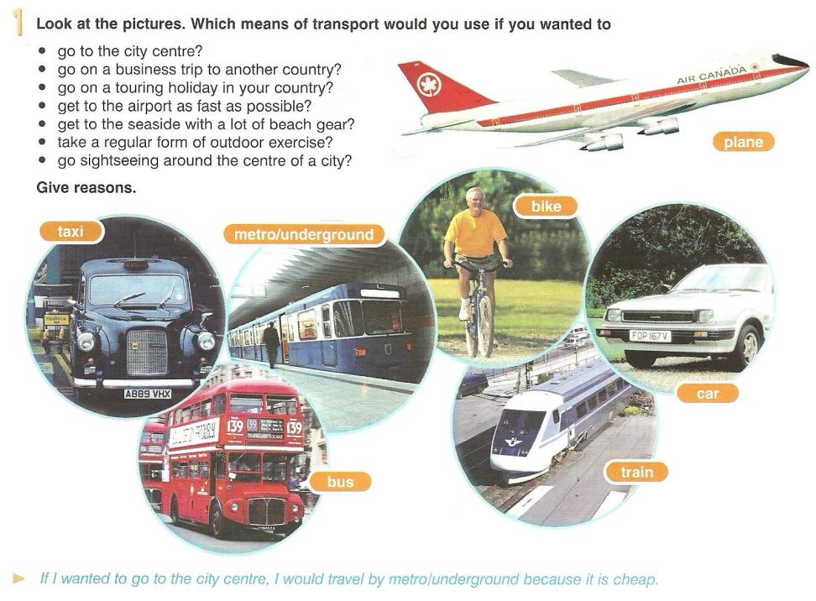

Exercise 2
Answer the following questions.
1. What is your favorite means of private transport?
2. Do you drive a car? When did you learn to drive?
3. What skills do you need to practice to pass the driving test in your country? Did you pass your test first time? What do you find most difficult about driving?
4. Which is your favorite kind of public transport?
- buses or trains?
- ships or planes?
5. How do you usually travel to work, school or university in your country?
6. What transport do you think we’ll use in 50 years?
Exercise 3
Look at the pictures and answer the following questions. In your answers use the key words listed below.
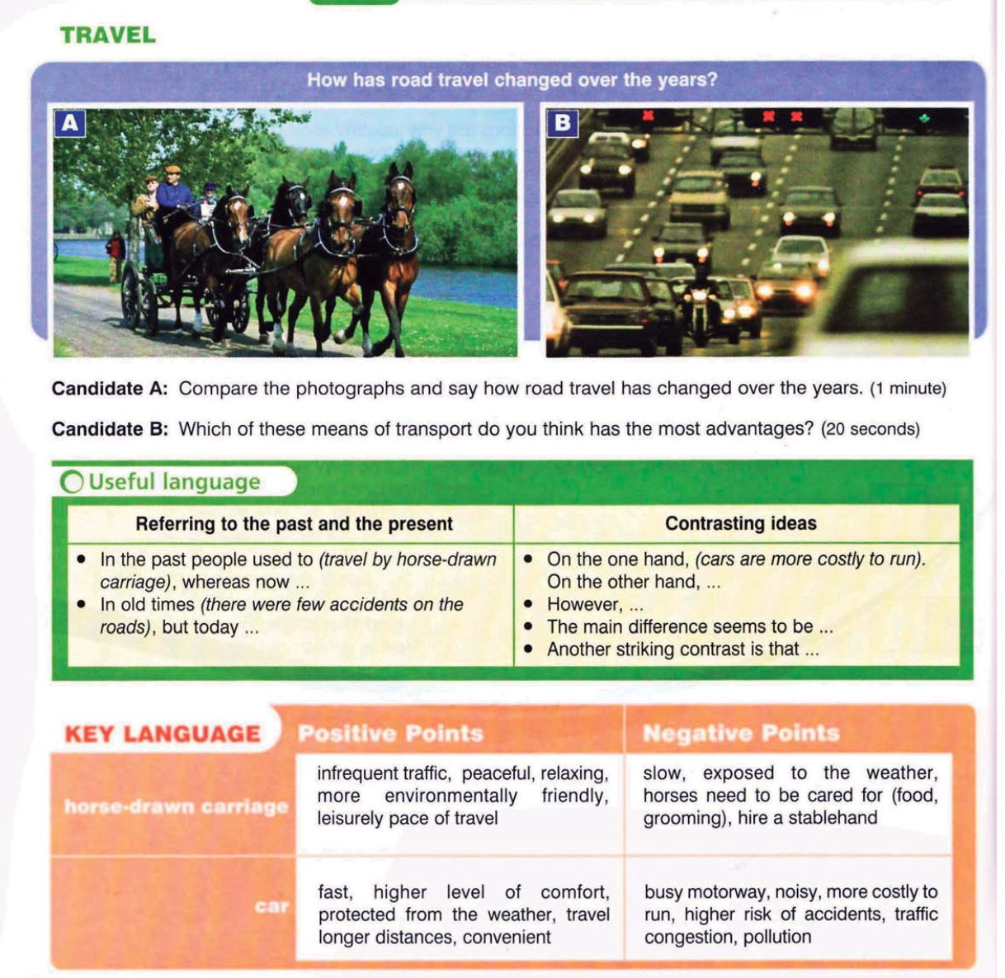

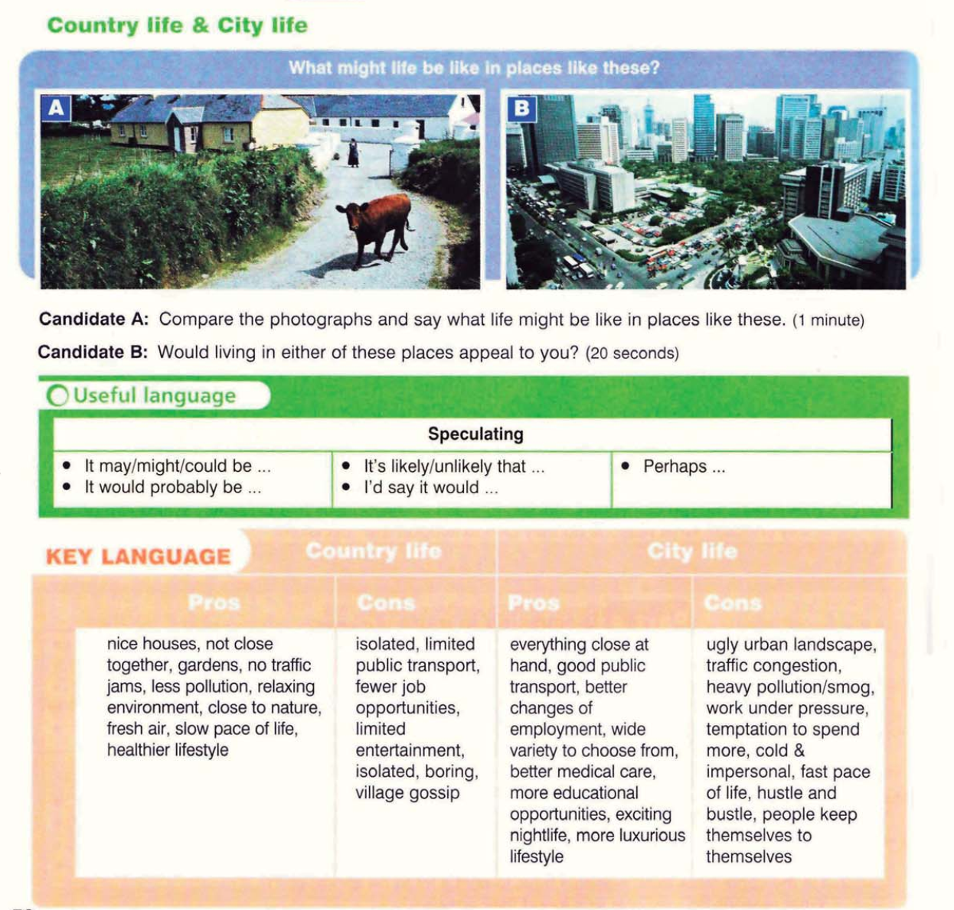

Exercise 4
Answer the following questions.
- If you had to give some visitors a tour of your hometown, what would you show them?
- What do you like to do when you visit a new town or city?
- What do you like about the town or city where you live now?
- If you could live in any city, where would you choose?
- Would you prefer to live in a city or in the country? Why?
- Are there “good” and “bad” parts of your town or city?
- Is your town changing? In what ways?

Exercise 5
Match the numbers on the pictures to the names of things you find in city streets.

Keys:
Exercise 5
1 – traffic lights; 2 – a sign; 3 – a zebra crossing; 4 – a cycle lane; 5 – a bus stop; 6 – a pavement; 7 – a bench; 8 – a rubbish bin; 9 – graffiti; 10 – a lamppost

