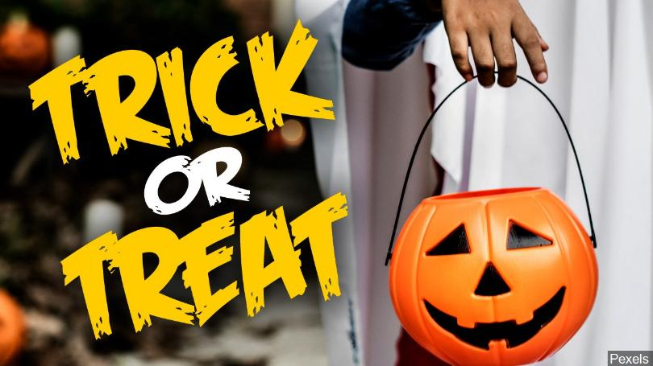
Exercise 1. Watch the video and answer the questions afterwards.
<iframe width="560" height="315" src="https://www.youtube.com/embed/R-VRAemIvbI" frameborder="0" allow="accelerometer; autoplay; encrypted-media; gyroscope; picture-in-picture" allowfullscreen></iframe>

1. Who were the first people to celebrate Halloween?
a) The Vikings
b) The Celts
c) The Romans
2. Why did Pagans used to gather and light fires at Hallowen?
a) To keep warm
b) To drive spirits back to the underworld
c) To see where they were going in the dark
3. When did Halloween begin to merge with Catholic festivals?
a) in the twelfth century
b) in the nineteenth century
c) in the seventh century
4. When is All Saints Day celebrated?
a) November 2
b) October 31
c) November 1
5. What was All Saints Day originally called?
a) All Hallows Eve
b) Hallowmas
c) Alloween
6. Which group of people introduced the holiday to the United States?
a) Italians
b) Irish People
c) Mexicans
7. What is the custom of playing pranks at Halloween called?
a) trick or treat
b) trick or trash
c) treat or trick

Exercise 2. Watch the video and answer the questions afterwards.
<iframe width="560" height="315" src="https://www.youtube.com/embed/5EucFzLgB80" frameborder="0" allow="accelerometer; autoplay; encrypted-media; gyroscope; picture-in-picture" allowfullscreen></iframe>

1. Halloween is celebrated on a different day each year?
a) not given
b) true
c) false
2. Which US state was the first to celebrate Halloween, according to official records?
a) Minnesota
b) Louisiana
c) not given
3. Which of these statements is true?
a) People celebrate the Halloween holiday for longer than they used to.
b) Fewer people in the US celebrate Halloween now than they used to.
c) People spend less money on Halloween than they used to.
4. Which of these statements about Halloween celebrations at the National Zoo is false?
a) Some of the animals are given Halloween treats.
b) The keepers dress the animals up in Halloween costumes.
c) kids visiting the zoo dress up in Halloween costumes.
5. The most popular Halloween kids costume for boys according to the video is …
a) an alien
b) a zombie
c) a pirate

Exercise 3. Watch the video and answer the questions afterwards.
<iframe width="560" height="315" src="https://www.youtube.com/embed/8FHrhH9k-PY" frameborder="0" allow="accelerometer; autoplay; encrypted-media; gyroscope; picture-in-picture" allowfullscreen></iframe>
1. How old is the Day of The Dead festival?
a) five hundred years old
b) nine hundred years old
c) seven hundred years old
2. When do Mexicans believe that the souls of children return?
a) The video doesn’t say
b) on the second of November
c) on the first of November
3. When do Mexicans believe that the souls of adults return?
a) The video doesn’t say
b) on the second of November
c) on the first of November
4. Why do Mexicans leave offerings for the dead?
a) The video doesn’t say
b) To please the gods of the underworld
c) To make their ancestors feel at home when they come to visit
5. What is the significance of the brad?
a) The bread is placed on altars
b) The video doesn’t say
c) The bread is eaten at the start of the festival
6. What happens to the sugar skulls at the end of the festival?
a) people break them and eat them
b) they are placed on graves as offerings
c) the video doesn’t say

