Lesson 22, Video, Pre-Intermediate
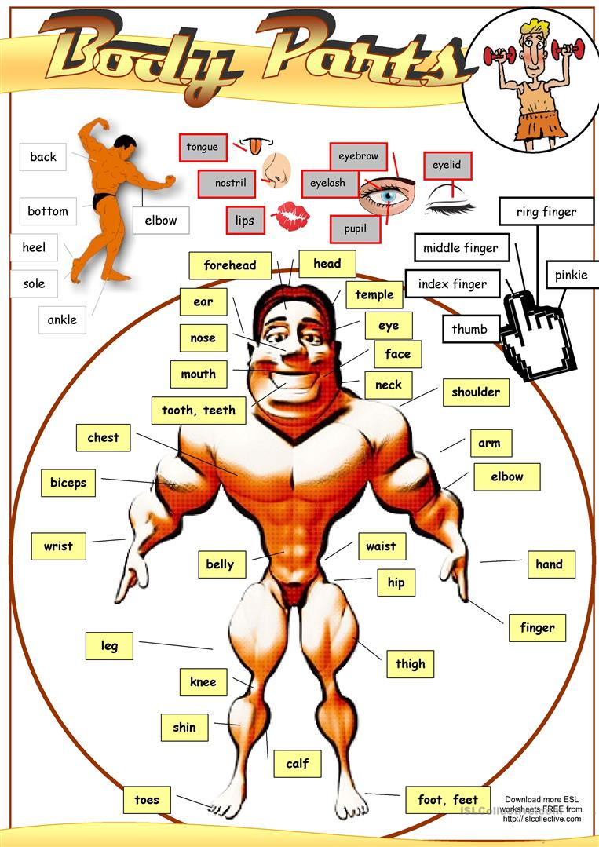

Exercise 1
Look at the words and translate them.
https://quizlet.com/493825331/lesson-22-video-pre-intermediate-exercise-1-flash-cards/
Exercise 2
Watch the video and define whether statements are true or false.
https://www.youtube.com/watch?v=0nKz81R327w
1)Human body is more complicated than a computer.-
2)Body parts never come in pairs.-
3) Water is the most important chemical in a body.-
4)Three-fourths of human weight is water.-
5) Our closest animal relatives are chimpanzees.-
6)We are all the same because of our genes that come from our parents.-
7)Organs are made up of skin.-

Exercise 3
Look at the words and translate them.
https://quizlet.com/493831347/lesson-22-video-pre-intermediate-exercise-3-flash-cards/
Exercise 4
Watch the video and choose the correct variant.
https://www.youtube.com/watch?v=Mzo1b3qo3H4
1)People eyes are:
a. fragile
b. itchy
c. flat
2) People`s eyes need to be:
a. hidden
b. protected
c. filled
3)Eyebrows sit:
a.under people`s eyes
b.above people`s eyes
c.is not mentioned
4)This part of the body stops dust from entering the eyes:
a.eyelids
b.eyelashes
c.both variants are correct
5)Tear glands produce drops of:
a. sour fluid
b. bitter fluid
c. salty fluid
6)The colour of your iris depends on the instructions for your eye colour that you inherit from:
a. your father
b. your mother
c. your parents

Exercise 5
Look at the words and translate them.
https://quizlet.com/493836364/lesson-22-video-pre-intermediate-exercise-5-flash-cards/
Exercise 6
Watch the video and define whether statements are true or false.
https://www.youtube.com/watch?v=_PnD8KCNurs

- Nowadays people think their emotions come from their hearts.-
- Emotions don`t come from brain.-
- People`s heart is a muscle.-
- Human`s heart is a bit bigger than human`s fist.-
- This amazing muscle easily gets tired.-
- The heart pushes blood around whole body.-
- People should be active every day for at least twenty minutes.-
- People should avoid sugary soft drinks and fruit drinks.-
- Smoking damages the heart and blood vessels.-
- The heart started pumping blood before we were born.-

Exercise 7
Look at the words and translate them.
https://quizlet.com/493841965/lesson-22-video-pre-intermediate-exercise-7-flash-cards/
Exercise 8
Watch the video and choose the correct variant.
https://www.youtube.com/watch?v=_kGv8jnB8EE
- Brain looks like:
- a sponge
- a soap
- a peanut

- Brain weights about:
a.2 kilos
b.1.5 kilos
c.1.3 kilos
3) When you learn to do something, you create connections between:
a. cells and brains
b. tissues and brains
c. both variants are correct
4) The main part of your brain is:
a. ceberum
b. cerebrum
c. cerebellum
5) These two components are important for your brain:
a.phosphorus and zinc
b.calcium and potassium
c.aluminum and potassium

Keys:
Exercise 2
1.True 2.False 3.True 4.False 5.True 6.False 7.False
Exercise 4
1.A 2.B 3.B 4.C 5.C 6.C
Exercise 6
1.False 2.False 3.True 4.False 5.False 6.True 7.False 8.True 9.True 10.True
Exercise 8
1.A 2.C 3.A 4.B 5.B

