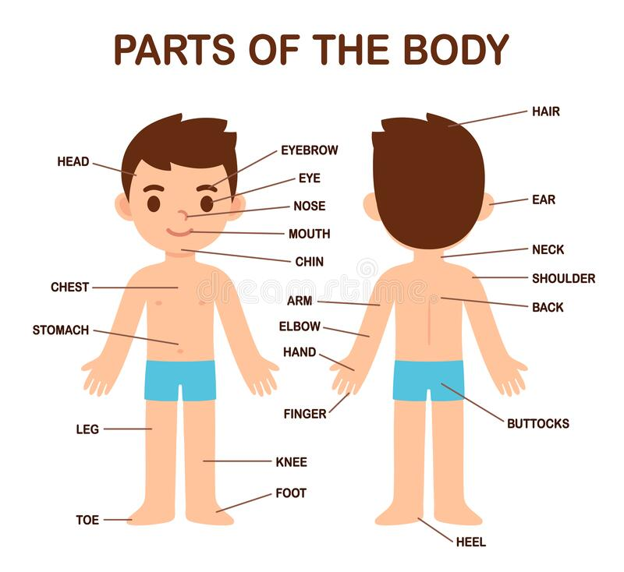

Exercise 1. Answer the questions with correct nouns either in singular or plural form.
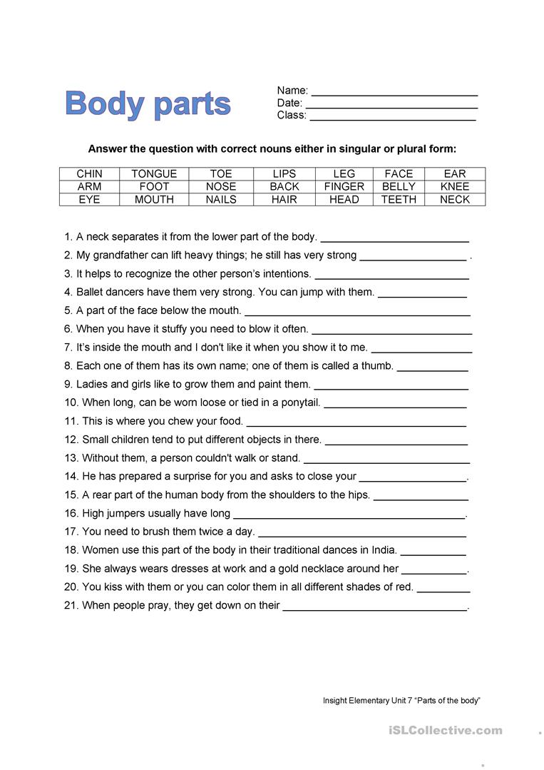
Exercise 2. Fill in the gaps.

Exercise 3. Read the text and answer the questions.
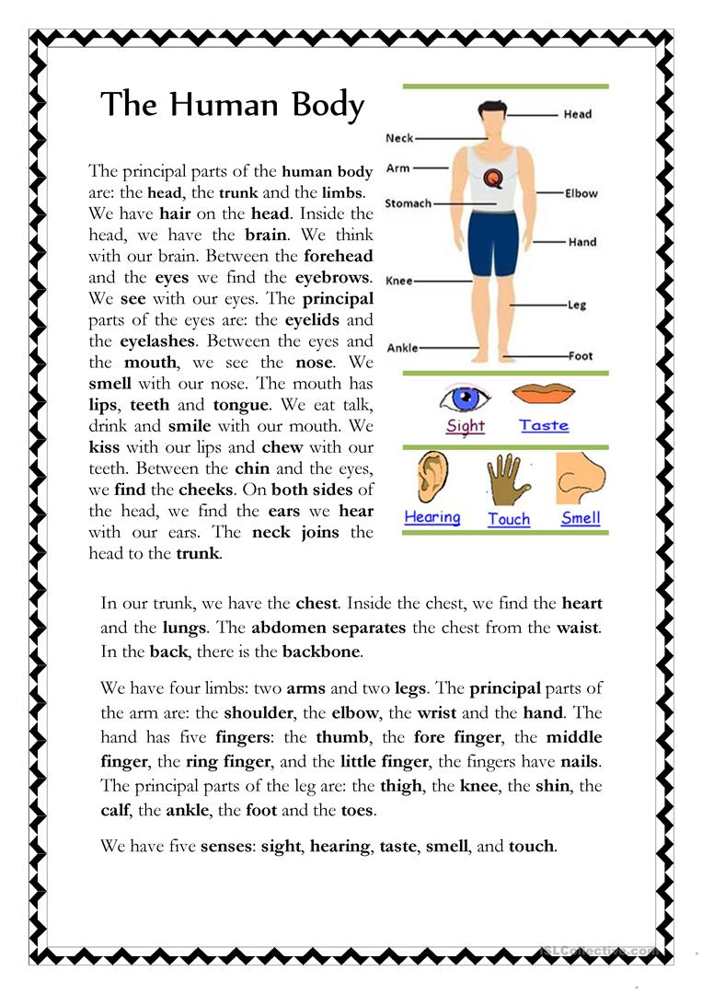

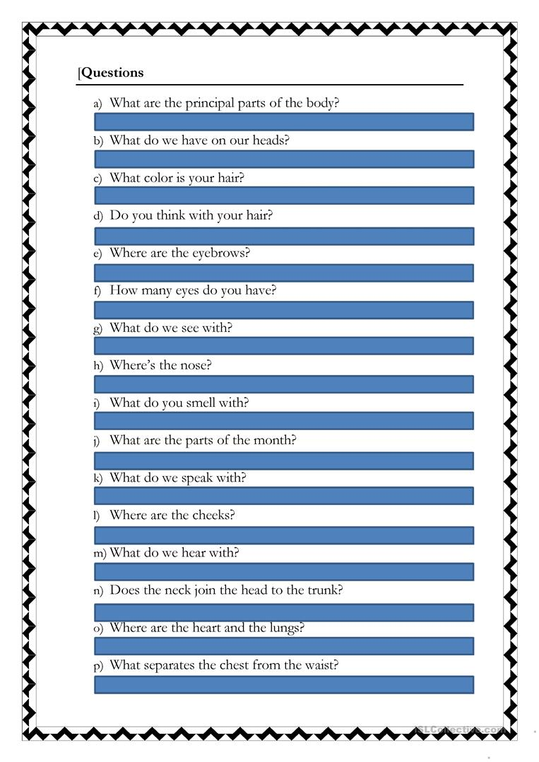

Exercise 4. Answer the questions.
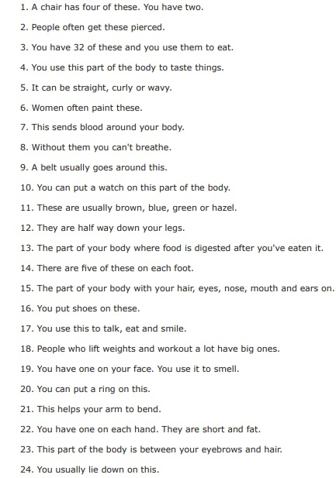

Answers:
Exercise 1. Answer the questions with correct nouns either in singular or plural form.
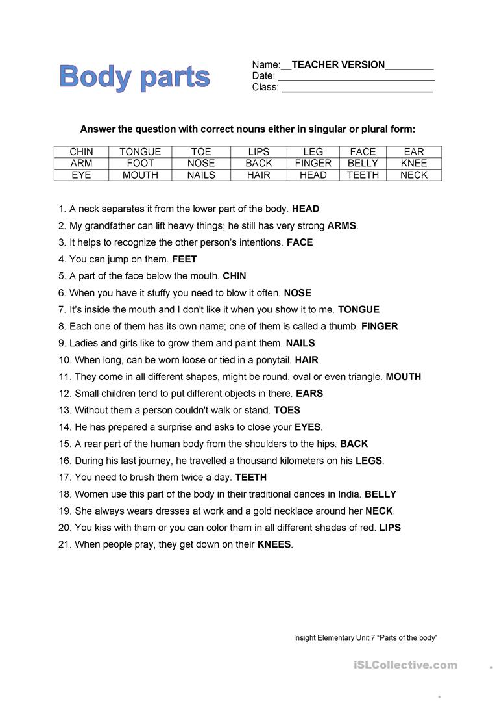

Exercise 4. Answer the questions.
