Exercise 1:
Watch the video about action verbs:
https://www.youtube.com/watch?v=8ZlSdZ59wd4

Exercise 2:
Form sentences using the following tips:
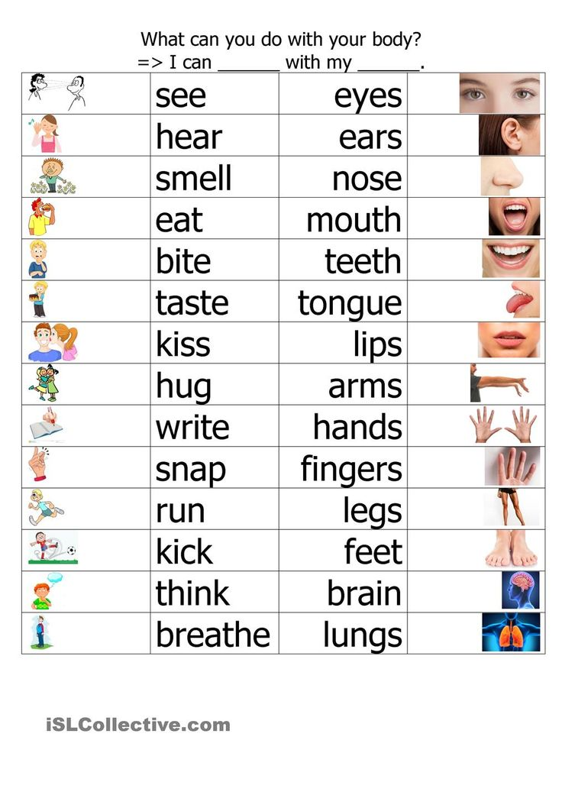

Exercise 3:
Look at the pictures and choose the correct variant. Then make up a sentence with this word:
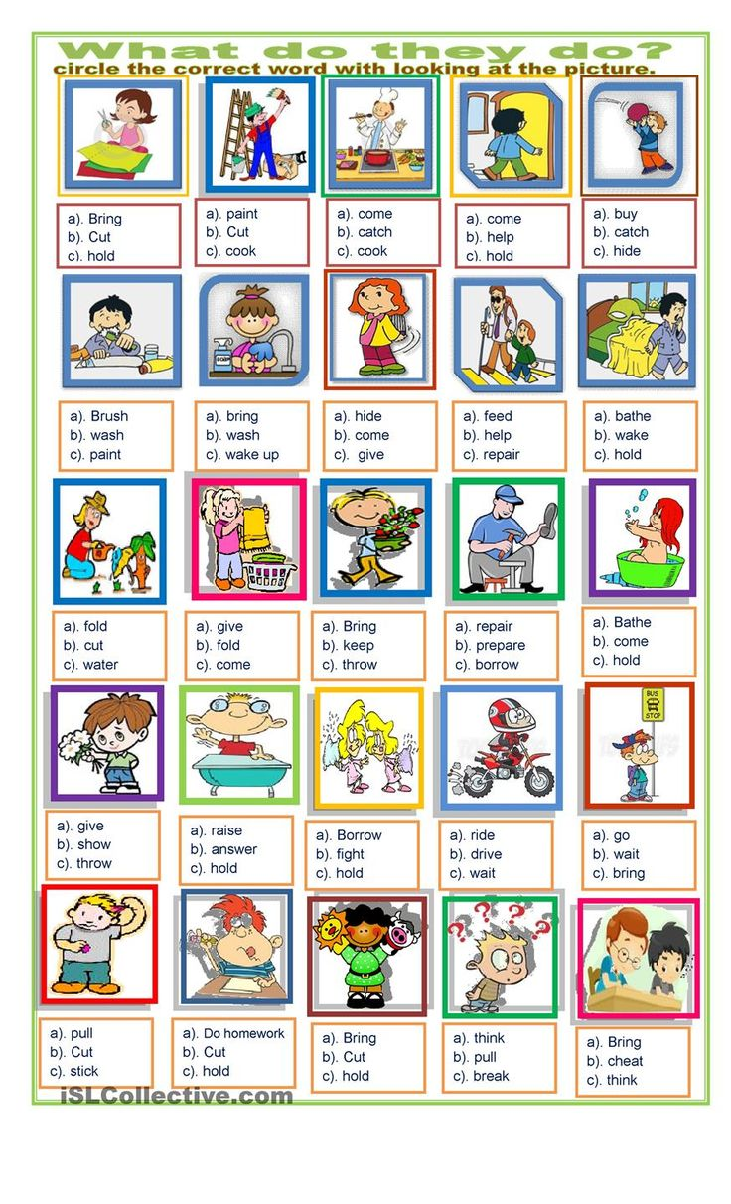
Exercise 4
Complete the sentences with necessary words (parts of the body):
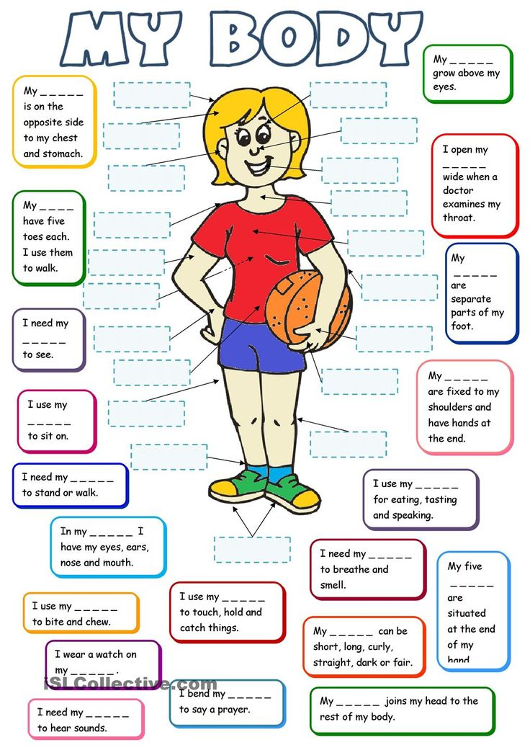
Keys:
Ex. 4
