Lesson 25, Listening, PI
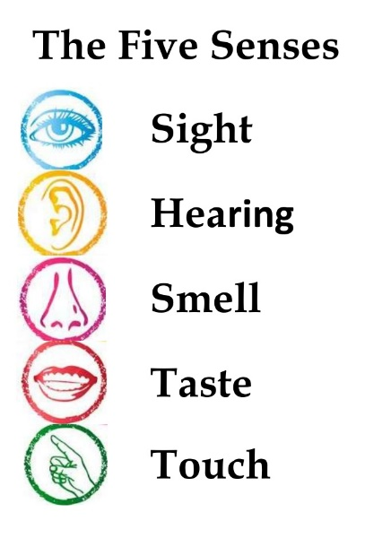
Exercise 1
Listen to the recording and then fill the gaps.
https://www.listenaminute.com/s/senses.html

can sense things can't imagine not I wonder why laughing faces Of all our senses or is it hearing or talk to dead smell, touch, taste

We only have five senses. . It doesn't seem a lot. We have the senses of , sight and hearing. Many people say they have a sixth sense. That's when you are happening that other people can't. Perhaps you can see into the future people. I'm not so sure this is a real sense. , I think the sense of sight is the most important. It's the most beautiful sense. I being able to see colours, or my children's happy, as they grow up. I'm not sure about my next favourite sense. Is it taste ? What would I miss most, tasting ice cream or listening to music? That's a difficult one. I wonder if this is the same for everyone.

Exercise 2
Listen to the recording and then fill the gaps.
https://www.listenaminute.com/s/smells.html

amazing how many can bring back freshly baked bread I love the smell of much because of of different fragrances think back to their to make themselves

Smells are interesting. It’s smells we know. Our noses are excellent at understanding thousands and odours. We all have favourite smells. Mine are and freshly brewed coffee. Many people spray themselves with perfume smell “nicer”. Personally, I think perfume is horrible. I hate smelling other people’s perfume. Smells memories. I’m sure everyone has an experience of smelling something that makes them childhood. I love smells that other people don’t like. the countryside and farms. I also quite like the smell of petrol, but I don’t want to smell it too the chemicals.

Exercise 3
Look at the words and translate them.
https://quizlet.com/496409321/lesson-25-listening-pi-six-senses-exercise-3-flash-cards/?new
Exercise 4
Watch the video and choose the best variant.
https://www.youtube.com/watch?v=ZxF_S3thP-4
1)This video is about:
a. deaf people
b. blind people
c. dead people
2)In communicating deaf people we suppose to:
a. speak loud
b. speak aloud
c. speak clearly
3) The best lip leaders can understand only:
a. 35%
b. 25%
c. 45%
4) People are supposed to be…… in their approach.
a. passion
b. reliable
c. flexible
5) Being deaf does not mean being:
a. disabled
b. incapable
c. uncapable
Exercise 5
Look at the words and translate them.
https://quizlet.com/496410976/lesson-25-listening-pi-exercise-5-flash-cards/?new
Exercise 6
Watch the video and answer the questions after that.
https://www.youtube.com/watch?v=uA-dXGUBVok
- What is this video about?
- What life can be without the ability to see?
- What is the most difficult moment about blindness?
- Do people who are blind have stronger senses?
- In your opinion can people who are blind see in their dreams?

Exercise 7
Answer the following questions.
1) What comes to your mind when you hear the word “sense”?
2) Which is your favorite sense?
3) How often do you think about how important your senses are?
4) Would you like to have a sixth sense?
5) What senses do you think you experience when you dream?
6) What sense would you choose to lose if you had to lose one?
7) Have you ever felt as if somebody is behind you?
8) Are you afraid of going to bed?
9) Do you listen you your intuition?
10) What gives you more pleasure, lovely music, a delicious taste, a beautiful scene, a nice smell, or the touch of the warm sun?
11) Oscar Wilde said: "Nothing can cure the soul but the senses, just as nothing can cure the senses but the soul." Do you agree?

Keys:
Exercise 1
We only have five senses. I wonder why. It doesn't seem a lot. We have the senses of smell, touch, taste, sight and hearing. Many people say they have a sixth sense. That's when you can sense things are happening that other people can't. Perhaps you can see into the future or talk to dead people. I'm not so sure this is a real sense. Of all our senses, I think the sense of sight is the most important. It's the most beautiful sense. I can't imagine not being able to see colours, or my children's happy, laughing faces as they grow up. I'm not sure about my next favourite sense. Is it taste or is it hearing? What would I miss most, tasting ice cream or listening to music? That's a difficult one. I wonder if this is the same for everyone.

Exercise 2
Smells are interesting. It’s amazing how many smells we know. Our noses are excellent at understanding thousands of different fragrances and odours. We all have favourite smells. Mine are freshly baked bread and freshly brewed coffee. Many people spray themselves with perfume to make themselves smell “nicer”. Personally, I think perfume is horrible. I hate smelling other people’s perfume. Smells can bring back memories. I’m sure everyone has an experience of smelling something that makes them think back to their childhood. I love smells that other people don’t like. I love the smell of the countryside and farms. I also quite like the smell of petrol, but I don’t want to smell it too much because of the chemicals.

Exercise 4
1.A 2.C 3.A 4.C 5.B

