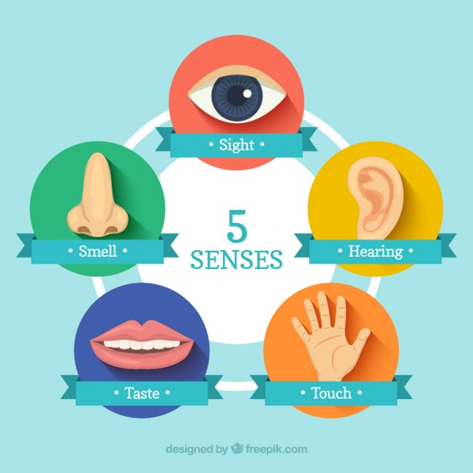
Exercise 1. Watch the video and do the tasks.
<iframe width='640' height='480' src='https://en.islcollective.com/video-lessons/embed/122979' frameborder='0' allowfullscreen></iframe>

Exercise 2. Lesson plan is designed around a short film titled Touch by Joshua Neale, commissioned by Huawei. Watch the video, try to identify and remember as many of things as you can.
<iframe title="vimeo-player" src="https://player.vimeo.com/video/144469104" width="640" height="360" frameborder="0" allowfullscreen></iframe>

Questions:
1. How can you explain the quote: “Touch is a powerful language.”
2. Do you like the film? Why/Why not?
3. Do you think the film is a good advert for a mobile phone? Why/Why not?
4. Do you feel disappointed that the film is an advert?
5. What was your favorite scene? Why?

Exercise 3. Watch the video and do the tasks.
<iframe width='640' height='480' src='https://en.islcollective.com/video-lessons/embed/104658' frameborder='0' allowfullscreen></iframe>

Exercise 4. Watch the video and answer the questions.
<iframe width='640' height='480' src='https://en.islcollective.com/video-lessons/embed/176766' frameborder='0' allowfullscreen></iframe>

