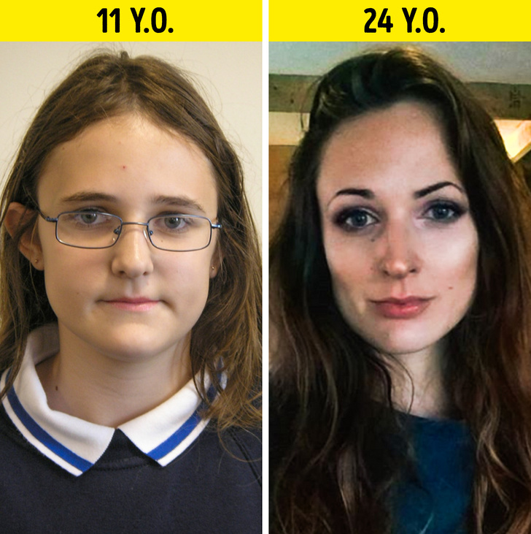
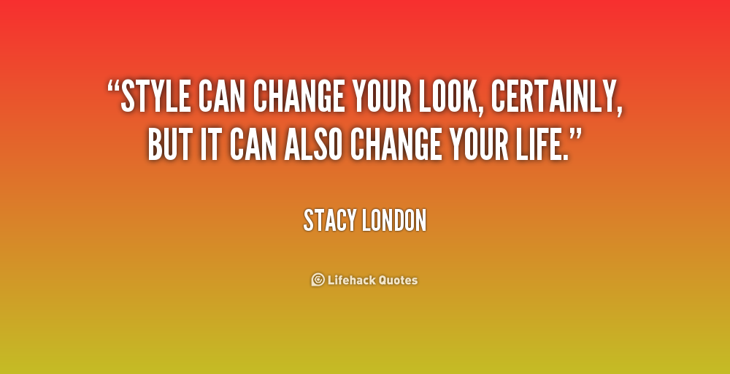
Exercise 1. Answer the questions.
(1) | How important is a person's appearance?
(2) | What could you do to improve your appearance?
(3) | What could I do to improve my appearance?
(4) | Has your appearance ever made you feel bad all day?
(5) | Is it rude to tell someone that they need to improve their appearance?
(6) | How often do you check your appearance in the mirror?
(7) | How often do you talk about other people's appearances?
(8) | Are people obsessed with appearance today?
(9) | Is what's on the inside more important than what's on the outside?
(10) | Is appearance more important in politics or show business?

Exercise 2. Look at the pictures and describe people’s appearance.
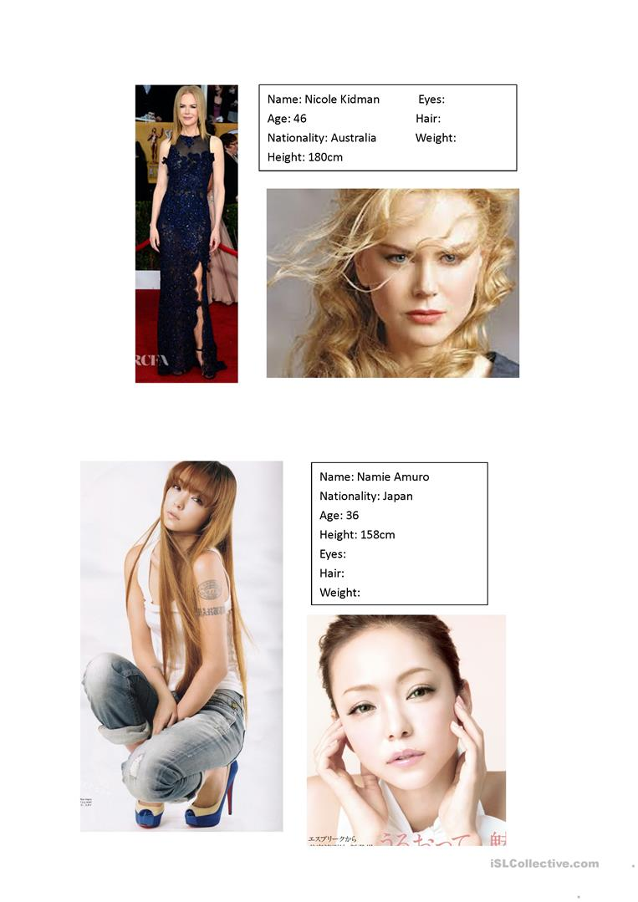
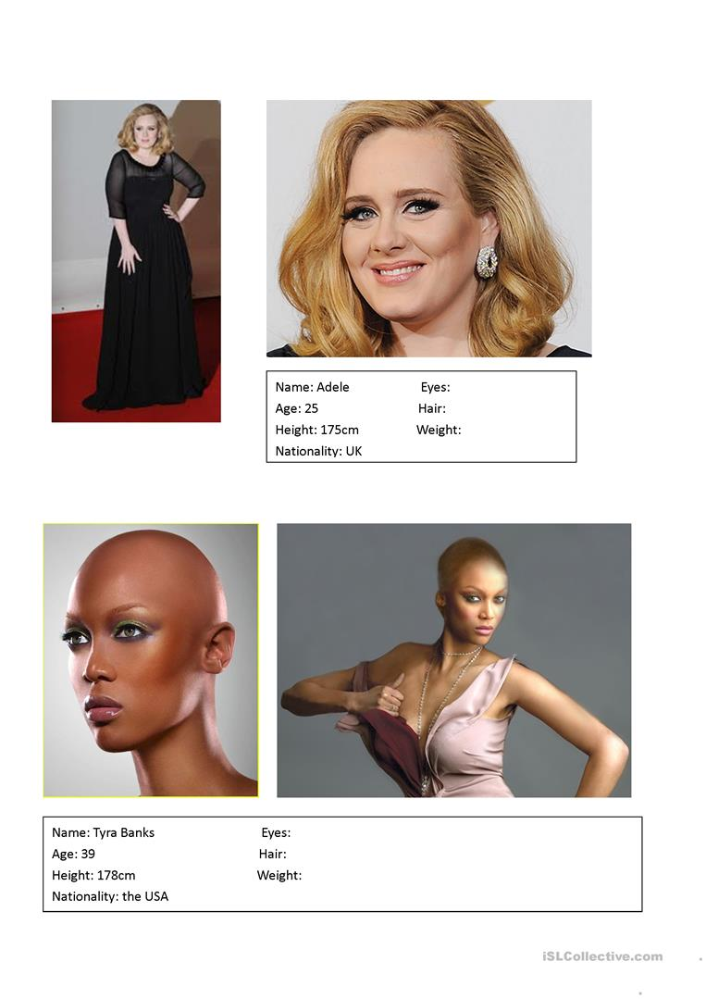
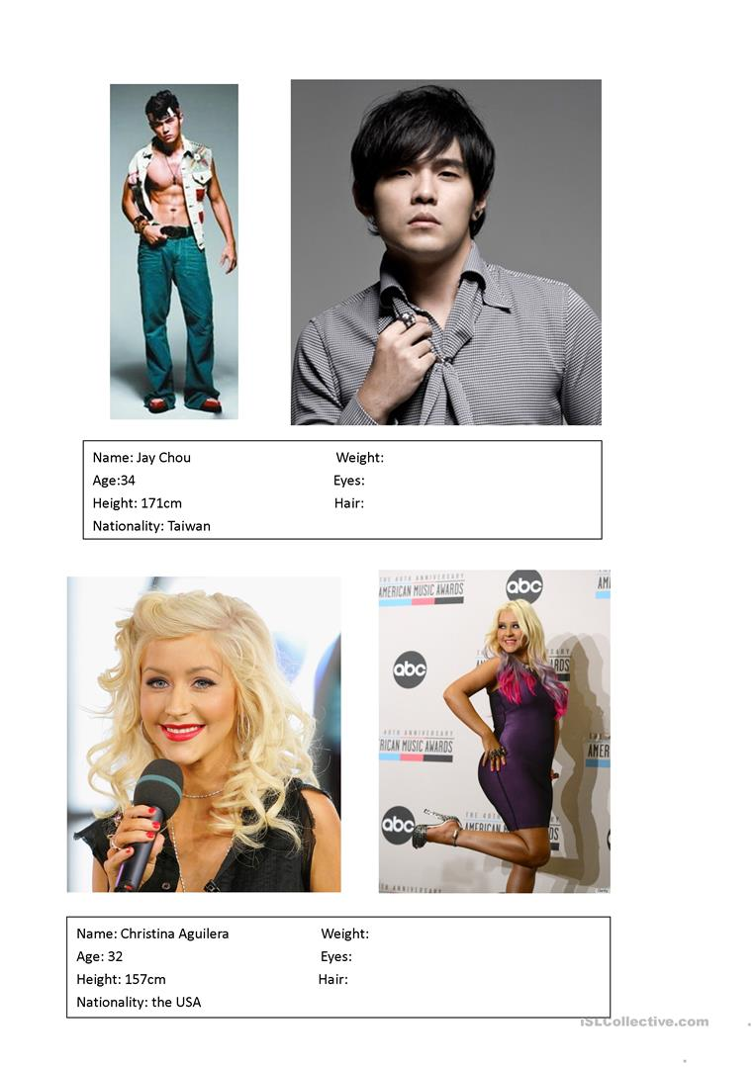

Exercise 3. Answer the questions, count your score and find out what it means.
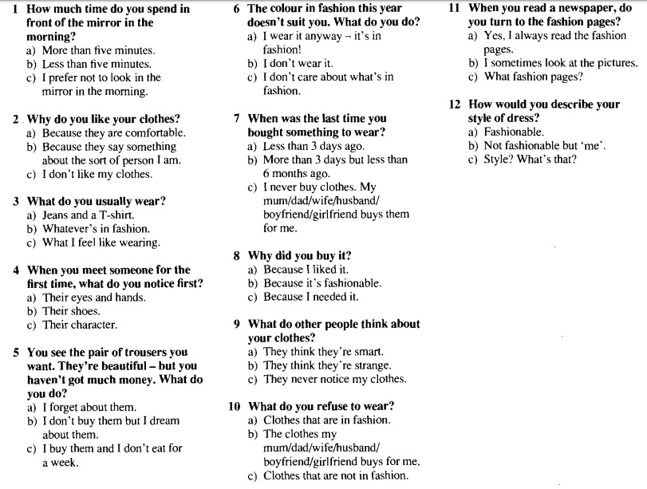
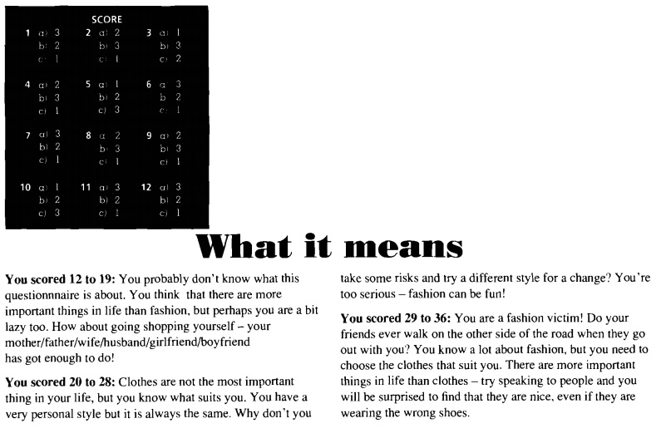
Exercise 4. Fill in the gaps.
