Lesson 29, Listening, PI (People- Appearance- Character)

Exercise 1
Look at the picture, describe it and answer the following questions.
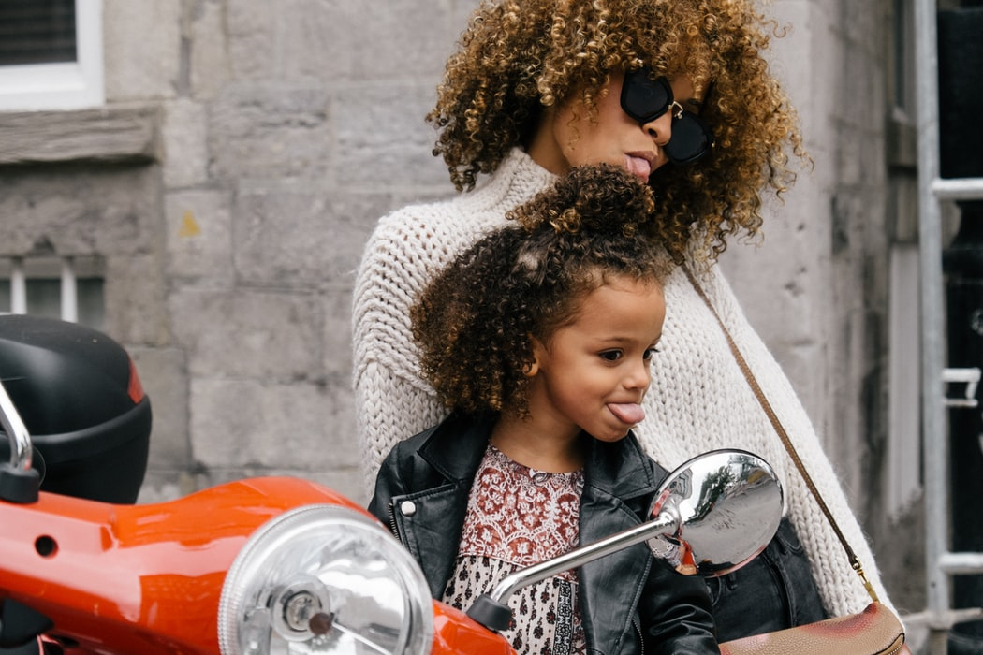

Do you look like any other people in your family?
Tell me about members of your family. What do they look like?
What does your best friend look like?
What kind of clothes do you like to wear?
Do you enjoy buying clothes?

Exercise 2
Kevin and Maria are talking about Maria and her sister, Catherine. Listen the recording and choose whether statements are true or false.
https://www.examenglish.com/A2/A2_listening_describing_people.htm
Exercise 3
Listen to the recording and then fill the gaps.
https://listenaminute.com/p/people.html
always think I’m pretty do agree with it life would be boring sad that all people they can help others usually take the things when they are strangers world a better place

“People are strange, .” That’s from a famous song. I , although I do think all people are strange. It’s a good thing that people are strange. If we were all the same, . It’s the fact that we are all strange that makes us all different. I like people from all over the world. It’s don’t get along. Many people say I’m strange. I’m not sure why. I normal. The people I like best are those who help other people. They make the . The people I hate most are greedy people. They other people need. All people need to think more about how .

Exercise 4
Listen to the recording and then fill the gaps.
https://listenaminute.com/p/personality.html
have rubbed off on I sulk when I don’t interesting to explore kind of personality do lot over the years see what they say true character shine was painfully shy

What you have? Do you ever think about your personality? I do. I think it’s very personality. My own personality has changed a . When I was a child, I , but now I’m brimming with confidence. I have learned how to be with people and let my . The personalities of my friends me, which I’m happy about. There are parts of my personality I’m not too happy with. I’m quick to get angry with people and sometimes get my own way. I think overall I have a good personality. I’m easy to get on with and I’m quite happy and cheerful. I might take some personality tests and about me.

Exercise 5
Read some sentences about physical descriptions and choose the correct alternative.
https://www.vocabulary.cl/Games/personality.htm
Exercise 6
Read some sentences about people`s personalities and choose the correct alternative.
https://www.vocabulary.cl/Games/personality.htm

Keys:
Exercise 2
1.True 2.False 3.False 4.True 5.False 6.True 7.True 8.True
Exercise 3
“People are strange, when they are strangers.” That’s from a famous song. I do agree with it, although I do think all people are strange. It’s a good thing that people are strange. If we were all the same, life would be boring. It’s the fact that we are all strange that makes us all different. I like people from all over the world. It’s sad that all people don’t get along. Many people say I’m strange. I’m not sure why. I always think I’m pretty normal. The people I like best are those who help other people. They make the world a better place. The people I hate most are greedy people. They usually take the things other people need. All people need to think more about how they can help others.
Exercise 4
What kind of personality do you have? Do you ever think about your personality? I do. I think it’s very interesting to explore personality. My own personality has changed a lot over the years. When I was a child, I was painfully shy, but now I’m brimming with confidence. I have learned how to be with people and let my true character shine. The personalities of my friends have rubbed off on me, which I’m happy about. There are parts of my personality I’m not too happy with. I’m quick to get angry with people and sometimes I sulk when I don’t get my own way. I think overall I have a good personality. I’m easy to get on with and I’m quite happy and cheerful. I might take some personality tests and see what they say about me.

