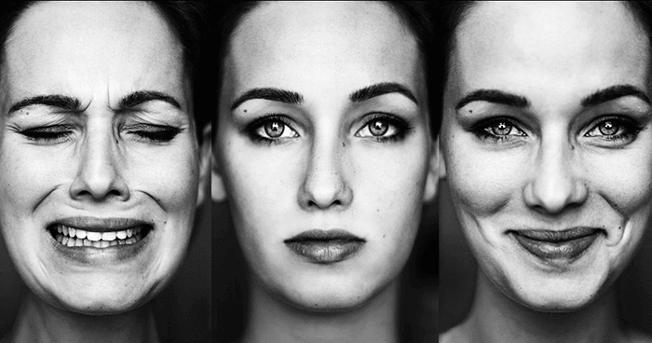
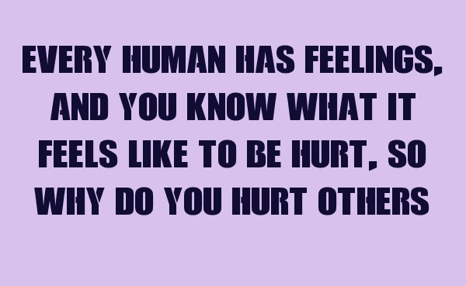

Exercise 1. Look at the picture. What the people in each picture are feeling? Try to explain the reasons for their feelings.
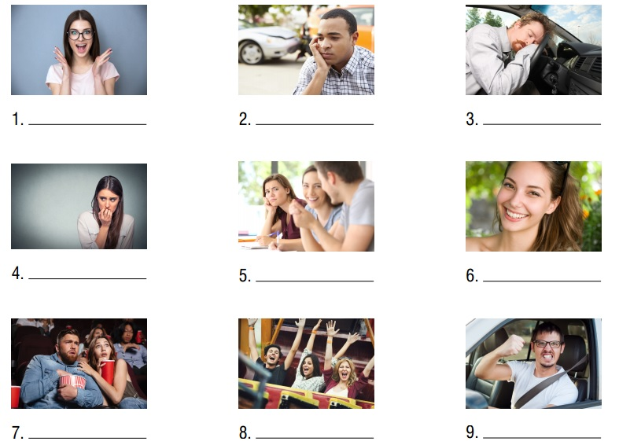

Exercise 2. Choose the best word for each sentence.
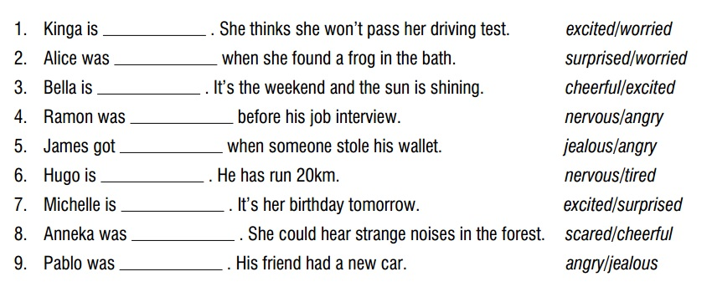

Exercise 3. Read the text and answer the questions.
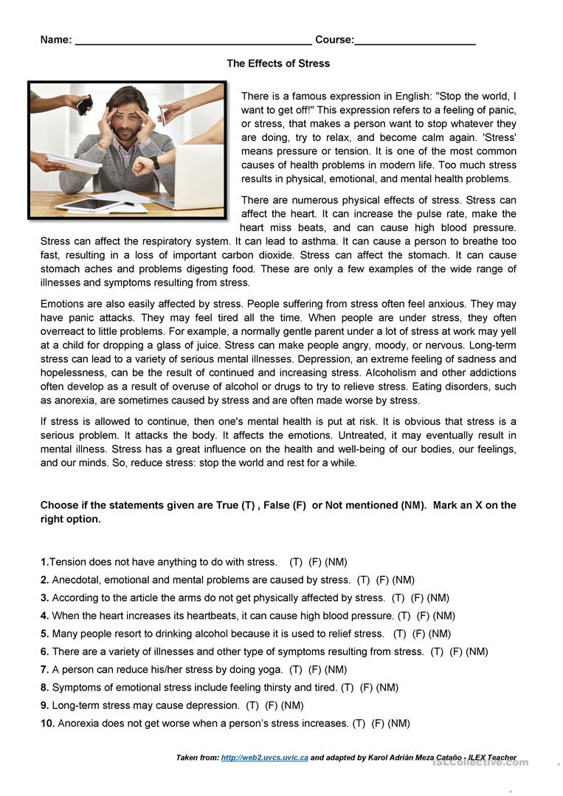

Exercise 4. Read the text and do the tasks.
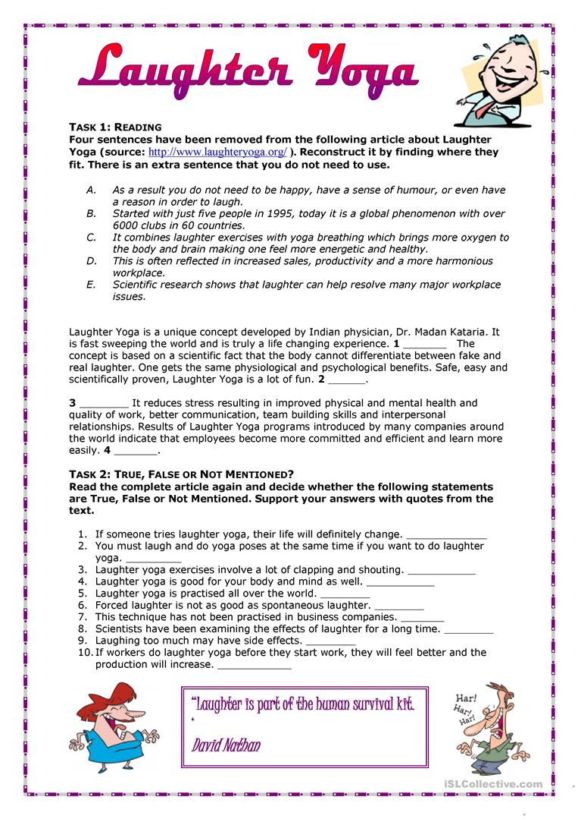

Exercise 5. Fill in the gaps and choose the correct answer.
