Lesson 32, Speaking, PI (Appearance, Character, Feelings)

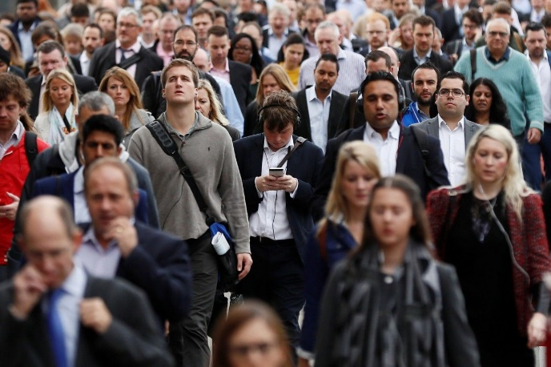

Exercise 1
Match the words with the pictures.
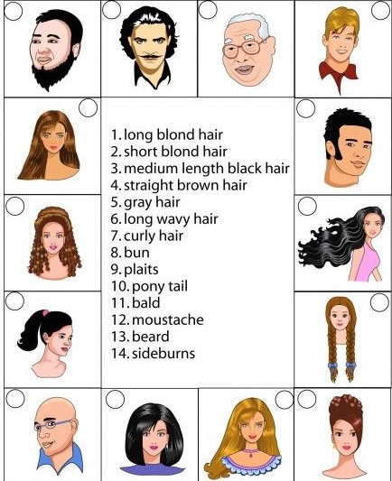

Exercise 2
Look at the pictures and answer the following questions.

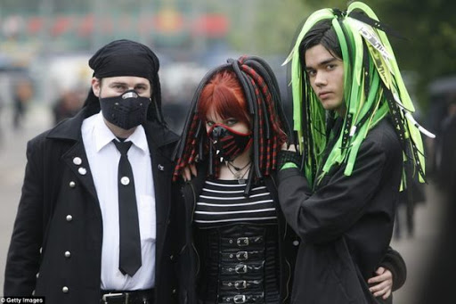
1) Compare these two photographs and say what impressions do these pictures evoke.
2) Do you think we should judge people`s character by the clothes they wear?
3) What things do you first notice about someone`s appearance?
4) Do you think the expression “Appearances are deceptive” is true? Why?

Exercise 3
Answer the following questions.
1) How do you think you look today?
2) What do you think when you look at yourself in the mirror?
3) Have you ever said someone looks good but really they don`t?
4) Has your mother ever complained about your appearance?
5) How are people`s appearances today different from 100 years ago?
6) Has your appearance ever made you feel bad all day?
7) How important is a person`s appearance?
8) Is it rude to tell someone that they need to improve their appearance?
9) How often do you check your appearance in the mirror?
10) How often do you talk about other people`s appearances?

Exercise 4
Match the words with the pictures.
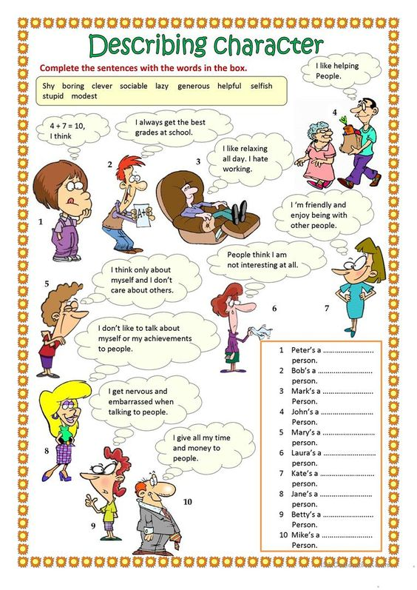
Exercise 5
Look at the pictures and answer the following questions.
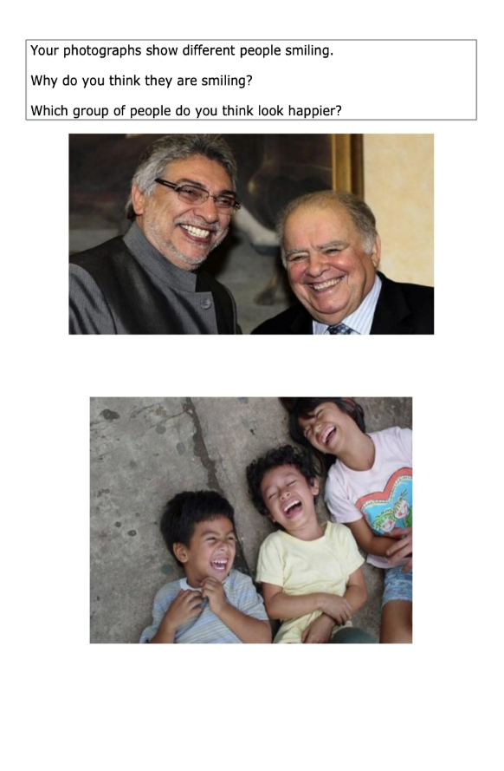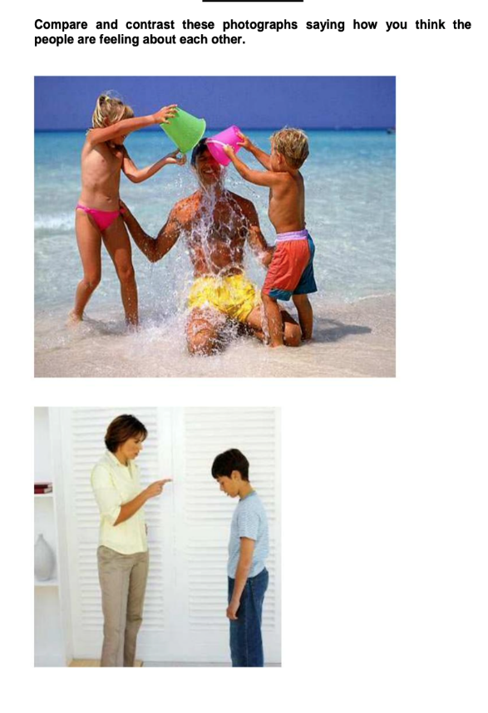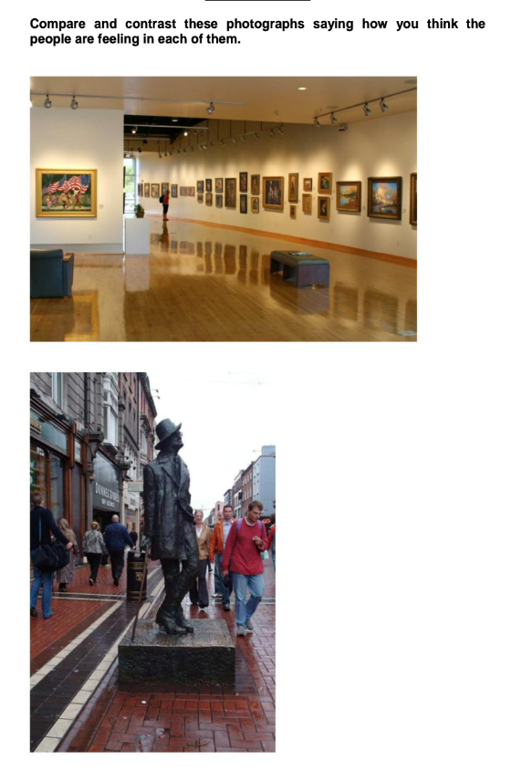

Exercise 6
- What are some characteristics of your personality?
- What makes you happy?
- What are some things that make you angry?
- Are you happy with your personality?
- Would you like to be different?
- Do you consider yourself selfish ? Why?
- Is your personality suited to your job?
- In what way has your personality changed? Why has it changed??
- Do you think you have an unusual personality? Why?
- Are you a sensitive person? Are you more emotional or less emotional than other people? What makes you think so?

