Exercise 1. Listen to the audio and fill in the gaps.
Job interviews are always _______________________ for me. Sometimes I have a great interview and get the job. Other times, my interview _______________________ and I don’t get the job. It’s really important _______________________. You must also be confident and _______________________ the interviewer knows you really want the job. The _______________________ is to make the interviewer think you are _______________________ for the job. I always wear my best suit and ______________________. I always smile when I walk into the interview room. First _______________________ are very important. It’s also a good idea to talk about your experiences - _______________________. Make sure you have a few good questions to ask at the end of the interview. Interview technique is something we learn over time – you _______________________ more the more interviews you have.

Exercise 2. Match the speaker with the correct job.
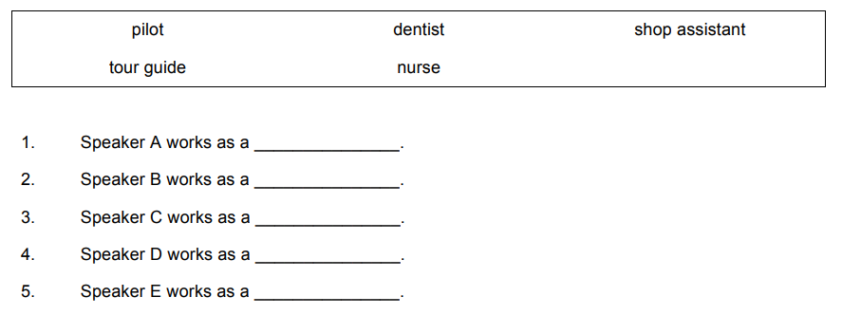

Exercise 3. Read the questions and choose the correct answer.
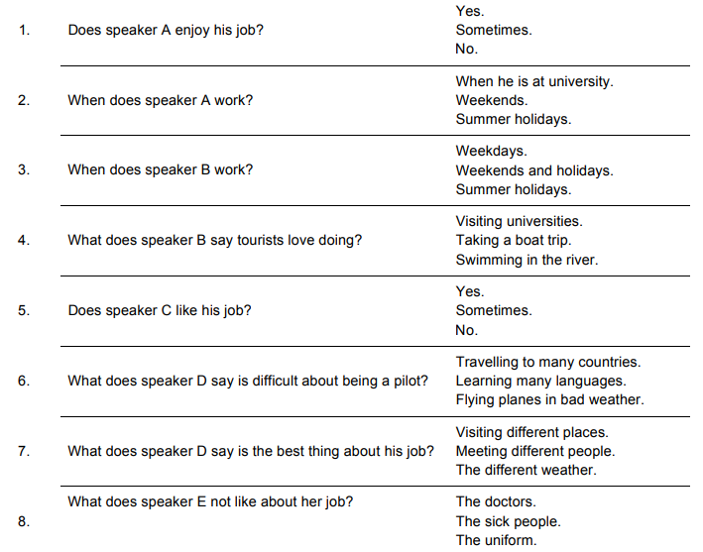

Exercise 4. Listen to the audio file and choose the best answer for each question.
1. How did Diana and the tourists travel to the canyon?
Car
Train
Bus
2. Why did some of the tourists stay at the hotel today?
They were tired.
They were ill.
They went to a different place.
3. Who is Mark?
A hotel manager.
Diana's colleague.
A worker at the canyon.
4. What did Diana do for lunch?
She didn't have time for lunch.
She ate something with the tourists.
She had lunch in the canyon cafe.
5. What does Diana think about her job?
The wages are good, but she hates the work.
They pay her poorly but at least she likes the job.
The wages are good and she likes the job too.
6. What did Diana do when she arrived back in the hotel?
She had a sandwich.
She spoke to the head of the tourist group about tomorrow.
She slept because she was exhausted.
7. What is the program for tomorrow?
Aquarium in the morning, museum in the afternoon.
Tour of the city in the morning, aquarium in the afternoon.
Museum in the morning, aquarium in the afternoon.

Exercise 5. Are the sentences true or false?
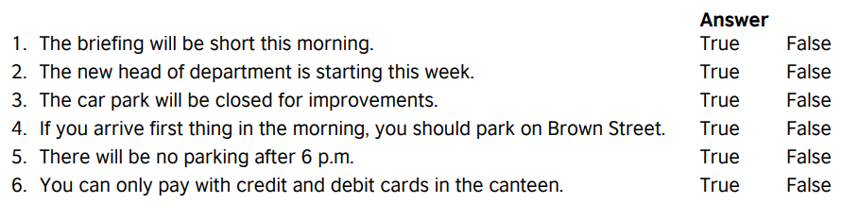

Answers:
Exercise 1. Listen to the audio and fill in the gaps.
Job interviews are always hit and miss for me. Sometimes I have a great interview and get the job. Other times, my interview bombs and I don’t get the job. It’s really important to prepare. You must also be confident and make sure the interviewer knows you really want the job. The trick is to make the interviewer think you are the best person for the job. I always wear my best suit and arrive early. I always smile when I walk into the interview room. First impressions are very important. It’s also a good idea to talk about your experiences - sell yourself. Make sure you have a few good questions to ask at the end of the interview. Interview technique is something we learn over time – you get to relax more the more interviews you have.

Exercise 2. Match the speaker with the correct job.
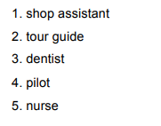
Exercise 3. Read the questions and choose the correct answer.

Exercise 4. Listen to the audio file and choose the best answer for each question.
1. How did Diana and the tourists travel to the canyon?
Car
Train
Bus
2. Why did some of the tourists stay at the hotel today?
They were tired.
They were ill.
They went to a different place.
3. Who is Mark?
A hotel manager.
Diana's colleague.
A worker at the canyon.
4. What did Diana do for lunch?
She didn't have time for lunch.
She ate something with the tourists.
She had lunch in the canyon cafe.
5. What does Diana think about her job?
The wages are good, but she hates the work.
They pay her poorly but at least she likes the job.
The wages are good and she likes the job too.
6. What did Diana do when she arrived back in the hotel?
She had a sandwich.
She spoke to the head of the tourist group about tomorrow.
She slept because she was exhausted.
7. What is the program for tomorrow?
Aquarium in the morning, museum in the afternoon.
Tour of the city in the morning, aquarium in the afternoon.
Museum in the morning, aquarium in the afternoon.

Exercise 5. Are the sentences true or false?
