Lesson 34, Video, PI

Exercise 1
Look at the words and translate them.
https://quizlet.com/497425150/lesson-34-video-pi-exercise-1-flash-cards/?new
Exercise 2

Watch the video in interactive mode and do the tasks while watching it.
https://en.islcollective.com/video-lessons/business-english-applying-jobs-part-1

1) Maria Martinez is going to write down any questions before calling the company.
- True
- False
2)
Put the words in order: I job. about more the need information
3) What were Maria Martinez's job interview questions? (More than one right answer)
- What would my responsibilities be?
- Is it a full time or part time position?
- Can I make an appointment for an interview?
- Is the boss strict?
- Are there coffee and cakes at work?
4) Maria Martinez wants to speak with Mr. Thomson.
- True
- False
5) Maria Martinez is calling about the executive management assistant position.
- True
- False
6) Maria Martinez didn't receive her high school degree.
- True
- False
7) Maria Martinez worked as a receptionist and an assistant.
- True
- False
8) Maria Martinez is fluent in English and Spanish.
- True
- False
9)
Put the words in order: an That exciting like sounds challenge to me.
10)
Put the words in order: Could you address, please? give your email me
11)
Put the words in order: your name for Could please last me? you spell

Exercise 3
After watching the video choose the best variant.
1) Purple Fashion is looking for a/an:
- executive officer
- executive management assistant
- shop assistant
2)Before calling Maria:
- wrote down some questions
- took some notes
- both (a and b variant)
3)Maria received a/an:
- bachelor`s degree
- high school diploma
- master`s degree
4)Maria worked as:
- flight attendant
- receptionist
- fashion designer
5)Maria has already had experience in:
- fashion business
- financial business
- manufacturing business
6)Maria is fluent in:
- Spanish and Arabic
- Indian and Italian
- Spanish and Italian
7)The position would involve (3 variants are correct):
- planning of all the executive`s affairs
- signing business papers
- creation of budgets and statistics
- taking care of all the executive correspondence
- supervision of all employees

Exercise 4
Match the job titles on the left with their descriptions on the right.

1) Optician a)a person who shaves men`s beards and cuts men`s hair
2) Vet b)a person that makes things from wood
3) Pharmacist c)a person who develops solutions to technical problems
4) Plumber d)a person that puts out fires
5) Lifeguard e)a person who looks after passengers
6) Flight attendant f)a person who saves lives where people swim
7) Barber g)a person that checks your eyes and corrects eyesight
8) Engineer h)a qualified person that works with medicine
9) Fire fighter i)a person who installs, repairs or works with pipes and water supplies.
10) Carpenter j)a qualified person that looks after sick animals

Exercise 5
Look at the words and translate them.
https://quizlet.com/497500108/lesson-34-video-pi-exercise-5-flash-cards/?new
Exercise 6

Watch the video in interactive mode and do the tasks while watching it.
https://en.islcollective.com/video-lessons/rachels-new-life-s1-ep1

1)
Put the words in order: input numbers, of much a it If doesn't don't I make those difference.
2)
Put the words in order: See, that’s how we buy stuff
3)
Put the words in order: this I abuse take not will
4) What did Rachel say?
Answer the question using your own words
5)
Put the words in order: I'm nothing for trained
6) What did Monica ask?
Answer the question using your own words
7)
Put the words in order: parents off whole your can't life. your live for You

Exercise 7
Solve job riddles
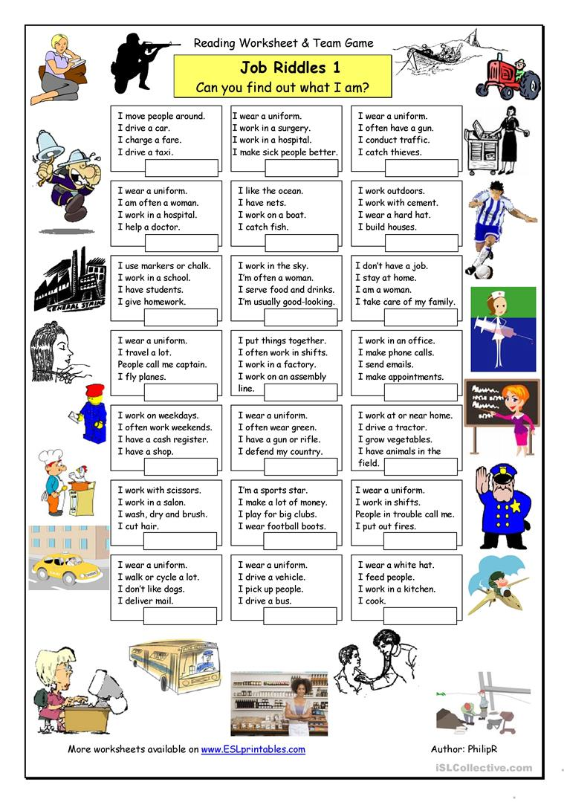

Keys:
Exercise 3:
1.B 2.C 3.B 4.B 5.A 6.C 7.A.C.D

Exercise 4:
1.G 2.J 3.H 4.I 5.F 6.E 7.A 8.C 9.D 10.B

