Lesson 35, Reading, PI (Work)

Exercise 1
Look at the company problems below. Match them to the descriptions.
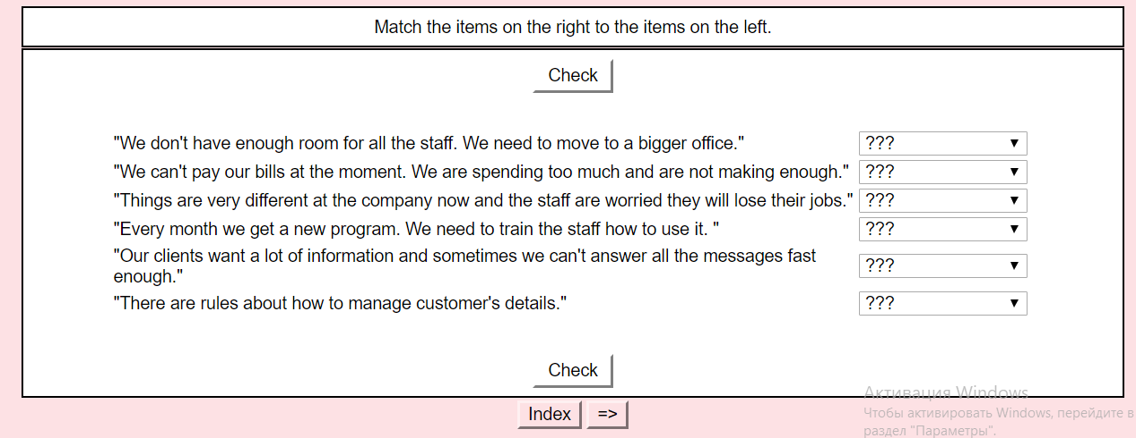

Exercise 2
Complete the gaps below with the correct words.
back check connection correct printer run size try

Lucy: Simon, can you help me? I can't print anything.
Simon: Is the on?
Lucy: Yes, it is.
Simon: Hmm, maybe turn it off and then turn it on again."
Lucy: I did that. Nothing happened.
Simon: Okay, well maybe there is a problem.
Lucy: How can I if that's the problem?
Simon: You can a test on your computer. It's really quick, let me show you.
Lucy: Okay, let's .
Simon: No, it's not the connection. Maybe the paper is wrong?
Lucy: Let's see. Oh it's not the right size.
Simon: Okay, you need to change it to the paper size.
Lucy: Alright. Let's see if this works.
Simon: Yes! It's working.
Lucy: Great! Thanks Simon.
Simon: No problem.

Exercise 3
Choose the best answer.
https://learnenglish.britishcouncil.org/vocabulary/beginner-to-pre-intermediate/jobs-2 (Task 3)

Exercise 4
Read an email invitation to a job interview and do the exercises.
https://learnenglish.britishcouncil.org/skills/reading/pre-intermediate-a2/an-invitation-to-a-job-interview

To: Grace Yang
Date: 6 September
Subject: Invitation to job interview
Dear Grace,
Thank you for your application for the position of sales manager.
We would like to invite you for an interview at 10 a.m. on Monday 21 September at our offices at The Shard, 32 London Bridge Street, London.
You will meet with our head of sales, Susan Park, and the interview will last for about 45 minutes. During this time, you will have the opportunity to find out more about the position and learn more about our company.
Please bring your CV and references to the interview. You will also need to show a form of ID at reception to receive a visitor's pass. Please ask for me as soon as you arrive.
If you have any questions or if you wish to reschedule, please call me on 555-1234 or email me by 12 September.
I look forward to meeting you.
Best regards,
Anna Green
Human Resources Assistant

Task 1
Choose the best answer.

Task 2
Complete the sentences.

Exercise 5

Read the texts and do the tasks.
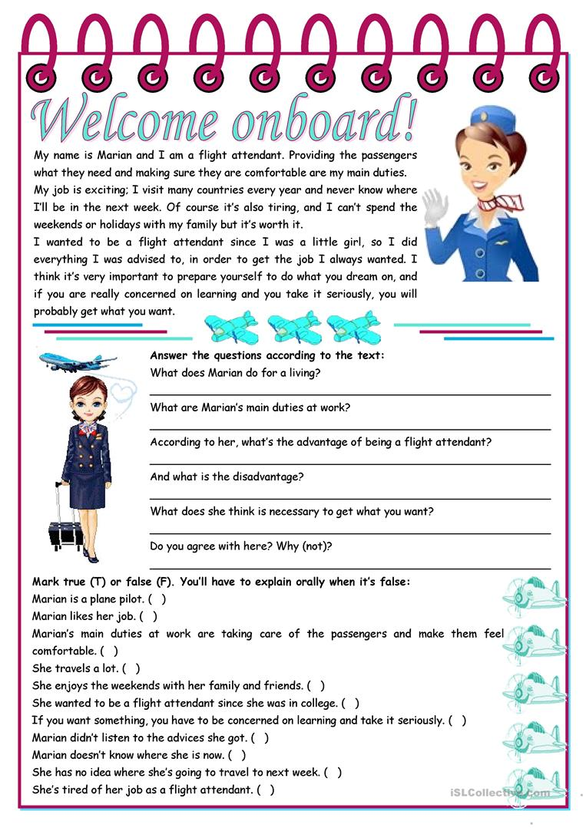

Keys:
Exercise 2
1.printer 2.back 3.connection 4.check 5.run 6.try 7.size 8.correct
Exercise 4

