Lesson 45, Reading, PI (Illnesses)
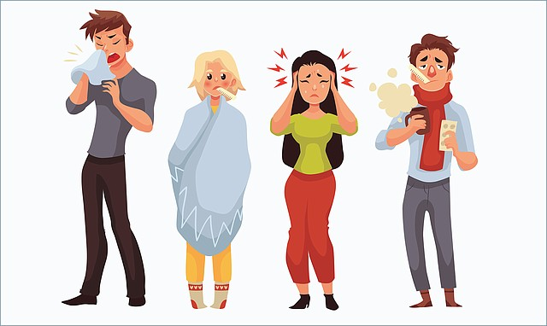
Exercise 1
Match the pictures with the words.

1)
a)Band aid

2)
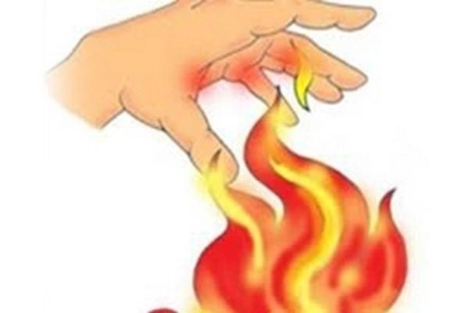 b)Burn

3)
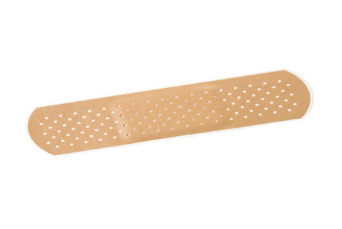 c)Sore throat

4)
d)Nurses

5)
e)Surgeon

6)
f)Headache

7)
g)Dentist

8)
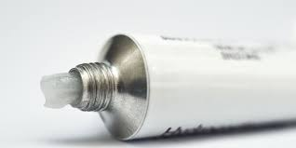 h)Ointment

9)
i)Hospital

10)
j)Physician

Exercise 2
Fill in the gaps.
band aid burn dentist headache hospital nurses ointment physician sore throat surgeon

a) He has a toothache so he should go to the .
b) If you have a you should put it under cold water.
c) Maria had her hand cut, and she used a to stop bleeding.
d) In the hospital take care of patients.
e) When you have you should take an aspirin
f) A talks with others about their problems.
g) She was so ill that she had to go to the .
h) Sometimes you should put an on your back, if it aches.
i) Jack had a and couldn`t speak much.
j) The said the operation went all right.

Exercise 3
Look at the words and translate them.

https://quizlet.com/498764548/lesson-45-reading-pi-flash-cards/?new
Exercise 4
Read the texts and do some tasks.
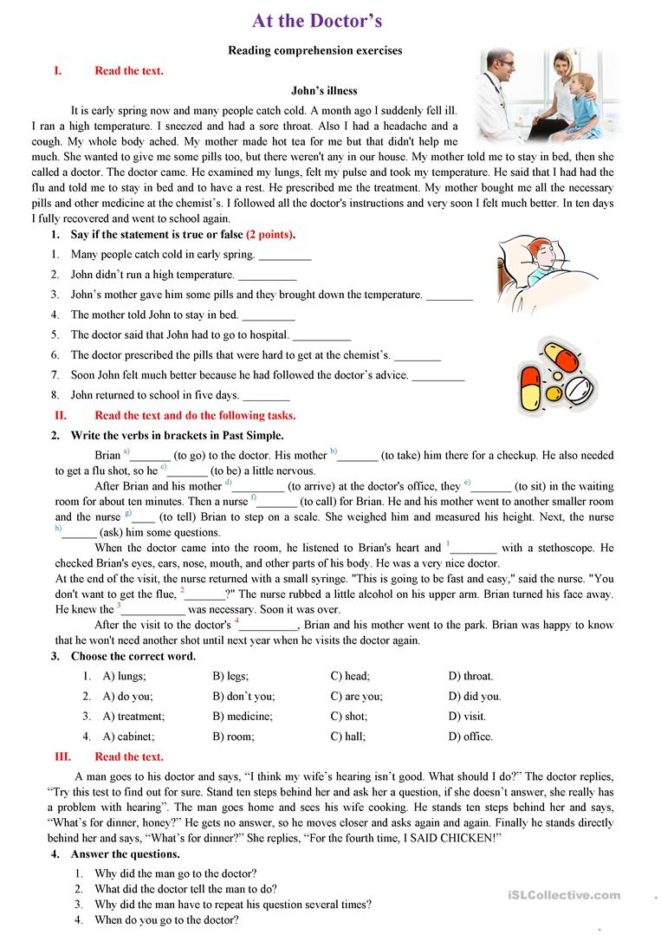

Keys:
Exercise 1:
1.G 2.B 3.A 4.D 5.F 6.J 7.I 8.H 9.C 10

Exercise 2:
a)dentist
b)burn
c)band aid
d)nurses
e)headache
f)physician
g)hospital
h)ointment
i)sore throat
j)surgeon

Exercise 4:
1)1.T 2.F 3.F 4.T 5.F 6.F 7.T 8.F
2)a.went b.took c.was d.arrived e.sat f.called g.told h.asked
3)1.A 2.A 3.C 4.D

