Lesson 46, Speaking, PI (Health)
Exercise 1
Match the words to the pictures.

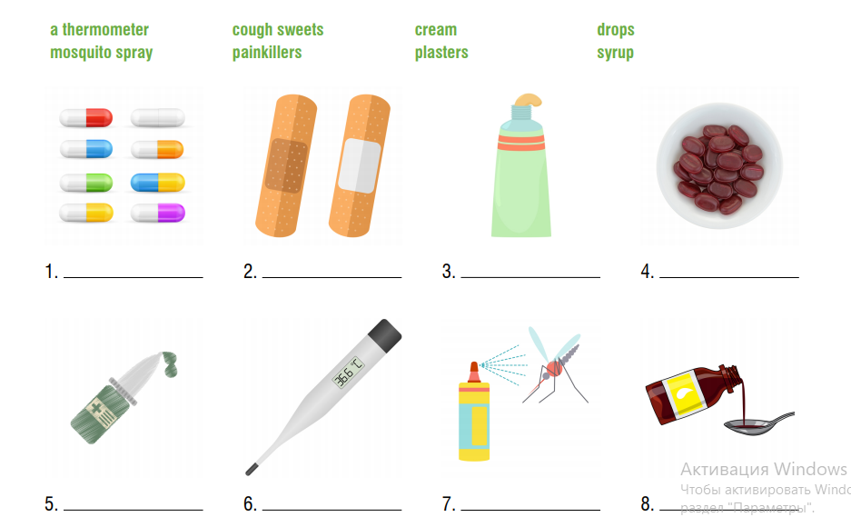

Exercise 2
Now match the items to the health problems.

Exercise 3

Have a look at the card and prepare a 1 minute speech

Exercise 4

Look at the pictures and answer the following questions.
In your answers use the key words listed below.
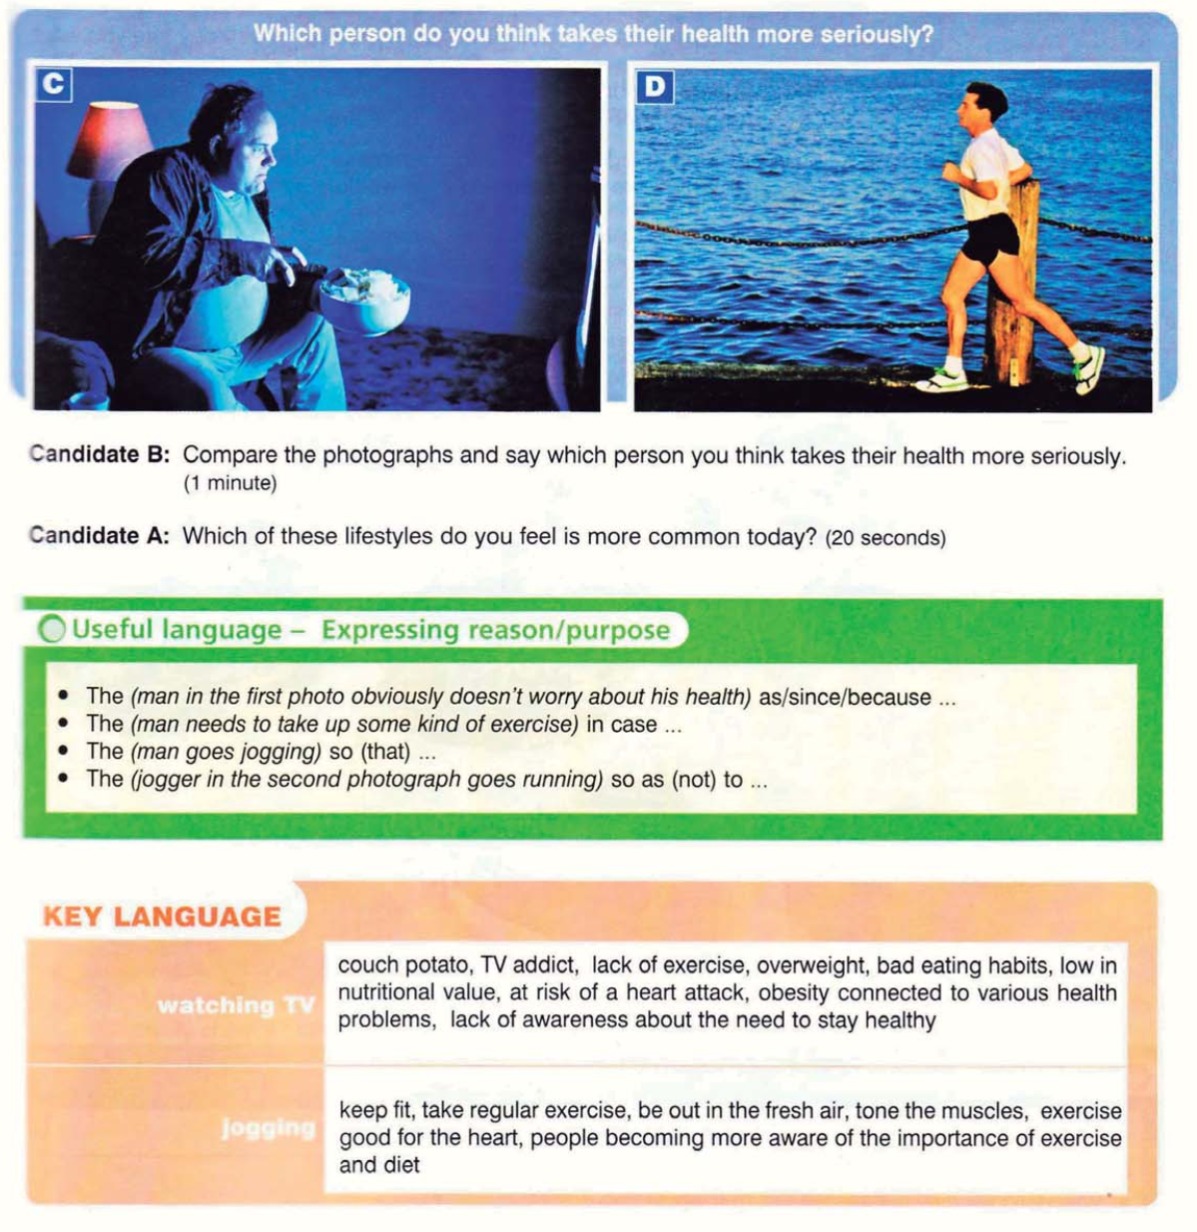
Exercise 5
Answer the following questions.
- Do you consider yourself a healthy person?
- How often do you get sick?
- What are the best ways to avoid getting sick?
- What healthy habits do you have?
- What can you do to improve your health?
- How often do you catch a cold?
- Do you always eat healthy food?
- Do you drink soda? How often do you drink soda?
- Do you skip breakfast?
- How often do you do exercises?
- Do you go to the dentist’s twice a year?
- Do you take long daytime naps?

Keys:
Exercise 1
Exercise 2

