Lesson 50, Video, PI(Disasters)
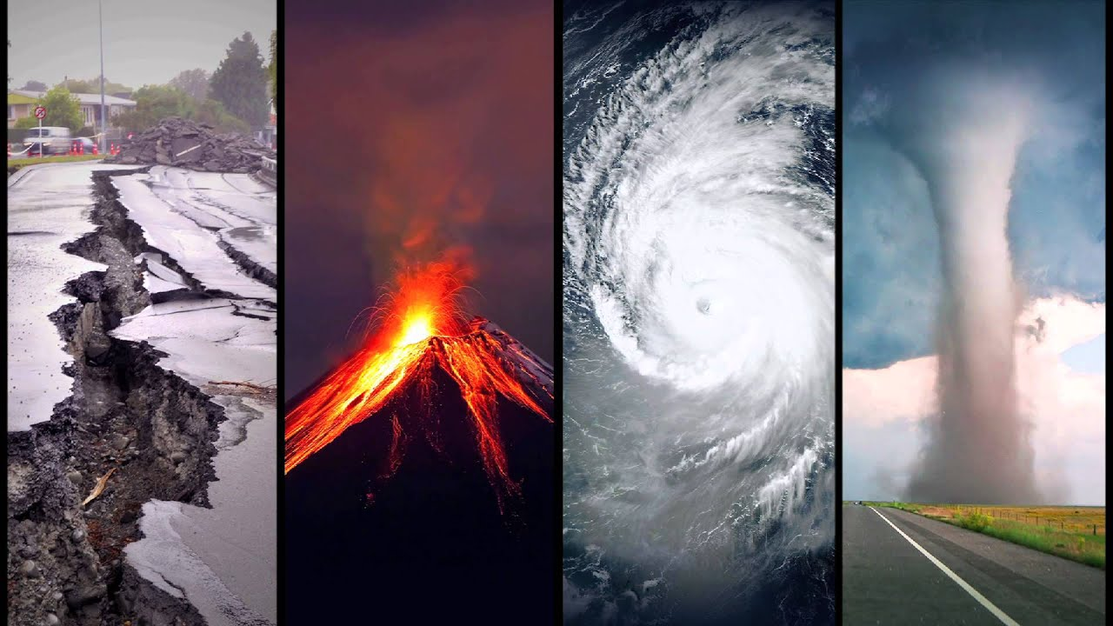
Exercise 1
Look at the words and translate them.
https://quizlet.com/498936084/lesson-50-video-pi-exercise-1-flash-cards/?new
Exercise 2

Watch the video in interactive mode and do the tasks while watching it.
https://en.islcollective.com/video-lessons/natural-disasters
1) What does this mean?
- Natural disasters are dangerous.
- Natural disasters aren't dangerous.
- Natural disasters are good for humans.
2)
Put the words in order: can of populations. They size change human the
3) There is an increase in risk when people move to these two places.
- coastlines and cities
- countryside and cities
- islands and coastlines
- forests and islands
4) Match the word to the definition.
Match the items:
Intensity | Possibility of danger.
Hazard | How often an event happens.
Frequency | A danger.
Risk | The strength of an event.
5)
Fill the gap: Hazards events can be ________________________ or ________________________
6)
Put the words in order: in or be origin. hazards Natural can local global
7) "Local events can have distant impact." What does this mean?
Answer the question using your own words
8) What are geoscientists continuing to find out? (occur = happen)
- When and where natural disasters occur
- Where and why natural disasters occur
- When and why natural disasters occur
- How and when natural disasters occur
9) Match the word to the definition.
Match the items:
Economic costs | Money spent to fix damage
Loss of life | People can die
Property damage | Buildings are destroyed

10) "An earth science literate public is essential for reducing risks of natural hazards." What does this mean?
- People should read and understand natural hazards.
- People don't need to know about natural hazards.
- People should fix the damage.
11) True or false? The government can help reduce risks of natural hazards.
- True
- False

Exercise 3
After watching the video define whether statements are true or false.
1) Natural hazards result from natural Earth processes. –
2) Earth processes include earthquakes, tsunamis, floods, wind. –
3) Hazardous events don`t have a great impact on humans. –
4) Hazardous events can change the size of human population. –
5) Hazardous events can be sudden or gradual. –
6) Drought is an example of a sudden event. –
7) Natural hazards can be local or global. –
8) Humans can eliminate natural hazards. –
9) Humans cannot engage in activities that reduce impacts of natural hazards. –

Exercise 4
Watch the video and answer the questions.
https://www.youtube.com/watch?v=WmVLcj-XKnM&feature=emb_title
1) On whose behalf is this video recorded?
2) What is this video about?
3) What emotions do you have after watching this video?
4) Should people be afraid that the nature will take revenge one day?

Exercise 5
Look at the words and translate them.
https://quizlet.com/498946727/lesson-50-video-pi-exercise-5-flash-cards/?new

Exercise 6
Watch the video in interactive mode and do the tasks while watching it.
https://en.islcollective.com/video-lessons/how-to-survive-tsunami
1) What were the people doing at the beach?
- They slept.
- They were sunbathing.
- It was relaxing.
2)
Put the words in order: in be Better minutes, of quickly; may underwater. matter a you act
3) What can cause tsunami? (choose all the right answers)
- flood
- earthquake
- avalanche
- volcanic eruption
4)
Fill the gap: Tsunami's waves can be 100 km ________________________ and sometimes ________________________ than 30 meters!
5) What percentage of natural disasters occur in Pacific Ocean?
Match the items:
75% | of volcanic eruptions
90% | of tsunamis
85% | of earthquakes
6)
Put the words in order: an tsunami. cases, In before earthquake a most comes
7)
Fill the gap: But once the shaking stops, move to ________________________ ground as ________________________ as possible.
8)
Correct the wrong word: The beach will look bigger, run the other way
9)
Put the words in order: the Instead, in opposite direction. head
10)
Fill the gap: 5 km from the ocean, or 30 metres ________________________ to ensure your safety.
11)
Put the words in order: roof inside as nearby, see get one to quickly you run the possible. as If and
12)
Fill the gap: A tsunami isn't ________________________ wave, but a series of waves, known as a tsunami wave train.
13) What should you do to survive tsunami
Match the items:
grab on to | something and hold on
be prepared | higher ground
run to | from the beach
know | for the next waves to follow
stay away | the signs of tsunami

Exercise 7
Look at the picture and say whether you agree or disagree with this quote.
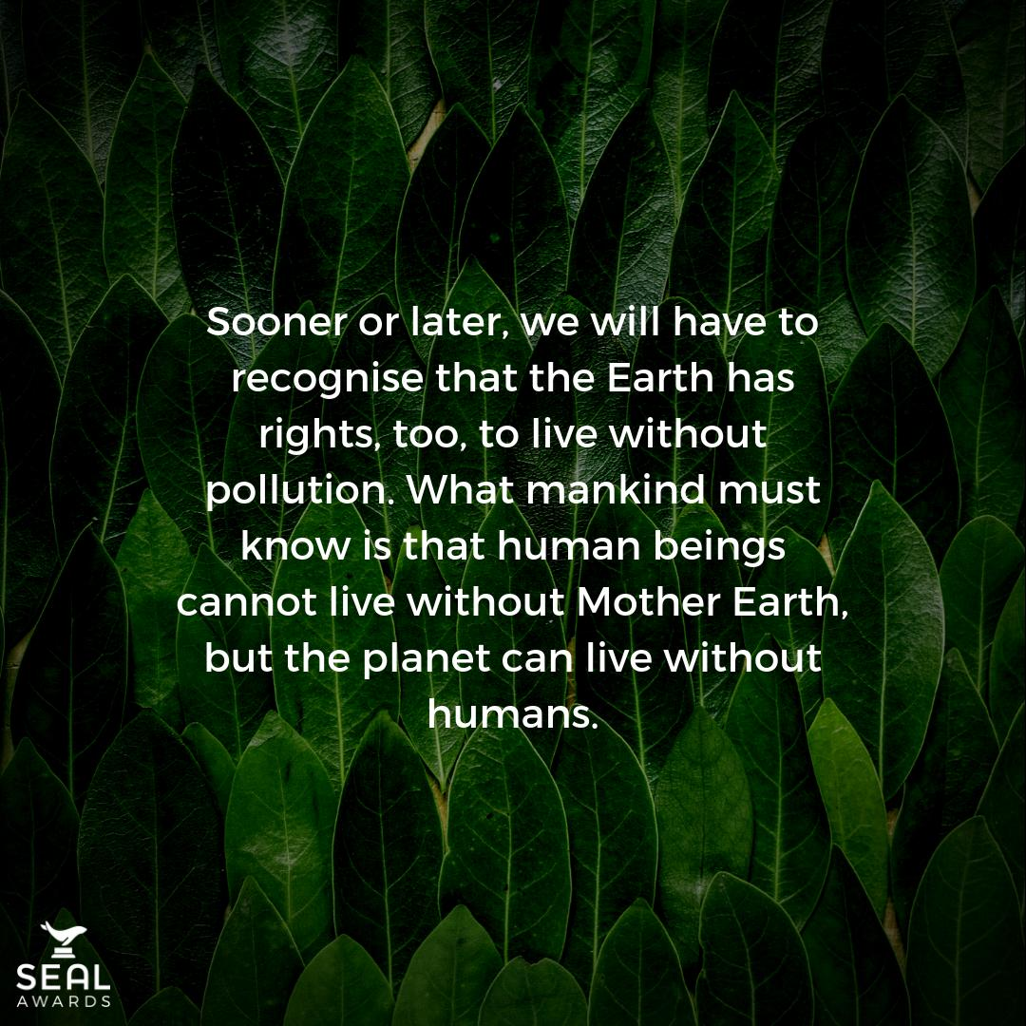

Keys:
Exercise 3
1.True 2.False 3.False 4.True 5.True 6.False 7.True 8.False 9.False

