Lesson 51, Reading, PI (Global Problems)

Exercise 1

Look at the words and translate them.
https://quizlet.com/509248028/lesson-51-pi-reading-exercise-1-flash-cards/?new

Exercise 2
Read the text and do the task after it.

Choose the best variant.

- Which of these is the biggest contributor to greenhouse gas emissions?
- Carbon dioxide
- Carbon monoxide
- Oxygen

2) What is global warming?
a. The earth heating due to build-up of greenhouse gases
b. When the average air temperature reaches 80°F
c. A rise in temperature in the earth's core

3) Trees give off carbon dioxide.
a. True
b. False
c. It doesn't say in the story.

4) Why would sea levels rise because of global warming?
a. Water pollution
b. Melting of the polar ice caps
c. Too many large ships

5) Burning which of these fuels puts carbon dioxide into the atmosphere?
a. Coal
b. Oil
c. Both are correct.

6) What's the best way to slow down global warning?
a. Work all the air conditioners harder.
b. Use more coal.
c. Use less fossil fuel.

7) What is deforestation?
a. The cutting down of trees
b. The planting of trees
c. A station set up to measure CO2 in the forest

8) Why would animals become extinct because of global warming?
a. Their natural habitat would change or disappear.
b. They would drown.
c. Hunters would kill them.

9) Trees soak up carbon dioxide.
a. True
b. False
c. It doesn't say in the story.

Exercise 3
Write the words below each picture.

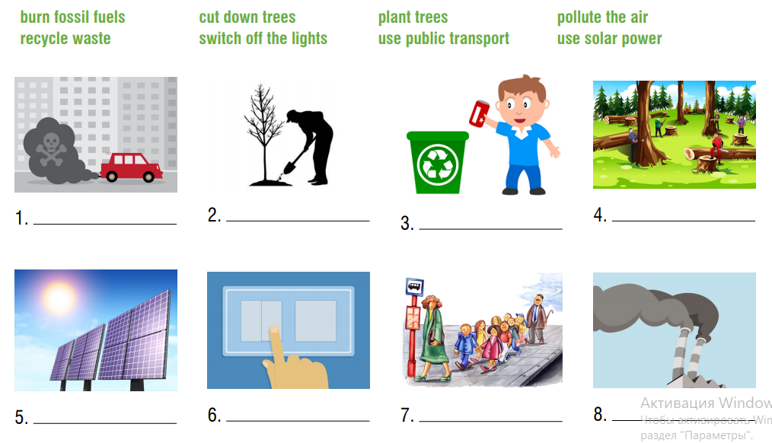

Exercise 4
Answer the following questions about the environment.
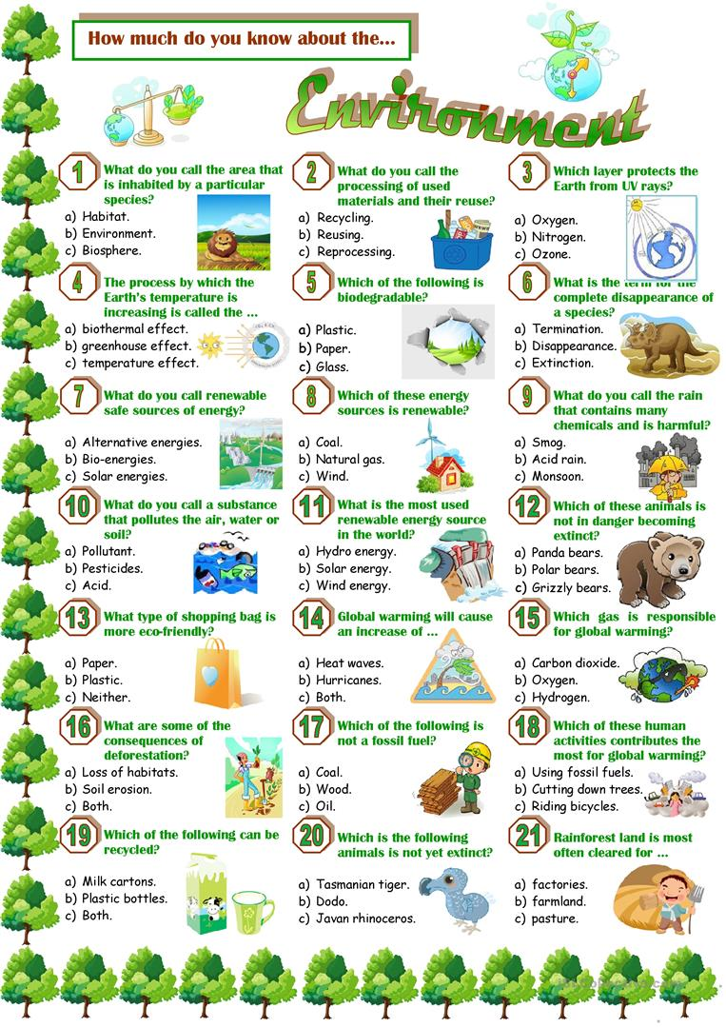

Keys:
Exercise 2
1.a 2.a 3.b 4.b 5.c 6.c 7.a 8.a 9.a
Exercise 3
- pollute the air 2. plant trees 3. recycle waste 4. cut down trees 5. use solar power 6. switch off the lights 7. use public transport 8. burn fossil fuels

