Exercise 1. Listen to the audio and answer the questions.

1) Stuart is going to ______ with his friends.
a) watch a football game
b) go for a drive and have a picnic
c )see a movie and have dinner

2) Why can't Amy go with her friends?
a) She doesn't have any spending money.
b) She already has plans to attend a party.
c) She has to study for an exam.

3) At the end of the evening, the friends are going to ____.
a) have a party
b) watch a video
c) play some games

4) How is Amy getting to the activity?
a) She's taking the bus.
b) She's driving her car.
c) Stuart is giving her a ride.

5) Amy wants to be home at ____.
a) midnight
b) 11:30 p.m.
c) 10:30 p.m.

Exercise 2. Listen to the audio and choose True or False for these questions.
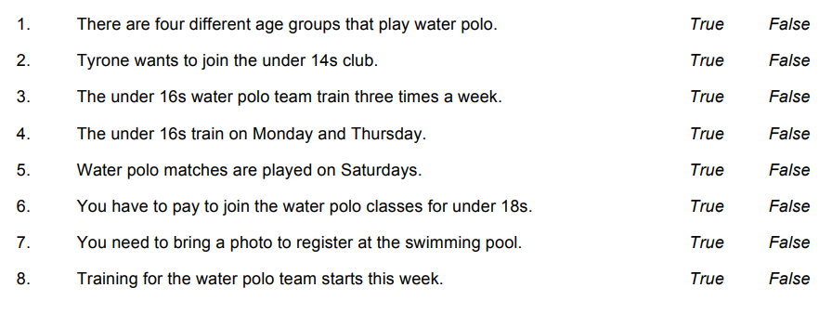

Exercise 3. Listen to the audio and answer the following questions about the interview.
1) She has played the piano ____ .
a) for three years
b) for eight years
2) What is the highest grade?
a) grade 3
b) grade 8
3) What is sight reading?
a) an easier way to play
b) a musical test
4) What does she enjoy more?
a) the piano
b) the violin
5) What does she do at Guides?
a) outdoor activities
b) swimming
6) What are joggers?
a) sports trousers
b) sports shoes

Exercise 4. Listen to the audio and choose True or False for these questions.
1 The swimming pool is open 24 hours a day.
a) True
b) False
2 You cannot use the sauna in the mornings.
a) True
b) False
3 You need to book to use the gym.
a) True
b) False
4 There are four squash courts on board.
a) True
b) False
5 The art class is at 2 o’clock.
a) True
b) False
6 There is a class in Italian cooking today.
a) True
b) False
7 There are limited places on the art and cooking classes.
a) True
b) False
8 You don’t have to pay extra to see the jazz band and comedy show.
a) True
b) False
9 You need a ticket to see the shows.
a) True
b) False
10 Today’s lecture is the same as tomorrow’s lecture.
a) True
b) False

Answers:
Exercise 1. Listen to the audio and answer the questions.

1) Stuart is going to ______ with his friends.
a) watch a football game
b) go for a drive and have a picnic
c )see a movie and have dinner

2) Why can't Amy go with her friends?
a) She doesn't have any spending money.
b) She already has plans to attend a party.
c) She has to study for an exam.

3) At the end of the evening, the friends are going to ____.
a) have a party
b) watch a video
c) play some games

4) How is Amy getting to the activity?
a) She's taking the bus.
b) She's driving her car.
c) Stuart is giving her a ride.

5) Amy wants to be home at ____.
a) midnight
b) 11:30 p.m.
c) 10:30 p.m.

Exercise 2. Listen to the audio and choose True or False for these questions.
Exercise 3. Listen to the audio and answer the following questions about the interview.
1) She has played the piano ____ .
a) for three years
b) for eight years
2) What is the highest grade?
a) grade 3
b) grade 8
3) What is sight reading?
a) an easier way to play
b) a musical test
4) What does she enjoy more?
a) the piano
b) the violin
5) What does she do at Guides?
a) outdoor activities
b) swimming
6) What are joggers?
a) sports trousers
b) sports shoes

Exercise 4. Listen to the audio and choose True or False for these questions.
1 The swimming pool is open 24 hours a day.
a) True
b) False
2 You cannot use the sauna in the mornings.
a) True
b) False
3 You need to book to use the gym.
a) True
b) False
4 There are four squash courts on board.
a) True
b) False
5 The art class is at 2 o’clock.
a) True
b) False
6 There is a class in Italian cooking today.
a) True
b) False
7 There are limited places on the art and cooking classes.
a) True
b) False
8 You don’t have to pay extra to see the jazz band and comedy show.
a) True
b) False
9 You need a ticket to see the shows.
a) True
b) False
10 Today’s lecture is the same as tomorrow’s lecture.
a) True
b) False

