Lesson 60, Speaking, PI

Exercise 1
Have a look at the cards and prepare a 1 minute speech

Exercise 2
Look at the picture and answer the questions.

Exercise 3
How can you comment on the following quotes about music?
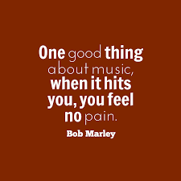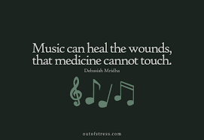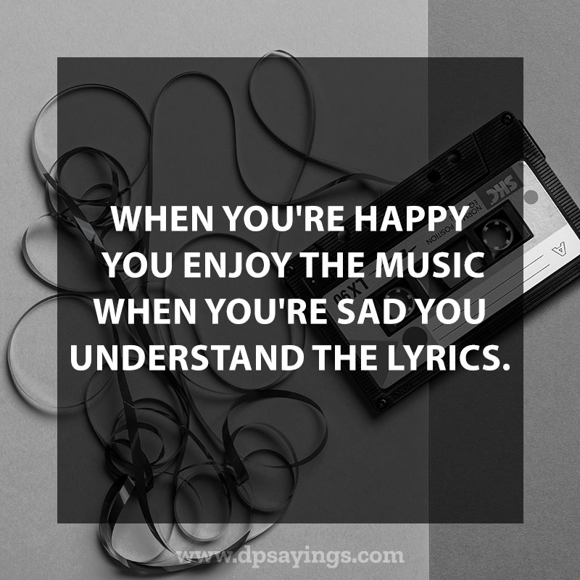

Exercise 4
Answer the following questions
1) What kind of music do you listen to?
2) Do you play any instruments?
3) Do you wish you could play any musical instrument?
4) Which is you favorite musical instrument?
5) When do you usually listen to music?
6) What kind of music did you like when you were younger?
7) Do you like the same music as your parents?
8) Do you think music is getting better as time goes on?
9) Do you think music has an effect on people’s lives?
10) Where do you think people enjoy listening to music the most?
11) What kind of music is popular in your country?
12) Is it better to go to a live concert to listen to a CD?
13) Is live music popular in your country?

