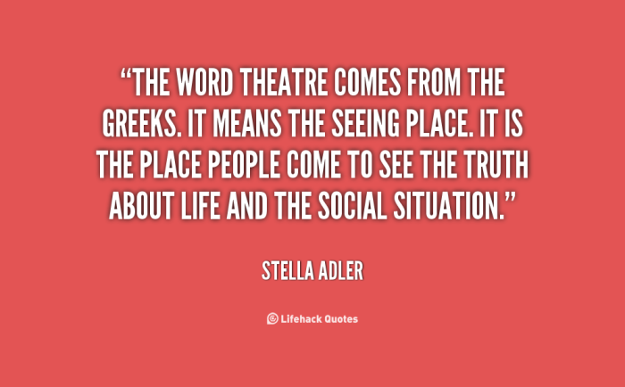

Exercise 1. Watch the video and do the tasks.
<iframe width='640' height='480' src='https://en.islcollective.com/video-lessons/embed/210410' frameborder='0' allowfullscreen></iframe>

Exercise 2. Watch the video and answer the questions.

Exercise 3. Watch the video and choose the best answer.

Exercise 4. Watch the video and do the tasks.
<iframe width='640' height='480' src='https://en.islcollective.com/video-lessons/embed/218301' frameborder='0' allowfullscreen></iframe>

Exercise 5. Answer the questions.
(1) What springs to mind when you hear the word ‘theatre’?
(2) Do you use the British spelling ‘theatre’ or the American spelling ‘theater’? Does it matter which one you use?
(3) How often do you go to the theatre?
(4) Is the theatre only for rich people?
(5) What do you like and dislike about the theatre?
(6) What’s the best thing you’ve ever seen at the theatre?
(7) Would you like to work as a theatre critic?
(8) Are theatre tickets easy to get in your country?
(9) How do you feel when you sit in a theatre before the performance begins?
(10) What’s the nicest theatre you’ve ever been to?

