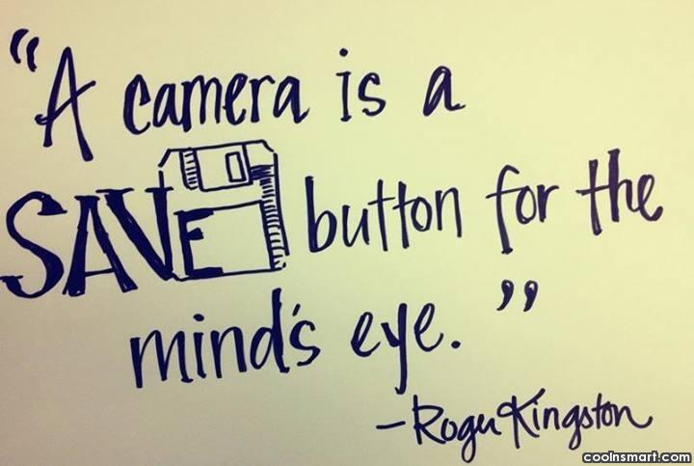

Exercise 1. Read the text and answer the questions.
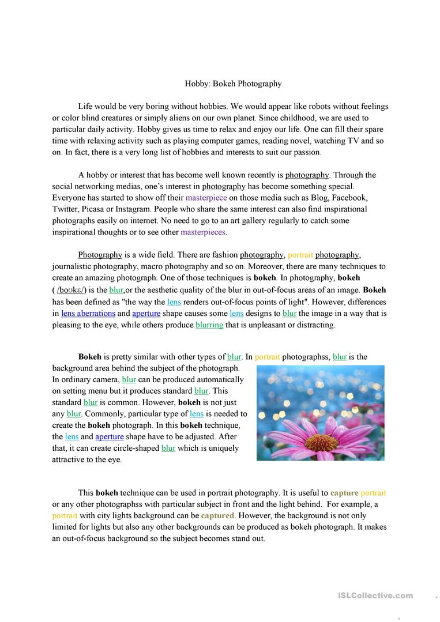
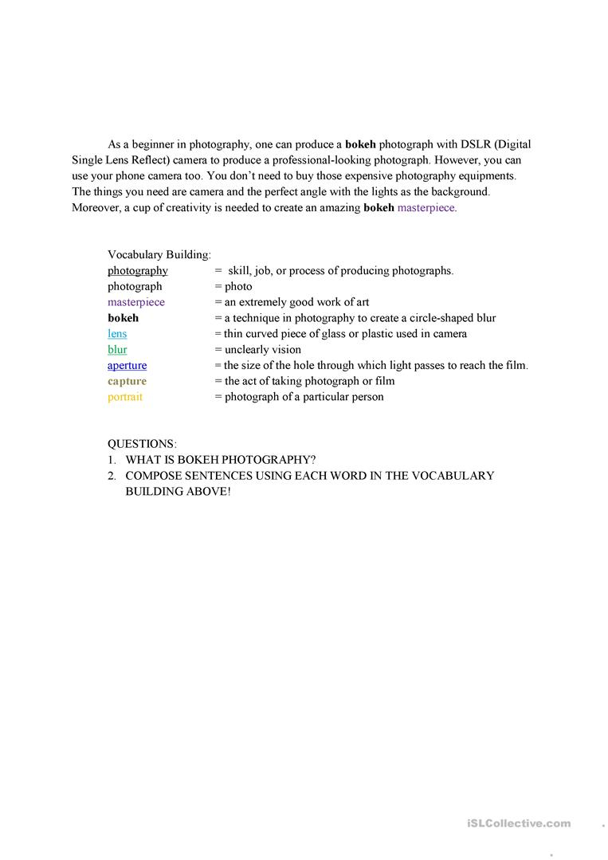

Exercise 2. Read the film reviews below of The Silver Glove and then decide the best answer for the questions below. For some questions there are two answers.

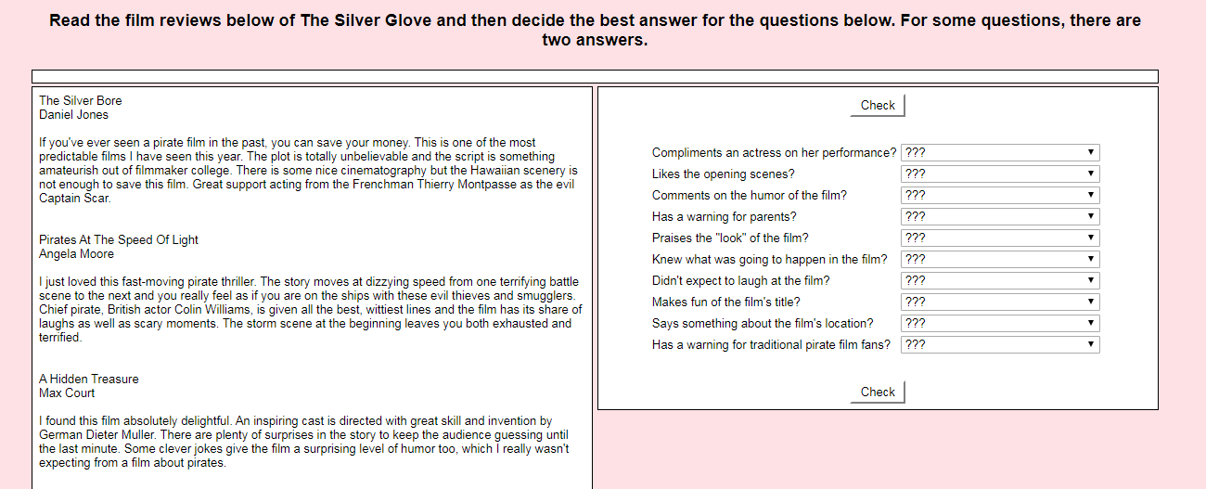

Exercise 3. Read the text and do the tasks.
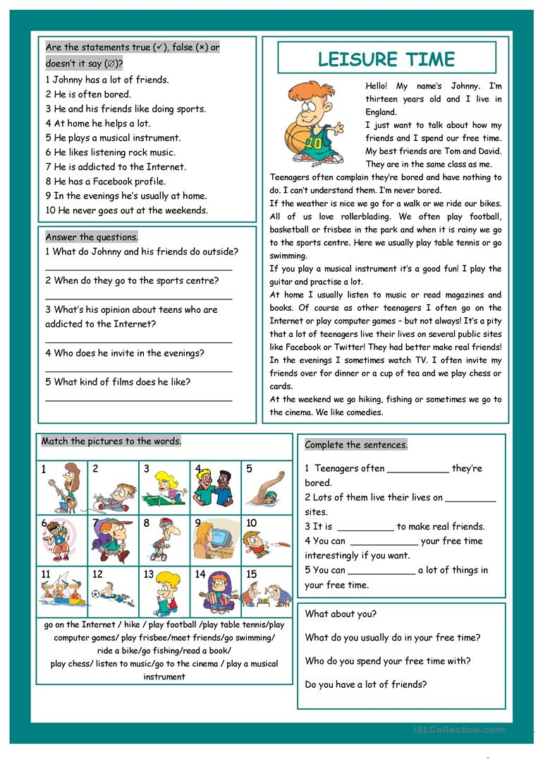

Exercise 4. Read the example and create your own film review.
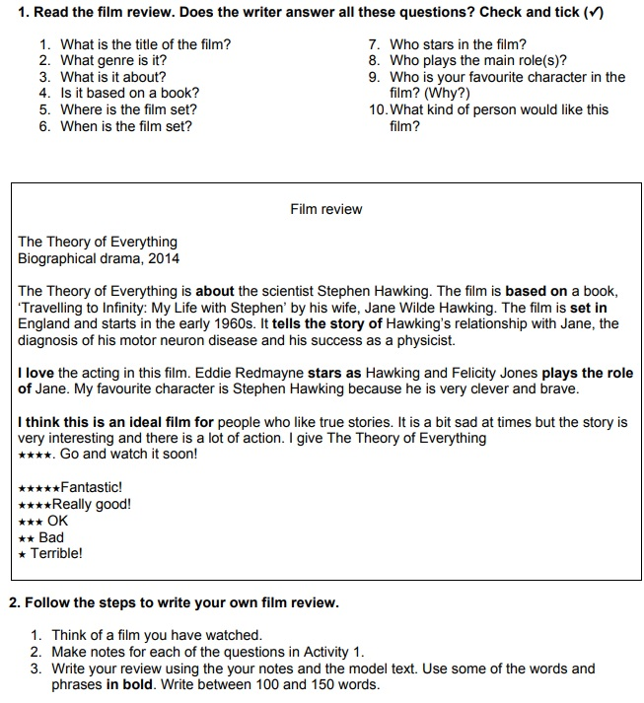

Exercise 5. Choose the best title for each paragraph.
