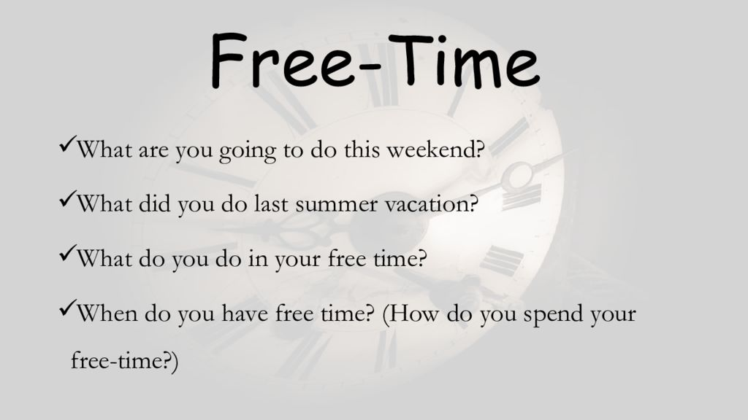
Exercise 1. Watch the video and answer the questions.
<iframe src="https://player.vimeo.com/video/119520956" width="640" height="360" frameborder="0" allow="autoplay; fullscreen" allowfullscreen></iframe>
<p><a href="https://vimeo.com/119520956">Taking Pictures (Animated Short Film)</a> from <a href="https://vimeo.com/simontaylor">Simon Taylor</a> on <a href="https://vimeo.com">Vimeo</a>.</p>
Questions:
1. Do you like to take pictures?
2. What kind of photos do you enjoy looking at?
3. What type of pictures do you keep in your family's photo albums?
4. Why do people take photos?
5. Are you a camera-shy? Or you like taking photos of yourself?
6. What kind of camera do you have?
7. Should pictures be posted on the internet without permission?
8. Have you ever wished you had not been in a particular picture?
9. How do you like to look at photos?
10. Do you always bring a camera wherever you go for vacation?

Exercise 2. Answer the questions.
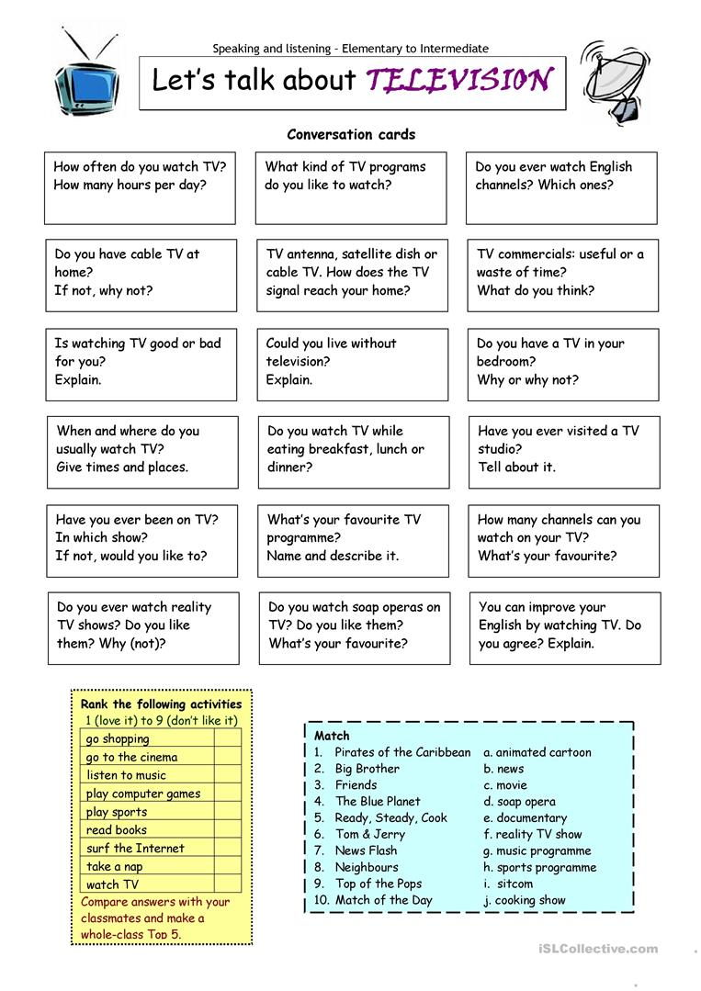

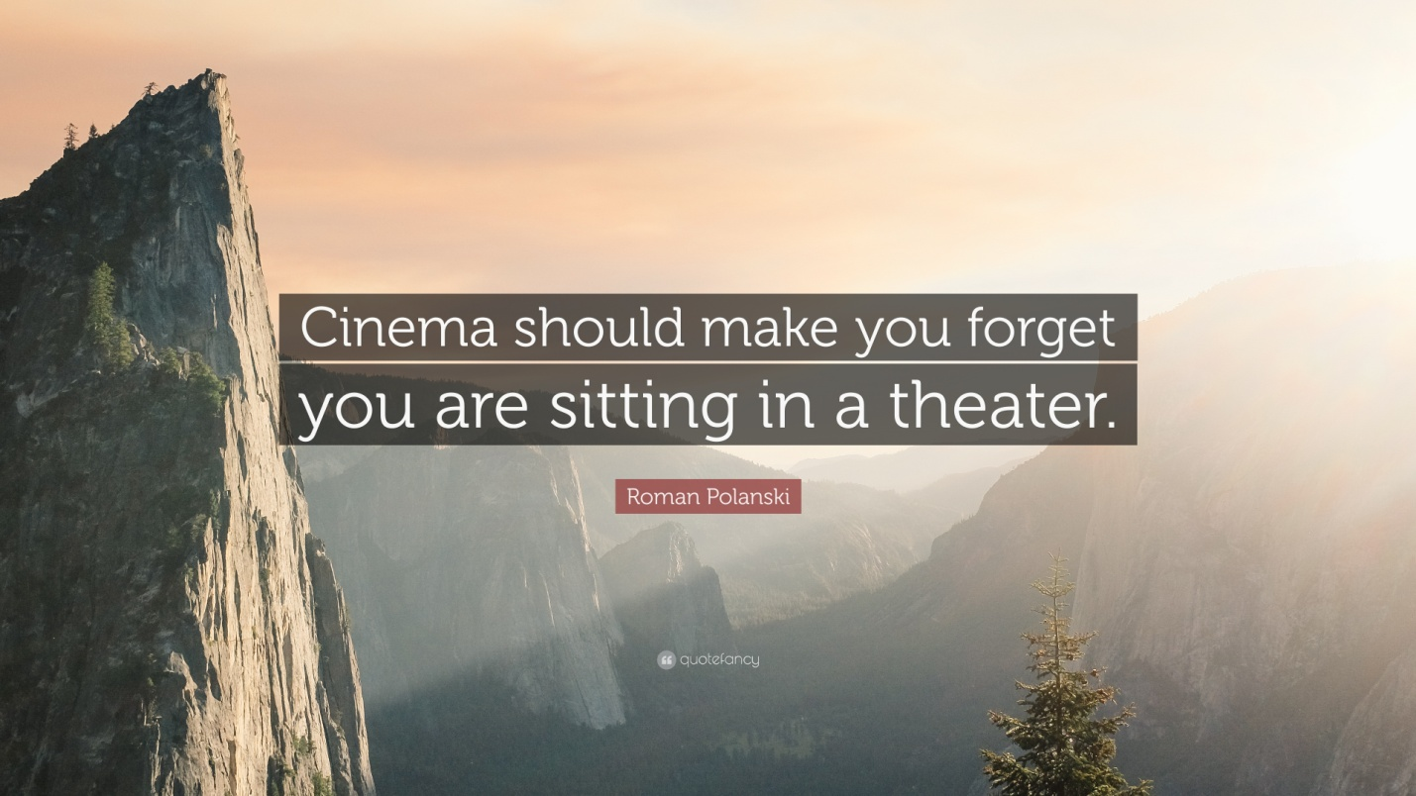

Exercise 3. Watch the video and answer the questions.
<iframe width="560" height="315" src="https://www.youtube.com/embed/3aIfMX7FBbI" frameborder="0" allow="accelerometer; autoplay; encrypted-media; gyroscope; picture-in-picture" allowfullscreen></iframe>
