Lesson 65, Listening, PI
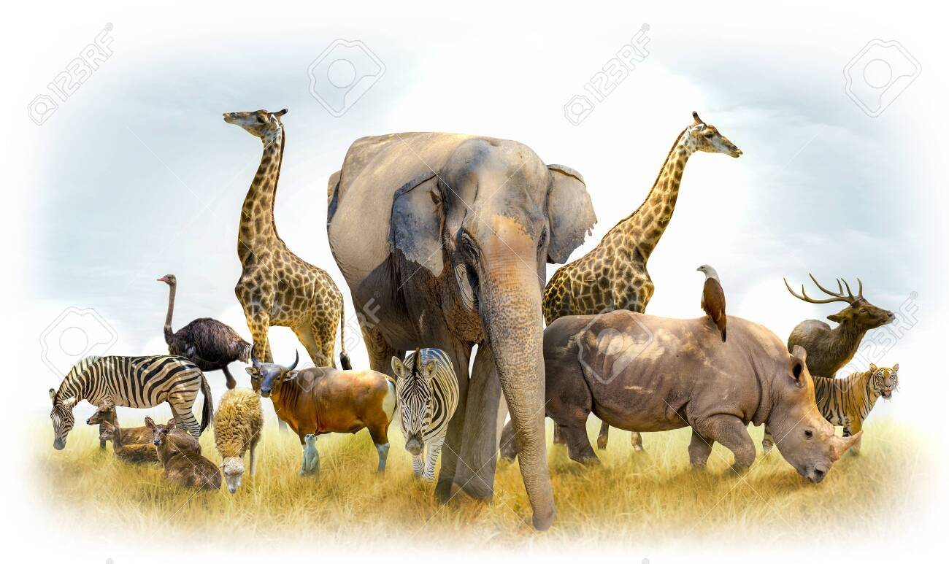

Exercise 1
Listen to the recording and then guess the names of the animals.
https://www.123listening.com/freeaudio/animals2-5.mp3
1. a) whale
2. b) snake
3. c) giraffe
4. d) dolphin
5. e) sheep
6. f) shark
7. g) zebra
8. h) kitten
9. i) mouse
10. j) monkey

Exercise 2
Listen to the recording and then complete the sentences.
https://listenaminute.com/a/animals.html
I’m lover. I’m fascinated by the whole animal kingdom. I loved animals when . I used to read every book I could find on animals. I knew all the different . The most exciting thing for me was going to the zoo. hours just watching the animals walk around, sit, . When I was older, I went on a safari to Tanzania. I animals in the wild. Everyone should do this once in their lives. Looking at animals habitat is a real honour. Now I’m the future of many animals. Some of my favourite animals are dying out. We really need to change our lifestyle so our children can have seeing animals in the wild.

Exercise 3
This video has 5 activities, do the them during watching it.
Skip activity 3.
https://www.youtube.com/watch?v=XOs4kapFlhU
Task 1
Watch the video till 1:40 minutes and then define whether statements are true or false
1) Wild animals live in jungles or on plaints.
2) A tiger is a king of the beasts.
3) A giraffe eats bushes.
4) An elephant has two trunks and one tusk.
5) Some bears are black, some are brown.
6) White bears do not exist.
7) Kangaroos live in Africa.
8) You can see raccoons, squirrels and chipmunks running wild in Canada.

Task 2
Watch the video from 1:40 to 2:50 minutes and then complete the sentences.
cage frightening jungle mighty wild

1) He was attacked by animals.
2) There is a beautiful bird in the .
3) Tigers are found in the of Asia.
4) He gave it a push and it opened.
5) The situation was getting quite .

Exercise 4
Watch the video and answer the questions after watching.
https://www.youtube.com/watch?v=m7Bc3pLyij0&feature=emb_title
- What is the message of this video?
- Can pets make people happier?
- Do you believe that dogs are more loyal than people?
- What can children learn by heaving a pet?

Exercise 5
Answer the following questions.
- What is your favorite animal?
- Have you got a pet?
- What are the advantages of having a pet?
- Should people spend a lot of money on pets instead of helping people in need?
- Do you like visiting zoos?
- Is keeping animals in zoos cruel?
- What do you think about using animals in circuses?

Keys:
Exercise 1:
1. J 2. G 3. I 4. F 5. H 6. D 7. B 8. E 9. C 10. A
Exercise 2:
I’m a real animal lover. I’m fascinated by the whole animal kingdom. I loved animals when I was a kid. I used to read every book I could find on animals. I knew all the different animal species. The most exciting thing for me was going to the zoo. I would spend hours just watching the animals walk around, sit, or even sleep. When I was older, I went on a safari to Tanzania. I saw real wild animals in the wild. Everyone should do this once in their lives. Looking at animals in their natural habitat is a real honour. Now I’m worried about the future of many animals. Some of my favourite animals are in danger of dying out. We really need to change our lifestyle so our children can have the chance of seeing animals in the wild.
Exercise 3, Task 1:
1.True 2.False 3.False 4.False 5.True 6.False 7.False 8.True

