Lesson 66, Video, PI
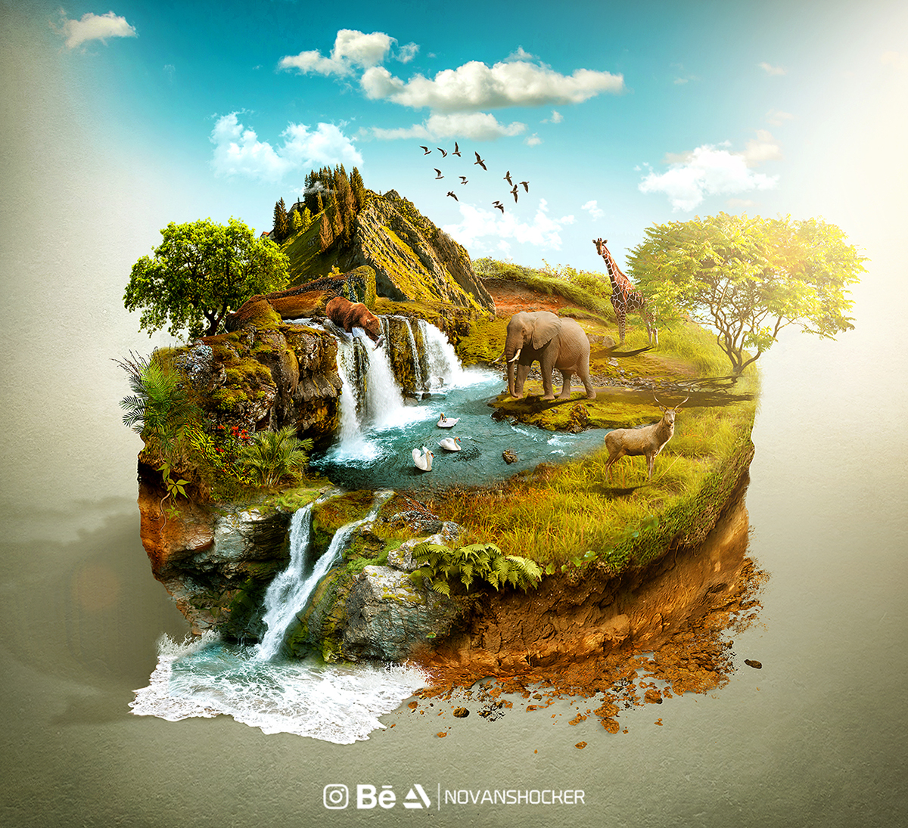
Exercise 1
Look at the words and translate them.
https://quizlet.com/501587421/lesson-66-video-pi-exercise-1-flash-cards/?new
Exercise 2
Watch the video and choose the best variant.
https://www.youtube.com/watch?v=-S14SjemfAg
1) We are living in the beginning of a:
a) mass ambush
b) mass extinction
c) mass reunion
2) To survive people need to stop burning:
a) fossil human bone
b) avian fossil
c) fossil fuels
3) Trees suck … out of the air:
a) Carbon
b) Oxygen
c) Radon
4) An example of natural climate solution is a:
a) bush
b) tree
c) stem
5) Natural Climate Solution gets just…% of all the money used on tackling climate breakdown.
a) 1,5
b) 2
c) 3
6) Up to … species are going extinct every single day.
a) 220
b) 202
c) 200
7) What should people do?
a) protect, restore, fund
b) protect, fund, assassinate
c) restore, assassinate, replicate

Exercise 3
Watch the video and answer the following questions.
https://www.youtube.com/watch?v=IlFRPkT-hVc
- How would you define an expression “seven worlds”?
- Can you name these ”seven worlds”?
- Does every “world” unique? Why?

Exercise 4
Watch the videos and answer the following questions.
https://www.youtube.com/watch?v=rM6txLtoaoc&list=PL5WqtuU6JrnXjsGO4WUpJuSVmlDcEgEYb&index=8&t=0s
https://www.youtube.com/watch?v=lVMV3StvLCs&list=PL5WqtuU6JrnXjsGO4WUpJuSVmlDcEgEYb&index=12&t=0s

- What is the message of these videos?
- What can people do in order to protect nature?
- Do you believe that people poison oceans and coral reefs? Why?

Exercise 5
How can you comment on the following quotes?

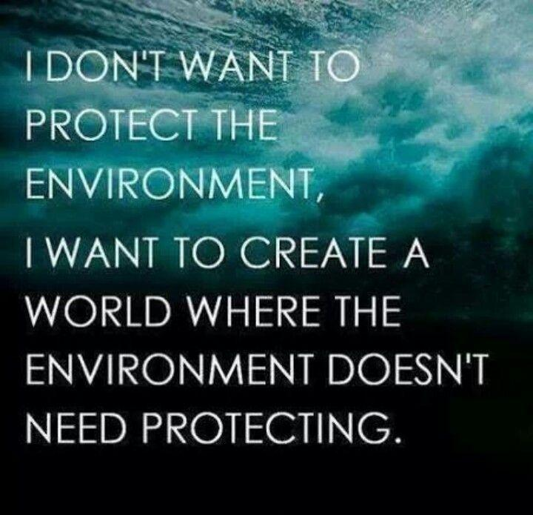
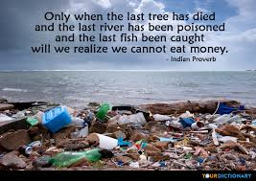

Exercise 6
Look at the words and translate them.
https://quizlet.com/501695824/lesson-66-video-pi-exercise-6-flash-cards/
Exercise 7
Watch the video and define whether statements are true or false
https://www.youtube.com/watch?v=5vVh6tnyknE
- Our planet is not struggling.
- Thousands of animals and plants disappear every day.
- Water sources are decreasing.
- Conservation agreement is a deal between a community and a group or person funding a conservation project.
- Individuals and communities receive benefits in return for conservation actions.

Keys:
Exercise 2:
1.B 2.C 3.A 4.B 5.B 6.C 7.A
Exercise 7:
1.False 2.False 3.True 4.True 5.True

