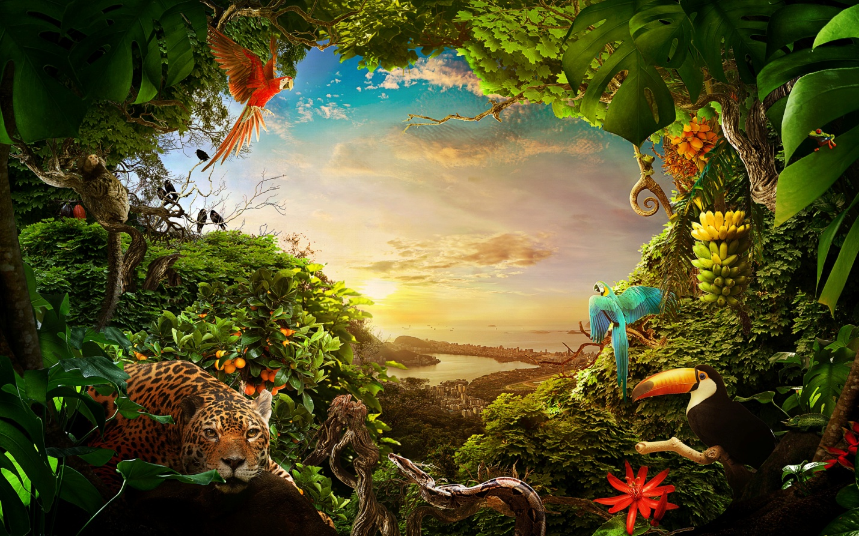
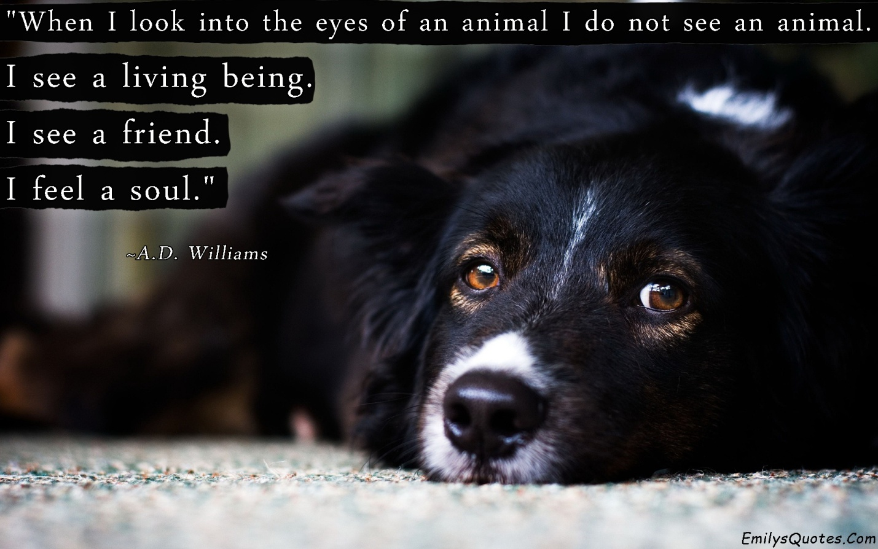

Exercise 1. Answer the questions.
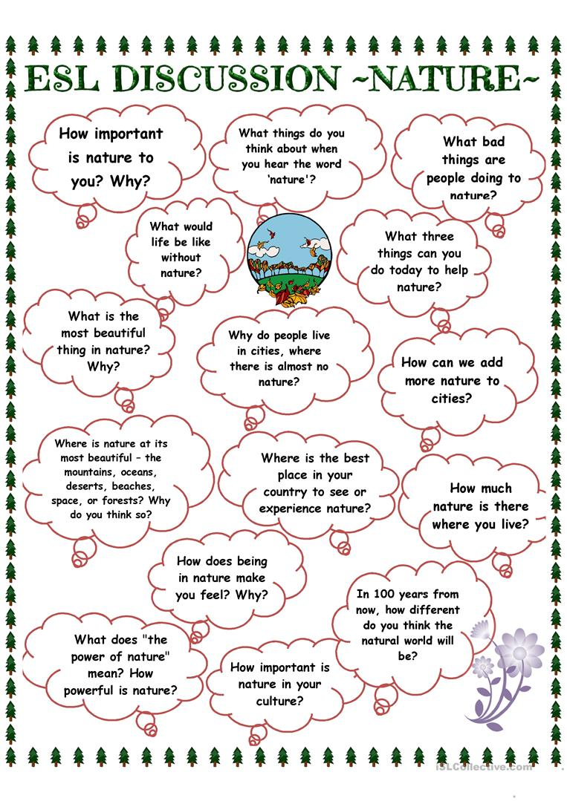

Exercise 2. Describe the nature in the following pictures.
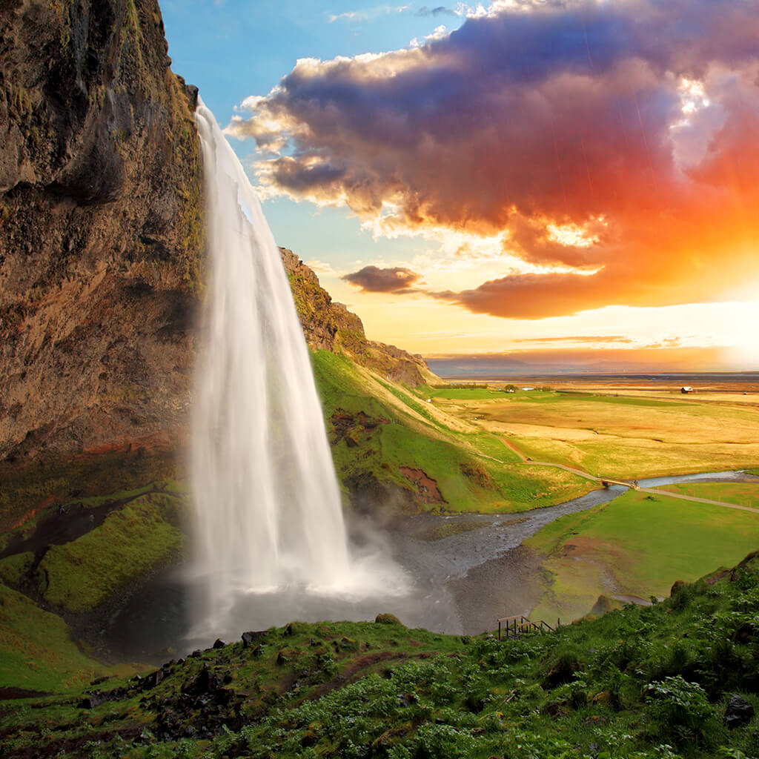
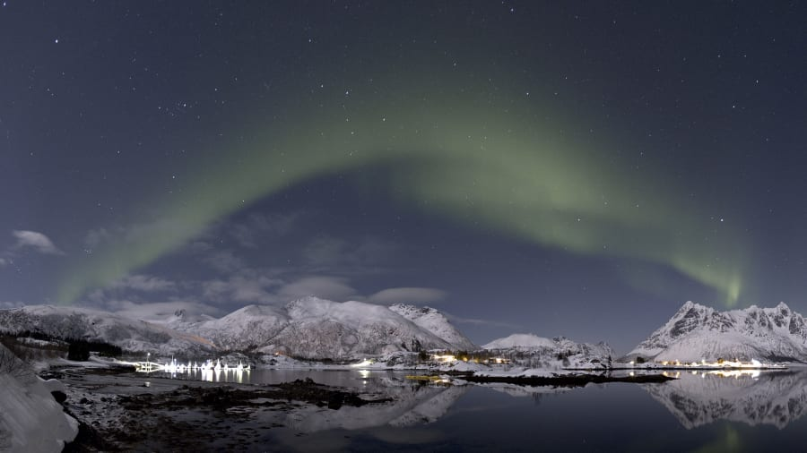
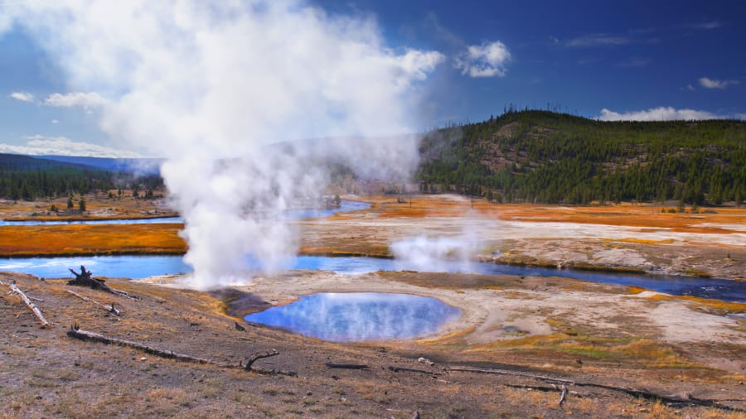
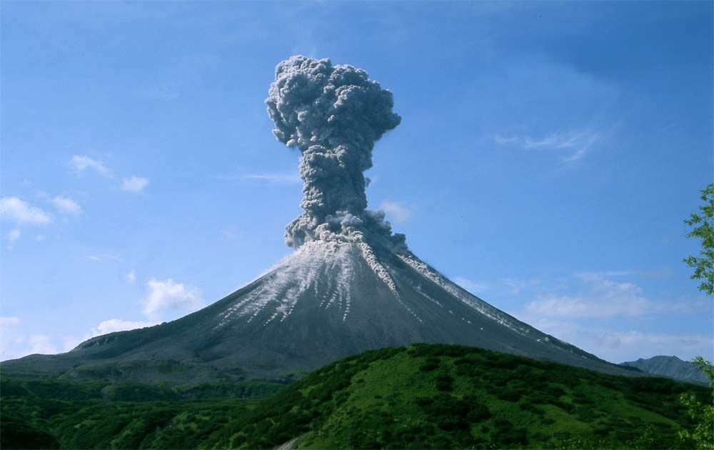
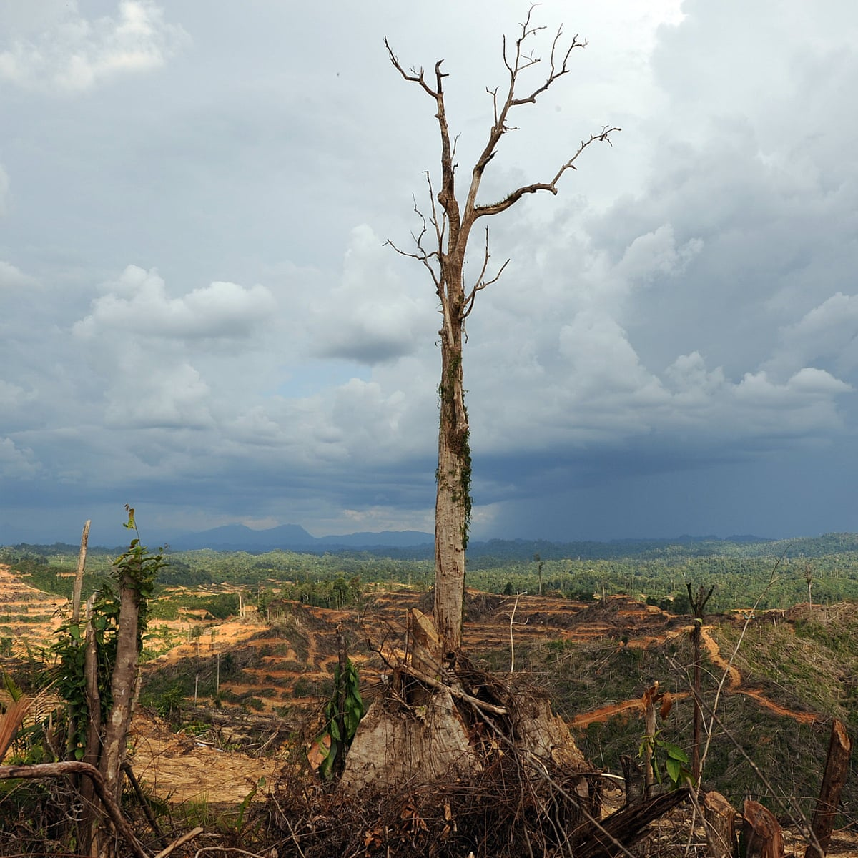
Exercise 3. Answer the questions.
1. How much do you worry about the environment?
2. Are you interested in reading articles or watching TV programs about environmental problems?
3. What are the main environmental problems in your country?
4. How do you feel about recycling?
5. What are the biggest environmental problems in the world?
6. Are the recent natural disasters the result of human influence on the environment?
7. Do you see any changes in the weather or climate of your place?
8. What can governments do to save our environment?
9. What can people do to help the environment?
10. Have you ever done anything to help the environment?
11. How will the world look like in 100 years?

Exercise 4. Watch the video and answer the questions.

Exercise 5. Answer the questions.
1. What’s your favorite animal?
2. Have you got a pet?
3. What are the advantages of having a pet?
4. What are the disadvantages of having a pet?
5. What can children learn by having a pet?
6. Should people spend a lot of money on pets instead of helping people in need?
7. Do you like visiting zoos?
8. Is keeping animals in zoos cruel?
9. What do you think about using animals in circuses?
10. How do you feel about hunting?
11. How do you feel about using animals for medical researches?
12. What’s the biggest difference between people and animals?

