Exercise 1. Listen to the audio and fill in the gaps.
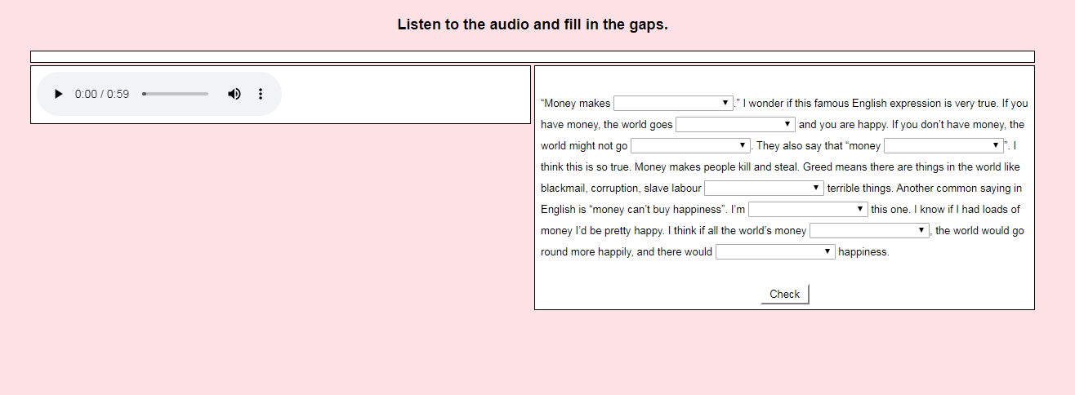

Exercise 2. Listen to the recording and answer the questions.

1) How much does the father owe his son in allowance?
a) three dollars
b) thirteen dollars
c) thirty dollars

2) The father hasn't given his son allowance recently because _____.
a) his son already has money
b) he doesn't have any money now
c) he didn't remember to do it

3) When does the father usually give his son money?
a) on Saturday
b) on Sunday
c) on Friday

4) Where does the man get money to pay his son?
a) from the bookstand
b) in his bedroom
c) at the bank

5) The boy is going to ________.
a) buy some toys
b) give money to the poor
c) spend his allowance on food

Exercise 3. Listen to the audio and answer the questions.

1) The man needs a suitcase to _______.
a) visit his mother
b) move to a new apartment
c) go on vacation

2) The man borrowed $500 for ______.
a) a car
b) school
c) medical expenses

3) He got a payday loan because it was _____.
a) fast
b) affordable
c) secure

4) Interest rates for payday loans can be _______ personal loans from banks.
a) more expensive than
b) less expensive than
c) as expensive as

5) The man is going to pay back the loan by ______.
a) getting a second job
b) borrowing money from his family
c) selling some of his things

Exercise 4. Listen to the recording and answer the following questions about the interview.
1) Why is Anita bad at saving money?
a) She gives money to her friends
b) She buys a lot of things

2) What does Martin think about saving money?
a) He doesn't want to do it
b) He will learn to do it

3) Why is Jeannie's family jealous?
a) She has a lot of nice things
b) She is good at saving money

4) When does Mark spend a lot of money?
a) When he has it
b) When it's the weekend

5) Ruth spends money ________.
a) on things she needs
b) about one day a month

6) What does Simon spend money on?
a) nothing
b) everything

7) In general, most people are_____
a) excellent at saving
b) not very good at saving
c) hardworking
d) good at planning

Exercise 5. Listen to the recording and answer the following questions about the interview.
How does Anita usually prefer to pay for things?
a) Credit card
b) Cash
c) Both

2) How does Todd prefer to pay for things?
a) Cash
b) Credit card
c) Check

3) What does Anita use to keep track on her expenses?
a) Notebook computer
b) Paper cashbook
c) Online statement
d) Memory

4) What does Anita worry about with credit cards?
a) Interest rates
b) Credit reports
c) Credit card fraud
d) Overspending

Answers:
Exercise 2. Listen to the recording and answer the questions.

1) How much does the father owe his son in allowance?
a) three dollars
b) thirteen dollars
c) thirty dollars

2) The father hasn't given his son allowance recently because _____.
a) his son already has money
b) he doesn't have any money now
c) he didn't remember to do it

3) When does the father usually give his son money?
a) on Saturday
b) on Sunday
c) on Friday

4) Where does the man get money to pay his son?
a) from the bookstand
b) in his bedroom
c) at the bank

5) The boy is going to ________.
a) buy some toys
b) give money to the poor
c) spend his allowance on food

Exercise 3. Listen to the audio and answer the questions.

1) The man needs a suitcase to _______.
a) visit his mother
b) move to a new apartment
c) go on vacation

2) The man borrowed $500 for ______.
a) a car
b) school
c) medical expenses

3) He got a payday loan because it was _____.
a) fast
b) affordable
c) secure

4) Interest rates for payday loans can be _______ personal loans from banks.
a) more expensive than
b) less expensive than
c) as expensive as

5) The man is going to pay back the loan by ______.
a) getting a second job
b) borrowing money from his family
c) selling some of his things

Exercise 4. Listen to the recording and answer the following questions about the interview.
1) Why is Anita bad at saving money?
a) She gives money to her friends
b) She buys a lot of things

2) What does Martin think about saving money?
a) He doesn't want to do it
b) He will learn to do it

3) Why is Jeannie's family jealous?
a) She has a lot of nice things
b) She is good at saving money

4) When does Mark spend a lot of money?
a) When he has it
b) When it's the weekend

5) Ruth spends money ________.
a) on things she needs
b) about one day a month

6) What does Simon spend money on?
a) nothing
b) everything

7) In general, most people are_____
a) excellent at saving
b) not very good at saving
c) hardworking
d) good at planning

Exercise 5. Listen to the recording and answer the following questions about the interview.
1) How does Anita usually prefer to pay for things?
a) Credit card
b) Cash
c) Both

2) How does Todd prefer to pay for things?
a) Cash
b) Credit card
c) Check

3) What does Anita use to keep track on her expenses?
a) Notebook computer
b) Paper cashbook
c) Online statement
d) Memory

4) What does Anita worry about with credit cards?
a) Interest rates
b) Credit reports
c) Credit card fraud
d) Overspending

