Lesson 71, PI, Reading (Business)

Exercise 1
Fill the gaps.
book cash cheques currency debit exchange savings wage

1) I'd like to make a deposit into my account.
2) In addition to my weekly , I got a lot of tips.
3) The bank can supply you with foreign .
4) Foreign currency, travellers` , credit cards or cash may be used to pay hotel and other expenses in Mexico.
5) Always keep your cheque card and cheque separately.
6) Why does my card work in one machine and not in another ?
7) I paid with my card.
8) The rate is likely to fall in the near future .

Exercise 2
Match the words in column A with those in column B.
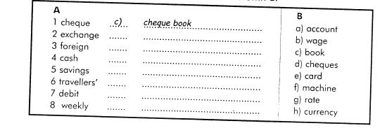

Exercise 3
Read the text and answer the questions.
The Gold Rush
It was January 1848. A man was digging near the small village of San Francisco, California. Suddenly, he saw something shiny-gold!
By the next year the California gold rush had begun. Thousands of men came to California. They were called "forty-niners," after the year 1849. The forty-niners came from all around the United States. They even came from other countries, including Mexico, Australia, China, France, and England. They left their families and jobs, and made the difficult trip to California. They all shared a dream. They all wanted to make a fortune in gold.
Towns and camps grew quickly wherever gold was found. These towns were rough places. There was almost always a saloon, where the men drank whiskey and gambled at cards. In mining towns, men stole and sometimes killed for gold.
Did the miners make their fortune? Some did, especially those who came early and were lucky. In 1848, miners usually made about twenty dollars a day. In 1852 miners made about six dollars a day. Many other people came to California to make money from the miners. Prices were very high. A loaf of bread, which cost five cents in New York, cost almost a dollar in San Francisco.
In 1848 San Francisco had been a village. Six years later it was a city with a population of 50,000. In 1850 California had enough people to become a state.

QUESTIONS
- How long did the California gold rush last?
a. For a year
b. For a few years
c. For a few months
2. What name did people who came to California in period of gold rush have?
a. Forty-niners
b. Forty-eighters
c. Forty-seveners
3. What was the main goal for these people?
a. To become famous
b. To make a fortune
c. To become the richest
4. What was the result of gold rush?
a. People became much richer
b. People didn’t die because of dangerous illnesses
c. The population of California grew quickly
5. What can we say about the quality of life in California?
a. It was the best.
b. The prices were much bigger.
c. People didn’t have places to live.
6. How did people in California spend their free time?
a. They drank whiskey and played cards.
b. They didn’t have free time.
c. They played chess and cards.
7. What is the synonym for the word ‘gambled’ (paragraph 3)?
a. Played
b. Lied
c. Cheated
d. Watched

Exercise 4
Tracy`s sister saves her pocket money. Solve the clues, and you will see what she is saving for.
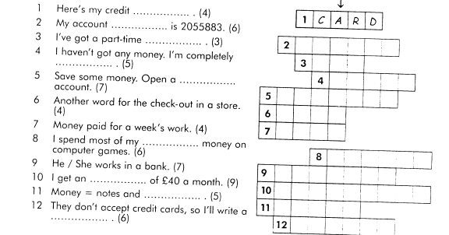
Exercise 5
Answer the following questions
1) Are you mostly a saver or a spender?
2) Do you ever give money to charities?
3) Have you ever gambled?
4) Have you ever found any money?
5) Have you ever had any money stolen from you?
6) Would you rather be rich and ugly or poor and good-looking?
7) What would you do with $1,000,000?
8) What are the advantages of being rich?
9) What are the disadvantages of being rich?
10) Can money buy love?
11) Is it possible to be happy in spite of being poor?
12) Are poor people usually more generous than rich ones?
13) Do rich people generally spend their money wisely?

Keys:
Exercise 1
1) I'd like to make a deposit into my savings account.
2) In addition to my weekly wage, I got a lot of tips.
3) The bank can supply you with foreign currency.
4) Foreign currency travellers cheques, credit cards or cash may be used to pay hotel and other expenses in Mexico.
5) Always keep your cheque card and cheque book separately.
6) Why does my card work in one cash machine and not in another ?
7) I paid with my debit card.
8) The exchange rate is likely to fall in the near future.

Exercise 2
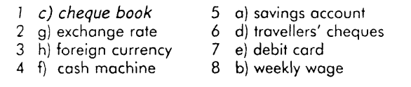
Exercise 3
1.b 2.a 3.b 4.c 5.b 6.a 7.a
Exercise 4

