Lesson 72, PI, Speaking (Money)
Exercise 1
Look at the picture and answer the following questions.
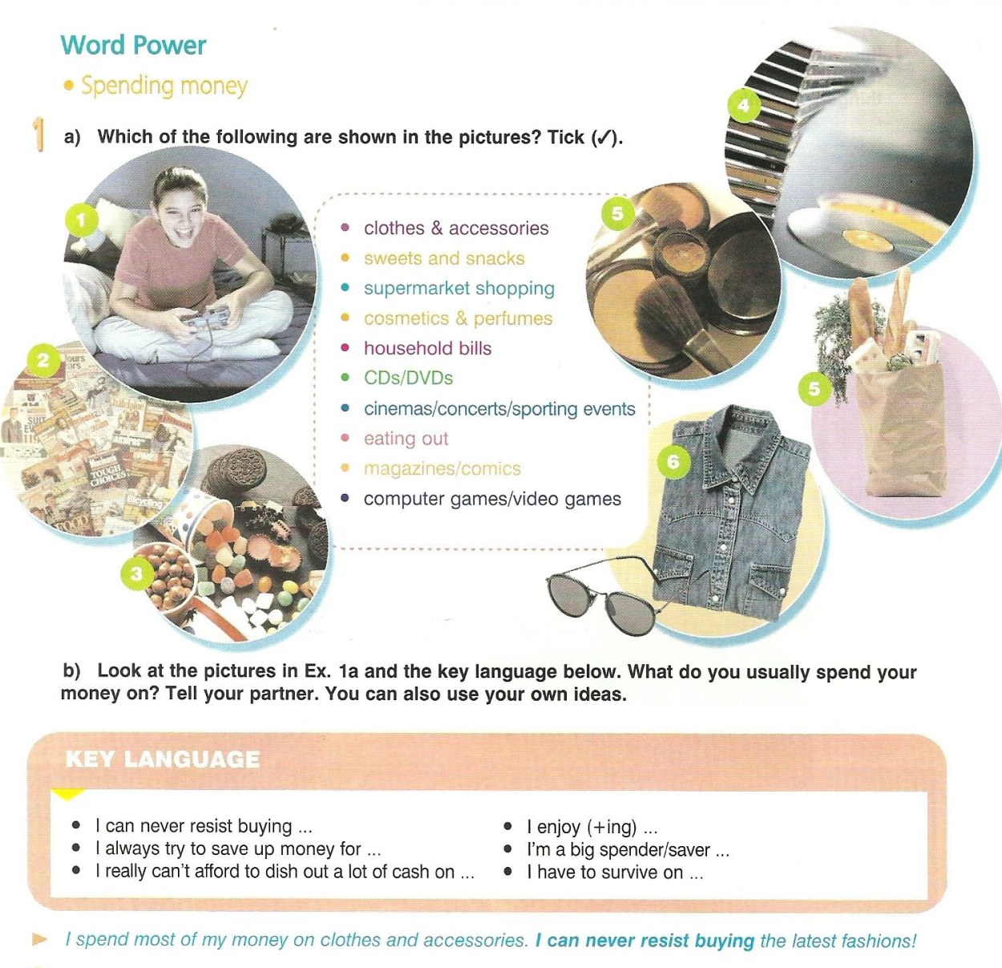
Exercise 2
Underline the item that best fits the sentence.
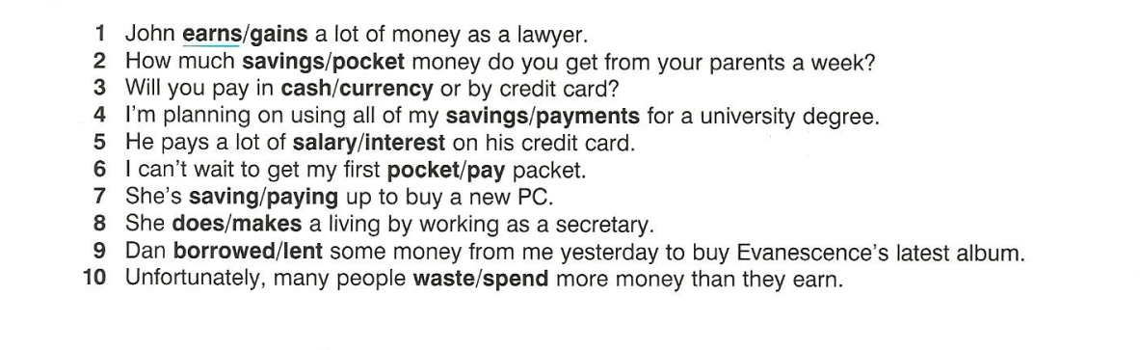
Exercise 3
How can you comment on the following quotes?

Exercise 4
Match the vocabulary with the correct definition
(для сайта сделала в hot potatoes)

Exercise 5
Answer the following questions.
1) Have you ever lost any money?
2) How much money would you like to earn a year?
3) Which company would you like to invest in now?
4) Have you ever borrowed money and not paid it back?
5) Is there anyone you don’t like lending money to?
6) Have you ever found any money? Did you keep it?
7) What did you last waste money on?
8) Do you owe anybody money now?
9) When did you last withdraw money from the bank?
10) Has anybody ever stolen money from you?

Keys:
Exercise 2
1.earns 2.pocket 3.cash 4.savings 5.interest 6.pay 7.saving 8.makes 9.borrowed 10.spend
Exercise 4
1.f 2.g 3.a 4.h 5.i 6.j 7.b 8.e 9.d 10.c

