Lesson 75, Reading, PI (Shops and shopping)
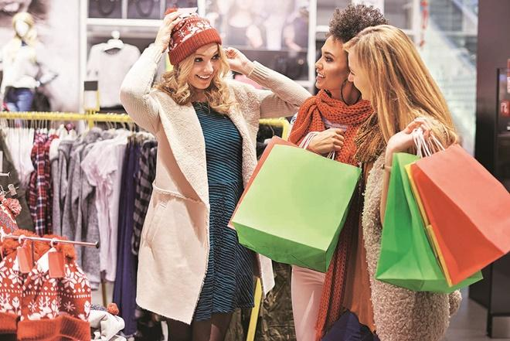

Exercise 1

Look at the words and translate them.

https://quizlet.com/510033211/lesson-75-reading-pi-exercise-1-flash-cards/?new

Exercise 2
Read about the new shopping mall and answer the questions after it.
Gatesbridge’s new Merriwether Mall is opening this September. With an area of 320,000 square metres, the Merriweather Mall will be the biggest mall in the south west. It’s located close to the motorway, has its own bus station and 2000 car parking spaces, so it is convenient for everyone.
The mall has five areas, all under cover. The largest, Main Street, is a shopping area on three floors. Here, you’ll find all the major chain stores and department stores. You can buy fashion items and all the famous brand names. There is also a large chemist.
Situated on two levels, the market square is where you can find traditional market stalls. On the lower floor, there are food stalls, including a butcher’s, baker’s, a fishmonger’s, greengrocer’s and delicatessen. On the upper floor, you will find stalls selling hardware and haberdashery.
Bohemia is at the rear of the mall. Here, you’ll find quirky, independent shops selling everything from second hand music and books to clothes and handicrafts.
The Palisade is more upmarket. Here you will find fashion boutiques, jewelers, antiques and furniture. There are also two banks and a post office located along The Palisade.
The Showground is the entertainment centre of the mall. On the ground floor, there is a food court where you’ll find cuisine from around the world, including Chinese, Japanese, Thai and Italian food. There is a large arena where events will take place through the year. There is also an eight-screen cinema, a night club and a bowling alley.
And if that is not enough, we are offering you a voucher which will give you £10 off any purchase over £40 that you make in the Merriwether Mall between 10th and 16th September. You can’t afford to miss it!

1. Where is the best place in the mall to buy an expensive necklace?
2. Where is the best place in the mall to buy some bacon?
3. buy some Nike trainers?
4. buy a used CD?
5. have a meal?
6. buy an expensive, old cupboard?
7. see a film?
8. buy some bacon?
9. buy some shampoo?
10. mail a parcel?

Exercise 3
Match the reasons to return a product to the statements.

Exercise 4
Complete the gaps below with the correct words.
credit exchange guarantee refund replacement

1. "They'll only give you a if you've got the receipt. "
2. "I'm really sorry it's not working properly. Bring it to the shop and we can do an ."
3. "You can have store , but not your money back. I hope you find something else you like."
4. "The washing machine has a two-year , so yes we can repair it for you free of charge."
5. "I don't want to return it, I need a . I really like it but there's a problem with the case."

Keys:

Exercise 2

Exercise 3

Exercise 4

1. "They'll only give you a refund if you've got the receipt."
2. "I'm really sorry it's not working properly. Bring it to the shop and we can do an exchange ".
3. "You can have store credit, but not your money back. I hope you find something else you like."
4. "The washing machine has a two-year guarantee, so yes we can repair it for you free of charge."
5. "I don't want to return it, I need a replacement. I really like it but there's a problem with the case."

