Lesson 76, Speaking, PI (Shops and shopping)

Exercise 1
How can you comment on the following quotes?
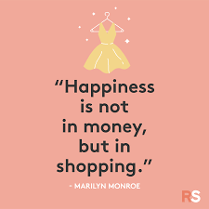

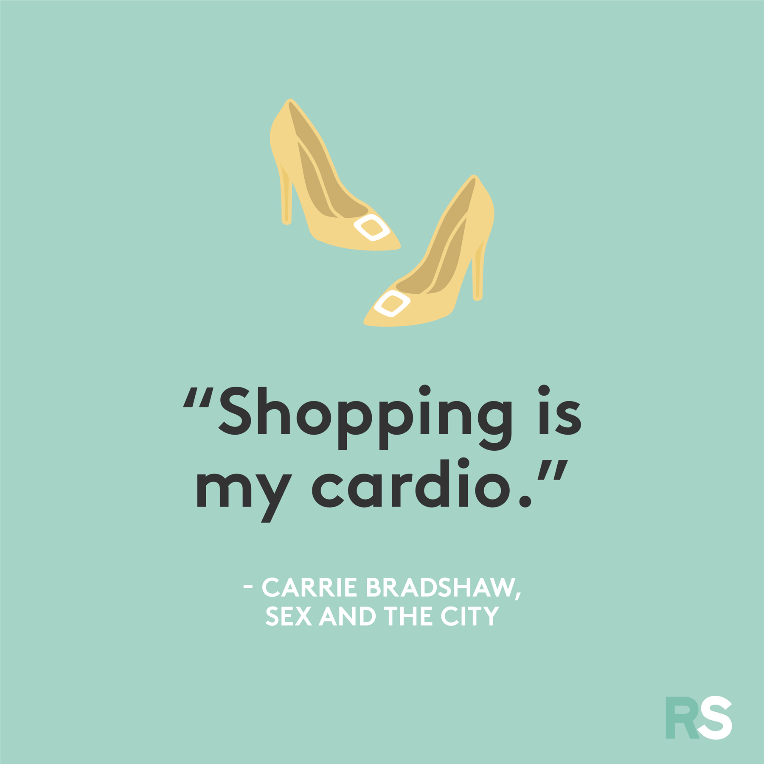

Exercise 2

Have a look at the cards and prepare a 1 minute speech.

Exercise 3

Look at the pictures and answer the following questions.
In your answers use the key words listed below.

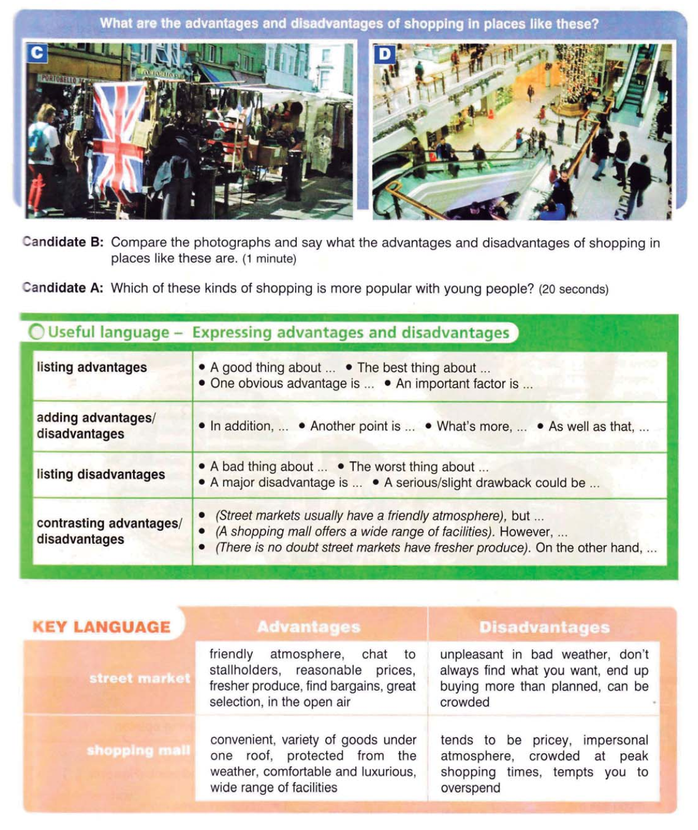

Exercise 4
Answer the following questions.
- How do you feel about shopping?
- What types of shops do you use regularly?
3) What changes have you seen in those shops in the past few years?
4) Do you like shopping on the internet?
5) What kinds of things do you buy online?
- Do you agree or disagree that women spend more time shopping than men?
- Do people generally prefer to buy products from their own or from other countries?
- Why do you think some people purchase things that they do not need?

