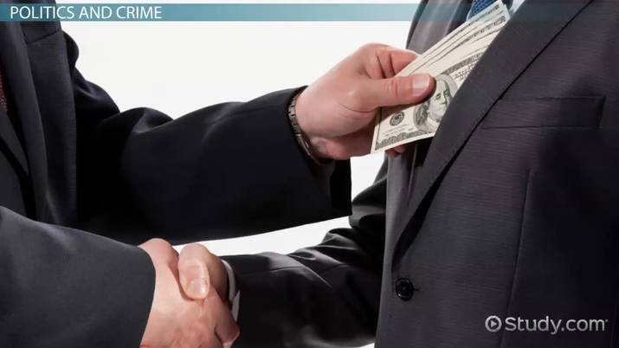

Exercise 1. Listen to the audio and guess if 1-8 below are true (T) or false (F).
- A report says there is a wave of micro crime in Britain. T / F
- Researchers were not surprised by their findings. T / F
- The report says three in four British people are hiding a criminal past. T / F
- The most common micro crime in Britain is related to tax. T / F
- The middle class commits more micro crimes than the working class. T / F
- Women commit more micro crimes than men. T / F
- The second most common micro crime was not paying for shopping bags. T / F
- Lying about your age to get a better deal is not a micro crime. T / F

Exercise 2. Choose the correct answer.
1) What kind of company made the report?
a) a criminal company
b) a countryside company
c) a microwave company
d) a market research company
2) How did the researchers feel about their findings?
a) surprised
b) shocked
c) stunned
d) sad
3) What did the researchers say three in four British people were hiding?
a) people
b) money
c) stolen goods
d) a criminal past
4) How many micro crimes have 74% of British people done?
a) thousands
b) 77
c) at least one
d) countless crimes
5) What will some people not pay when they get cash?
a) the price
b) bills
c) attention
d) tax
6) Which class of people were most likely to commit micro crimes?
a) the working class
b) the upper class
c) the middle class
d) ex-prisoners

7) What percentage of women committed micro crimes?
a) 71%
b) 70%
c) 77%
d) 74%
8) What is the second most common micro crime?
a) stealing plastic bags
b) lying
c) illegally downloading stuff
d) speeding
9) What percentage of people had illegally downloaded things?
a) exactly 30%
b) fewer than 30%
c) greater than 30%
d) about 30%
10) What did people lie about to get a better deal?
a) their age
b) money
c) everything
d) their job
Exercise 3. Listen to the audio and choose True, False or Not given.
1) Tonight is Alice Jackson’s anniversary.
- Not given
- True
- False
2) Henry confesses Alice about betrayal.
- False
- True
- Not given
3) Henry was killed by burglars.
- True
- Not given
- False
4) Alice was preparing for the party when Henry was killed.
- Not given
- True
- False
5) Sergeant Taylor asked Alice for a glass of water.
- True
- False
- Not given
Exercise 4. Listen to the audio and fill in the gaps.
I ___________________ what politics is. When I turn on the television and see ___________________, I think it looks like a circus. A lot of the politicians I see are like comedians. They lie, they steal money ___________________ all kinds of scandals. Politics should be about serving the people. This cannot happen when ___________________ think most politicians can’t do their job properly. I’ve always ___________________ there are usually only two kinds of politics in most countries. You vote for the Democrats or Republicans, ___________________. Some countries have a middle, but that’s still ___________________ for. I also think it’s strange that most politicians _____________________ the people want. People want better health and education, not war.

Exercise 5. Listen to the mp3 and choose True or False for each question.
1. Richard Cookson is a member of the governing party.
True
False
2. Anne is still not sure who she is going to vote for.
True
False
3. There has recently been a referendum.
True
False
4. Richard Cookson denies the information that Anne saw in the campaign ad.
True
False
5. Richard Cookson's party wants to do something about deforestation.
True
False
6. Some people will pay higher taxes under Richard Cookson's party's plans.
True
False
7. Richard Cookson tells Anne where she can vote on Election Day.
True
False
8. Richard Cookson is optimistic about the election result.
True
False

Answers:

Exercise 1. Listen to the audio and guess if 1-8 below are true (T) or false (F).
- A report says there is a wave of micro crime in Britain. T / F
- Researchers were not surprised by their findings. T / F
- The report says three in four British people are hiding a criminal past. T / F
- The most common micro crime in Britain is related to tax. T / F
- The middle class commits more micro crimes than the working class. T / F
- Women commit more micro crimes than men. T / F
- The second most common micro crime was not paying for shopping bags. T / F
- Lying about your age to get a better deal is not a micro crime. T / F

Exercise 2. Choose the correct answer.
1) What kind of company made the report?
a) a criminal company
b) a countryside company
c) a microwave company
d) a market research company
2) How did the researchers feel about their findings?
a) surprised
b) shocked
c) stunned
d) sad
3) What did the researchers say three in four British people were hiding?
a) people
b) money
c) stolen goods
d) a criminal past
4) How many micro crimes have 74% of British people done?
a) thousands
b) 77
c) at least one
d) countless crimes
5) What will some people not pay when they get cash?
a) the price
b) bills
c) attention
d) tax
6) Which class of people were most likely to commit micro crimes?
a) the working class
b) the upper class
c) the middle class
d) ex-prisoners

7) What percentage of women committed micro crimes?
a) 71%
b) 70%
c) 77%
d) 74%
8) What is the second most common micro crime?
a) stealing plastic bags
b) lying
c) illegally downloading stuff
d) speeding
9) What percentage of people had illegally downloaded things?
a) exactly 30%
b) fewer than 30%
c) greater than 30%
d) about 30%
10) What did people lie about to get a better deal?
a) their age
b) money
c) everything
d) their job

Exercise 3. Listen to the audio and choose True, False or Not given.
1) Tonight is Alice Jackson’s anniversary.
- Not given
- True
- False
2) Henry confesses Alice about betrayal.
- False
- True
- Not given
3) Henry was killed by burglars.
- True
- Not given
- False
4) Alice was preparing for the party when Henry was killed.
- Not given
- True
- False
5) Sergeant Taylor asked Alice for a glass of water.
- True
- False
- Not given

Exercise 4. Listen to the audio and fill in the gaps.
I often ask myself what politics is. When I turn on the television and see politicians in action, I think it looks like a circus. A lot of the politicians I see are like comedians. They lie, they steal money and get involved in all kinds of scandals. Politics should be about serving the people. This cannot happen when most of the people think most politicians can’t do their job properly.
I’ve always found it strange that there are usually only two kinds of politics in most countries. You vote for the Democrats or Republicans, the left or the right. Some countries have a middle, but that’s still not a lot to vote for. I also think it’s strange that most politicians do not focus on what the people want. People want better health and education, not war.

Exercise 5. Listen to the mp3 and choose True or False for each question.
1. Richard Cookson is a member of the governing party.
True
False
2. Anne is still not sure who she is going to vote for.
True
False
3. There has recently been a referendum.
True
False
4. Richard Cookson denies the information that Anne saw in the campaign ad.
True
False
5. Richard Cookson's party wants to do something about deforestation.
True
False
6. Some people will pay higher taxes under Richard Cookson's party's plans.
True
False
7. Richard Cookson tells Anne where she can vote on Election Day.
True
False
8. Richard Cookson is optimistic about the election result.
True
False

