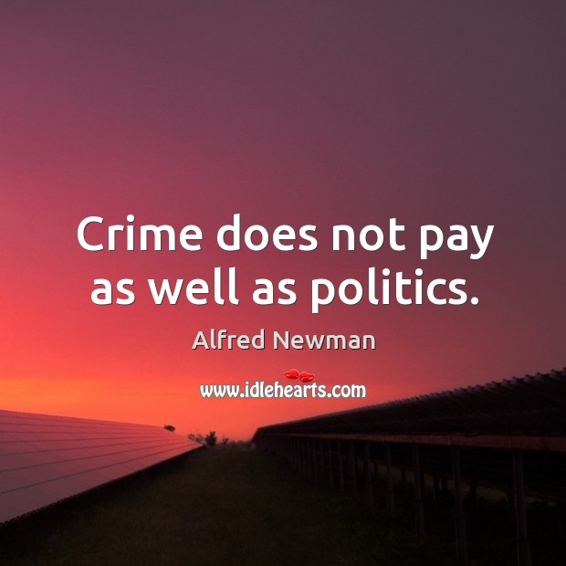
Exercise 1. Watch the video and answer the questions.
1. There are only three forensic scientists in the state.
a) true
b) false
2. Which of these things the forensic scientist doesn’t say they analyse?
a) slant
b) proportions
c) curvature
3. To train for this job, students are given real crime documents to analyse.
a) true
b) false
4. If a criminal writes with their opposite hand, or with their foot, mouth, etc. ...
a) it’s almost impossible to catch them
b) you can also identify and analyse their writing
c) you need a computer to analyse their writing
5. The technique the expert shows us can be used to ...
a) identify text that has been added to an original document
b) identify text that has been erased from an original document
c) identify the person who has written the text
6. He also works identifying signatures during elections.
a) true
b) false

Exercise 2. Watch the video and do the tasks.
<iframe width='640' height='480' src='https://en.islcollective.com/video-lessons/embed/200946' frameborder='0' allowfullscreen></iframe>

Exercise 3. Watch the video and answer the questions.
1. How many people in the UK are eligible to vote?
a) 46 million
b) 64 million
c) we don’t know
2. How many members of Parliament does each constituency have?
a) two
b) the video doesn’t say
c) one
3. You have to vote on election day to take part.
a) false
b) the video doesn’t say
c) true
4. The party with the most votes wins elections.
a) the video doesn’t say
b) false
c) true
5. The political party with the most MPs is called …
a)The Parliament
b) The government
c) The majority

Exercise 4. Watch the video and answer the questions.
<iframe width='640' height='480' src='https://en.islcollective.com/video-lessons/embed/163215' frameborder='0' allowfullscreen></iframe>

Exercise 5. Answer the following questions.
1. How much are you interested in politics?
2. Can you tell some recent political news?
3. How often do you read articles or watch TV programs on political issues?
4. Do you like talking about politics?
5. What are the main political problems in your country?
6. What do you think about your country’s political system?
7. What do you think about your country’s politicians?
8. What qualities make a good political leader?
9. Did you vote in the last election?
10. How do you decide who or what to vote for?
11. How have your political views changed during your lifetime?
12. How is it possible to get more people to vote?
13. How do you feel about stars who run for a position in politics?
14. Would you like to work in politics?
15. If you were a politician, what problems would you focus on?
16. What are the main political issues in the world?
17. What can cause a war?
18. What would the world be like without politics?

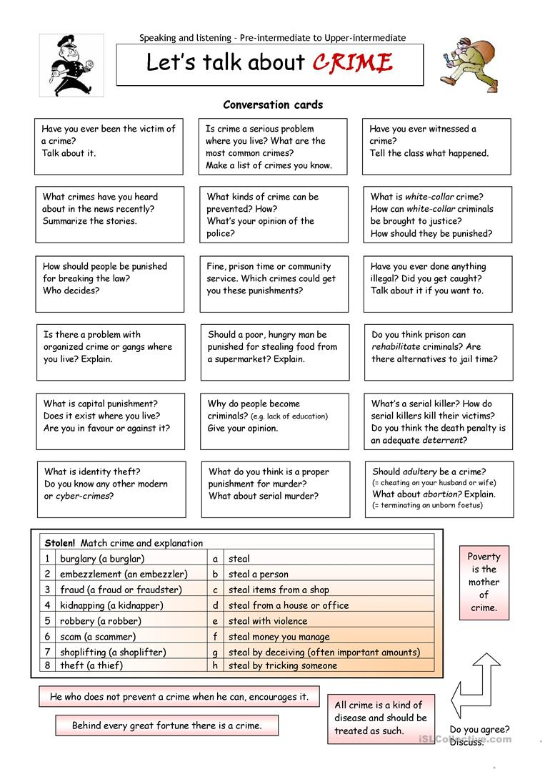

Answers:
Exercise 1. Watch the video and answer the questions.
1. There are only three forensic scientists in the state.
a) true
b) false
2. Which of these things the forensic scientist doesn’t say they analyze?
a) slant
b) proportions
c) curvature
3. To train for this job, students are given real crime documents to analyze.
a) true
b) false
4. If a criminal writes with their opposite hand, or with their foot, mouth, etc. ...
a) it’s almost impossible to catch them
b) you can also identify and analyze their writing
c) you need a computer to analyze their writing
5. The technique the expert shows us can be used to ...
a) identify text that has been added to an original document
b) identify text that has been erased from an original document
c) identify the person who has written the text
6. He also works identifying signatures during elections.
a) true
b) false

Exercise 3. Watch the video and answer the questions.
1. How many people in the UK are eligible to vote?
a) 46 million
b) 64 million
c) we don’t know
2. How many members of Parliament does each constituency have?
a) two
b) the video doesn’t say
c) one
3. You have to vote on Election Day to take part.
a) false
b) the video doesn’t say
c) true
4. The party with the most votes wins elections.
a) the video doesn’t say
b) false
c) true
5. The political party with the most MPs is called …
a)The Parliament
b) The government
c) The majority

